Instruction Manual
Dalton Aviation LLC
520-425-5155
tony@daltonaviation.com
35% Extra 260

SPECIFICATIONS

WING SPAN 103”
POWER 100/120cc
WEIGHT 27lbs+/-
RADIO 4 CH
WING AREA 2050 sq. in.

INTRODUCTION
Thank you for purchasing the 35% Dalton Aviation Extra 260. The builder of this model should be experienced in giant scale model building. If you are not experienced, please seek the advice of a qualified builder. The materials and techniques explained in this instruction manual have been flight tested thoroughly. However, the builder of this kit must make the final determination of the construction of his/her aircraft. The pilot of this model should be a member of the Academy of Model Aeronautics and experienced in RC Model Flying. Please read through the instruction manual before starting construction so you can get an idea of how the airframe is constructed and the construction sequence.
Before starting construction, it is a good idea to figure out what equipment you intend to use.
The Extra 260 has been engineered to use 2 servos in the tail to drive the rudder. When using this set up it is important to keep the tail as light as possible. It is recommended that you use a lightweight tail wheel assembly.
The following is the adhesives that I use.
For most of the fuselage construction I use Titebond Original wood glue.
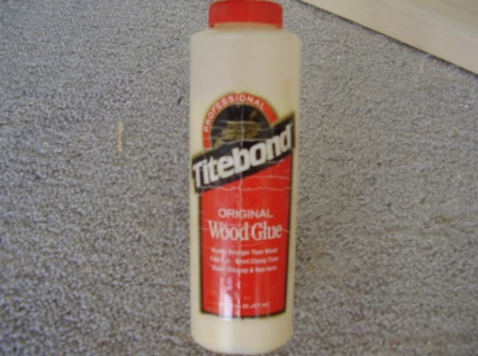
For edge gluing all the sheeting together and also gluing on all leading and trailing edges I use Titebond white glue. This glue will dry clear and makes a nice invisible joint for the sheeting.
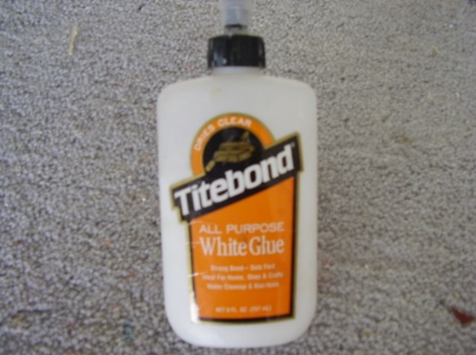
For gluing all of the sheeting to the foam cores I use a polyurethane glue called Gorilla glue.

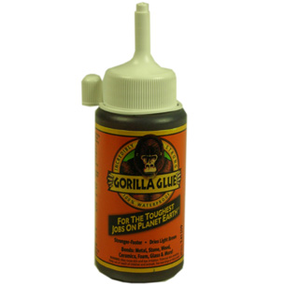

PARTS LIST
FOAM PARTS
QTY DESCRIPTION
(2) Foam Wing Cores
(2) Foam Stab Cores
(1) Foam Rudder Core
(1) Foam Turtle deck

QTY DESCRIPTION
(1) Cowl Bottom
(1) Cowl Top
(1) Wheel Pant Left
(1) Wheel Pant Right

MISC. PARTS
QTY DESCRIPTION
(2) Wing Tube Supports
(2) 1.5” Phenolics for wings
(1) 1.5” Phenolic for fuselage
(2) Aluminum Brackets for landing gear
(1) 5/8” x 16” Dowel ( hardpoints for flight surfaces )
(2) ½” Square x 9” Hardwood ( landing gear reinforcement )
(1) Full Size Plans for flight surface cutouts
(4) 1” X 1” dowel anti rotation hardpoints
(1) 3” aluminum tube guide tube for antirotation on stab
(1) ¼” X 3” dowel stab antirotation pins
(1) Aluminum landing gear
(1) Canopy
(1) 36” aluminum wing tube
(1) 14” aluminum stab tube with sleeve

BALSA PARTS
QTY SIZE DESCRIPTION
(4) 3/32” x 6” x 36” Fuselage Side Sheeting
(8) 1/16” x 10” x 48” Wing Sheeting
(2) 1/16” x 10” x 48” Fin & Rudder Sheeting
(2) 1/16” x 10” x 48” Stab Sheeting
(1) 1/16” x 10” x 48” Belly Pan
(4) 1/16” x 4” x 36” Turtledeck Sheeting
(4) 3/32” x 4” x 24” Hatch Sheeting
(6) 1/8” x 3/8” x 48” Balsa stick, trailing edges, fuselage sides
(7) ¼” x 1?4” x 48” Balsa stick fuselage longerons
(5) ½” x 3” x 24” LE & TE Stock tail section
(4) ½” x 3” x 48” LE & TE Stock wings
(1) ½” Tri stock Reinforcement at F1 and F2 formers

SPRUCE
QTY SIZE
(2) ¼” Square x 48” Fuselage stringers

Fuselage Construction
The fuselage should be built on a flat surface. There are no need for plans as the entire fuselage interlocks together. Start by locating the four pieces that make up the top plate, three pieces that make up the bottom plate and two pieces for the canopy frame. These can be glued together using CA glue. They are cut so they will only go together one way. Its best to lay all of them out first and check the fit before gluing.
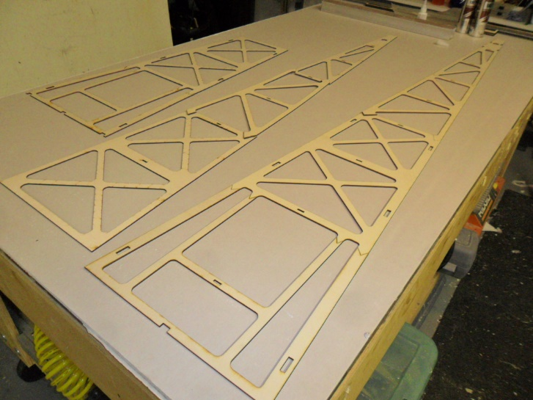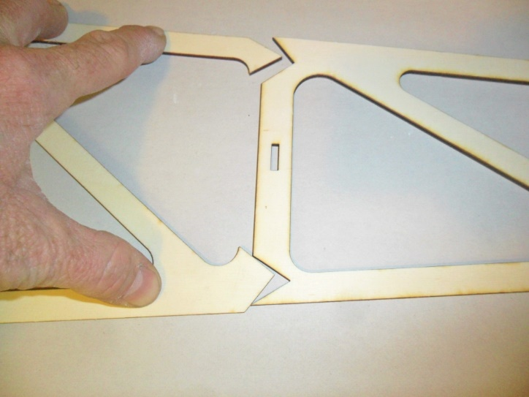
Top plate, bottom plate, and canopy frame Example of incorrect fit.

Next Locate the left and right motor box sides, gear plate, firewall, ignition battery floor, fuel tank floor and fuel tank floor support. You can assemble these dry to get familiar with the assembly process and make sure you have the left and right motor box side correct to give you right thrust at the firewall. Then disassemble and glue. ½” square hardwood should be used on the inside joint of motorbox and landing gear plate and ½” x ¾” hardwood behind the firewall. I will be necessary to sand a small angle on the hardwood to fit tight in the corner at the firewall because of the right thrust built into the assembly. Use clamps as necessary to hold in place until dry.
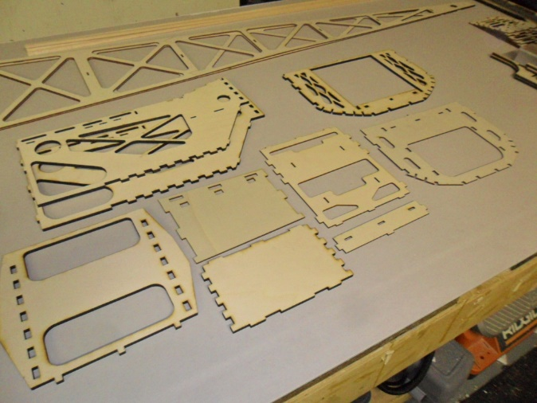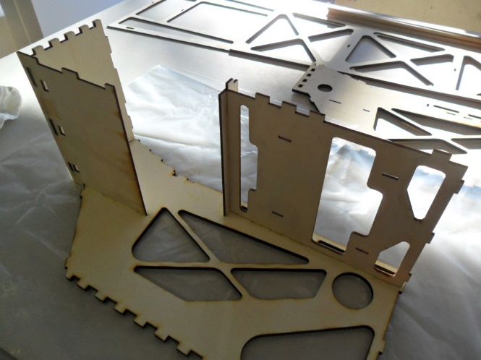
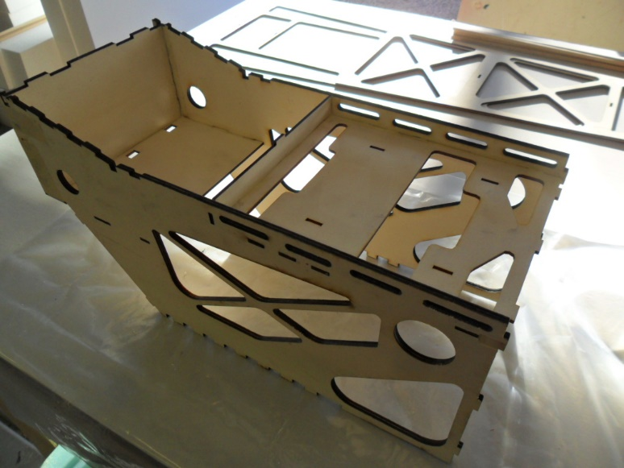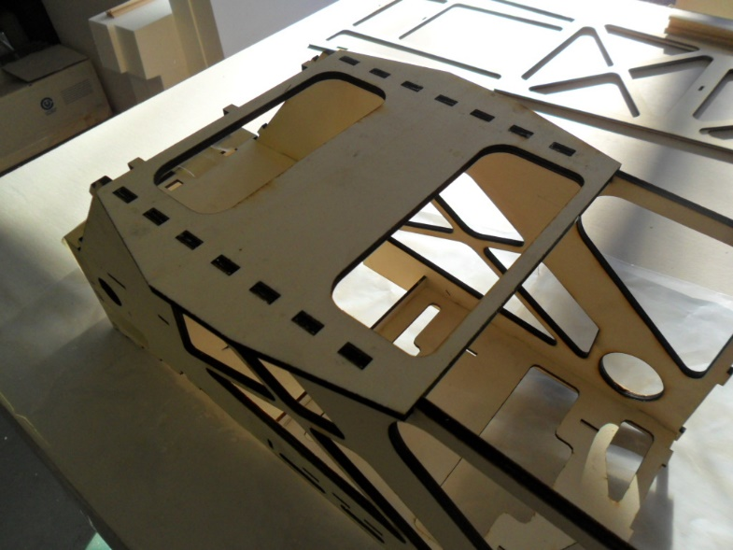
Next glue in formers 1 and 2 along with the fuselage sides. I like to also use ½” balsa tri stock on the backside of former 1 and the front side of former 2 to tie them into the motor box sides.
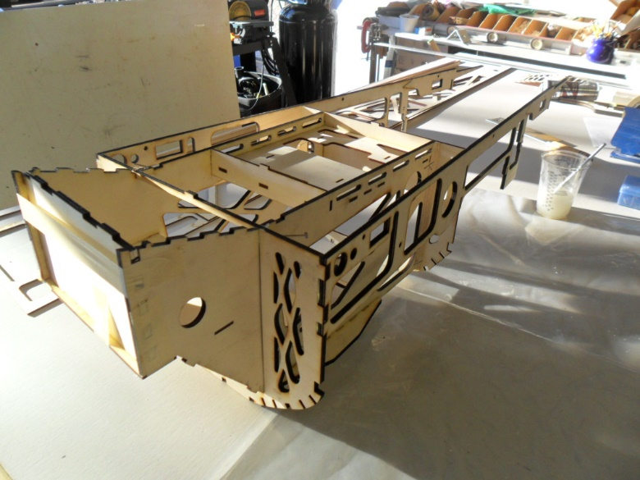

Next check the fit of this assembly to the top plate. Once satisfied with the fit glue in place.
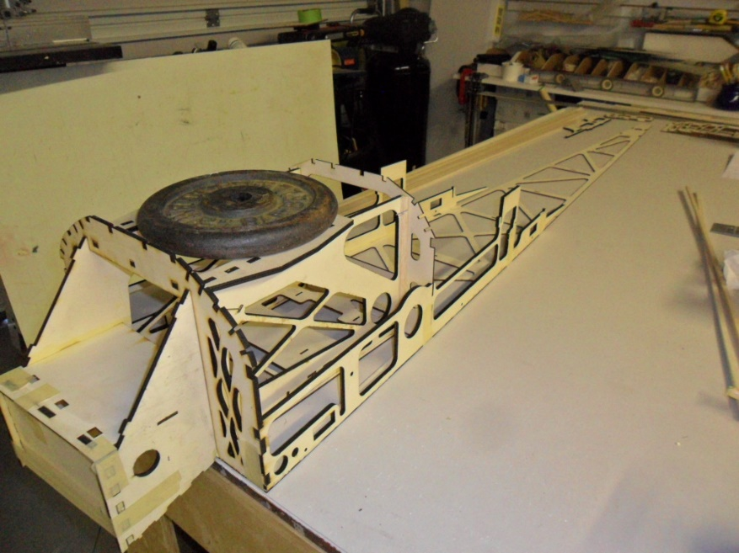

Next locate former 8 and 9 and the two sides pieces for the tail section and glue in place as shown.
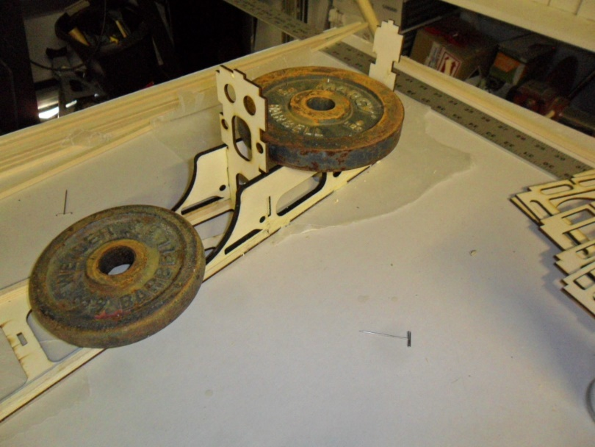
Next using ¼” square balsa sticks cut to length and glue into place to join the front section to the tail section. The joiner should also be glued to the top plate.
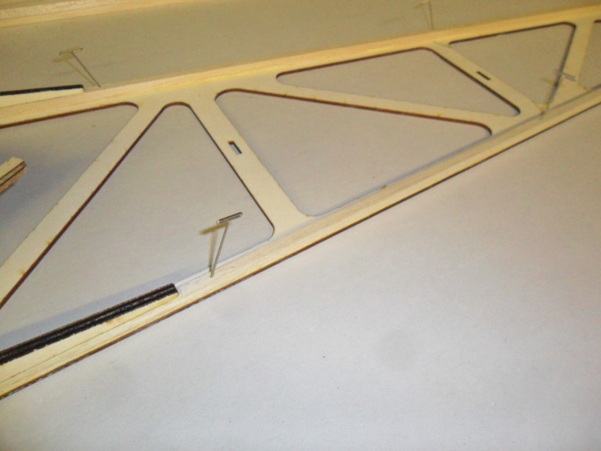

Locate the remaining formers 3 thru 7, the bottom plate and the remaining ¼” square spruce sticks. Ensure all servo wire routing holes are at the bottom of the fuselage and glue the formers in place keeping them at 90 degrees to the build surface. Next glue on the bottom plate and remaining longerons for the fuselage. Make sure that the cross bracing on the bottom plate is running in the opposite direction from the top plate. When viewing from above it should make a X between all formers.
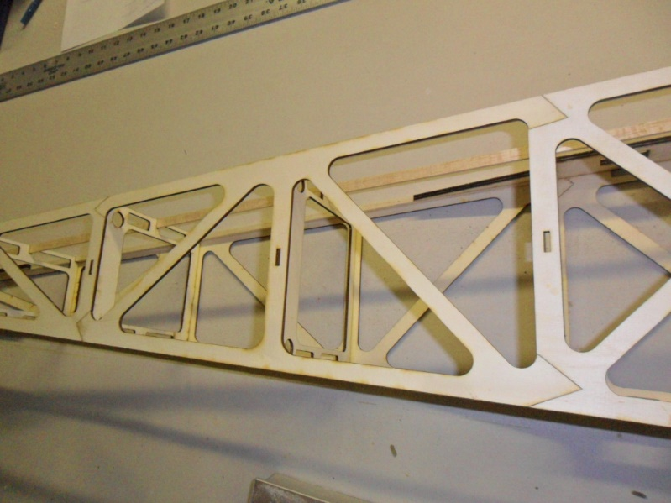
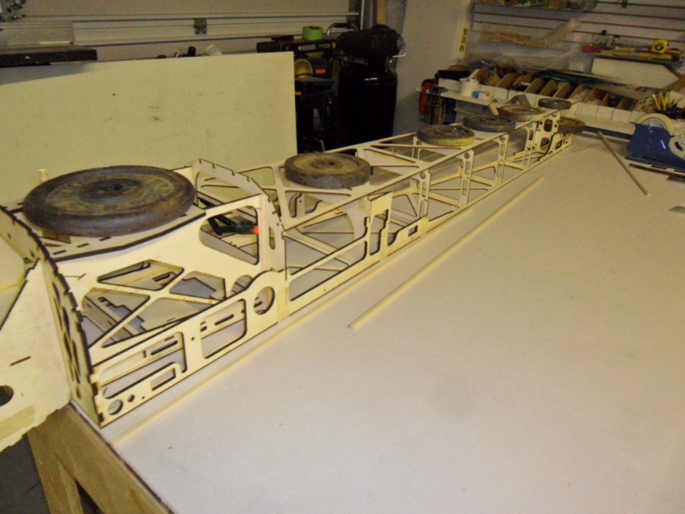

Also glue on the two formers to the landing gear plate. Note that the landing gear mounts over the solid area of landing gear plate.

Locate the two rudder servo mounts and glue in place. The mounts will hold two servos on each side however with todays high powered servos one on each side is more than enough. The two rear most locations should be used and will be cutout after the sides are sheeted.
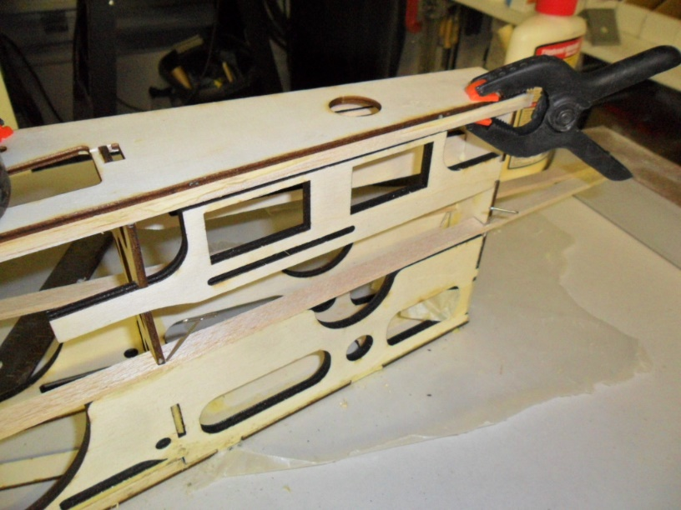
Glue in the remaining spruce sticks and 1/8 x 3/8 balsa. If using canister mufflers I leave out the two middle pieces to provide a large exit area for the canisters and hot air.
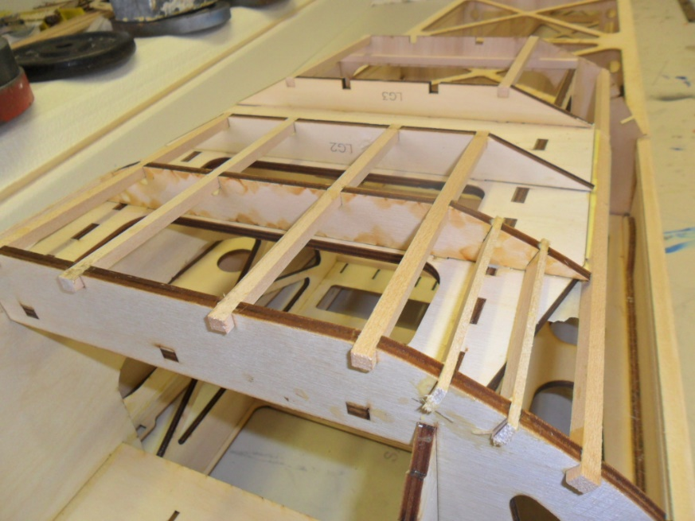
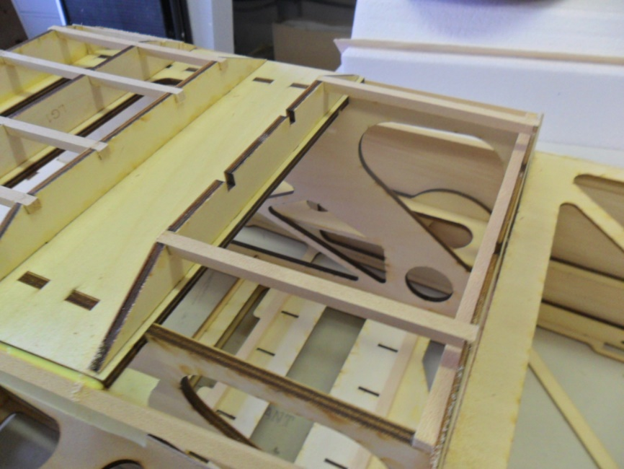

Using 3/32 balsa sheet the bottom area from former 2 forward as shown.
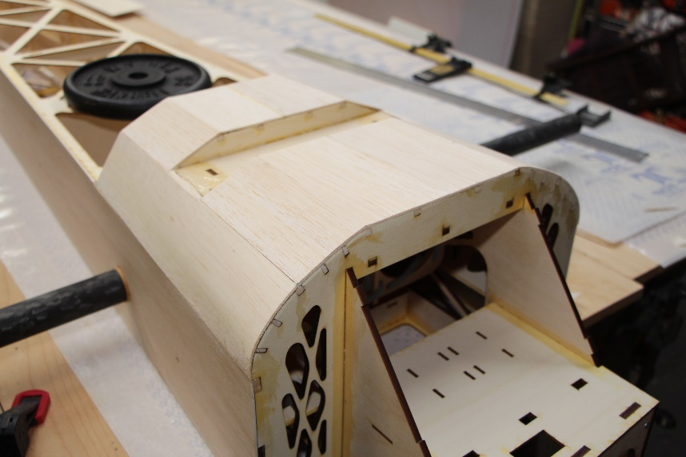

Once everything is dry you can remove the fuselage from your building surface.
Locate the 4 sheets of 3/32 x 7 x 48 balsa for the fuselage sides and join two sheets together long enough to sheet both sides from former 1 to 9.
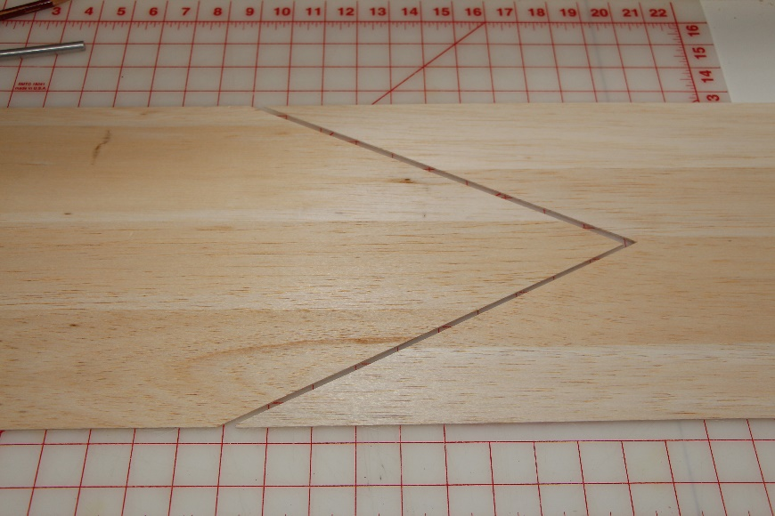
The sides should be sheeted as shown as the fuselage has a slight taper towards the back.
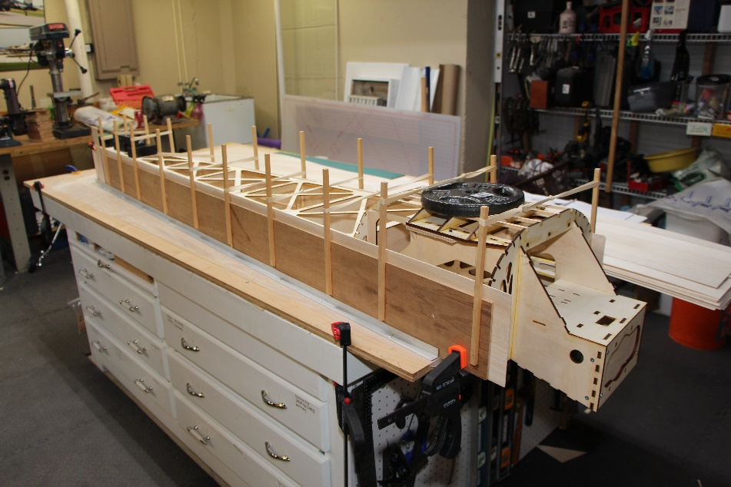

This next step is optional and is best done at this stage before gluing on the foam bottom. The speckle paint is nothing more than adding that finishing touch to your model. When done correctly it adds approximately 2.5 oz in weight. First tape off all area not to be sprayed and then spray I light coat of grey primer followed by a light coat of texture paint. I have always used grey but there are other colors available.
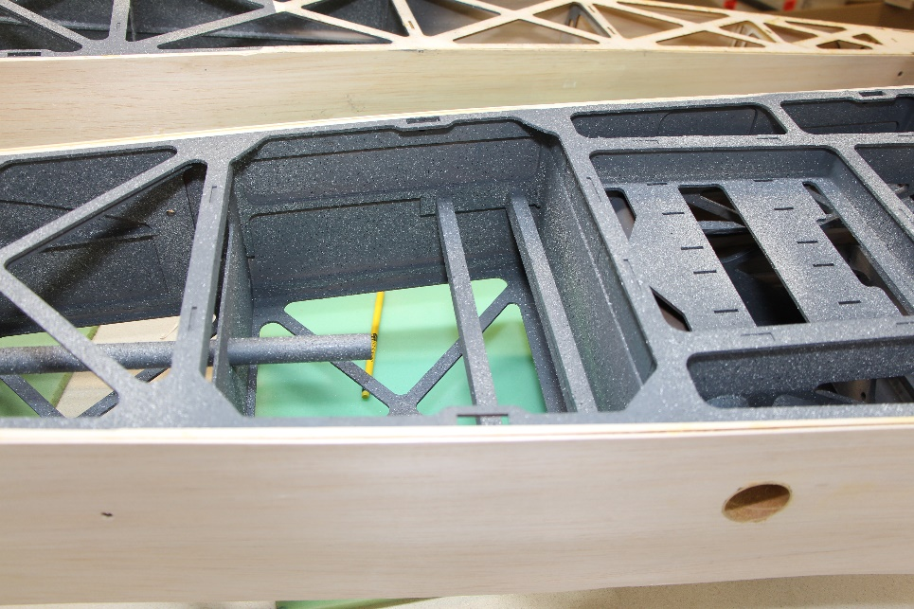
Next make up the sheeting using 1/16 x 10 x 48” (1 sheets) for the bottom foam belly.
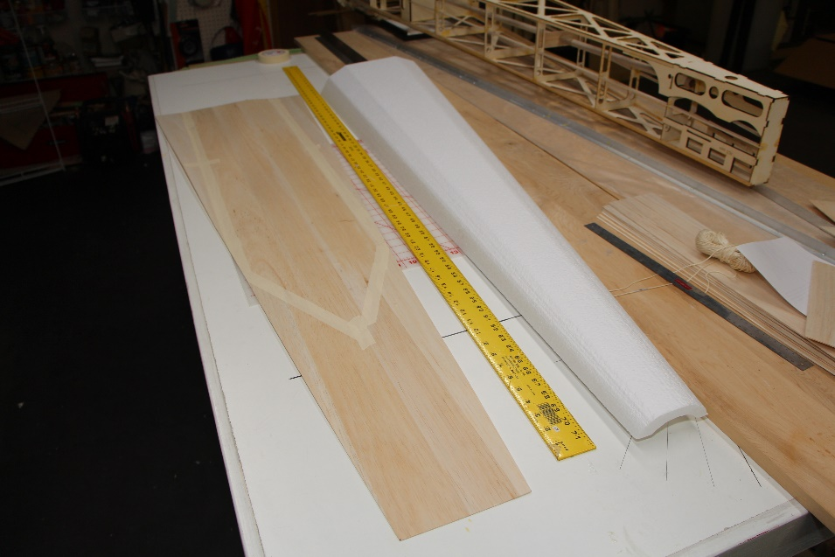
Using 4 sheets of 1/16 x 4 x36” balsa make up the turtle deck sheeting.
Sheet both assemblies using your preferred method.
Once dry trim all balsa flush with foam and prepare to glue to fuselage.
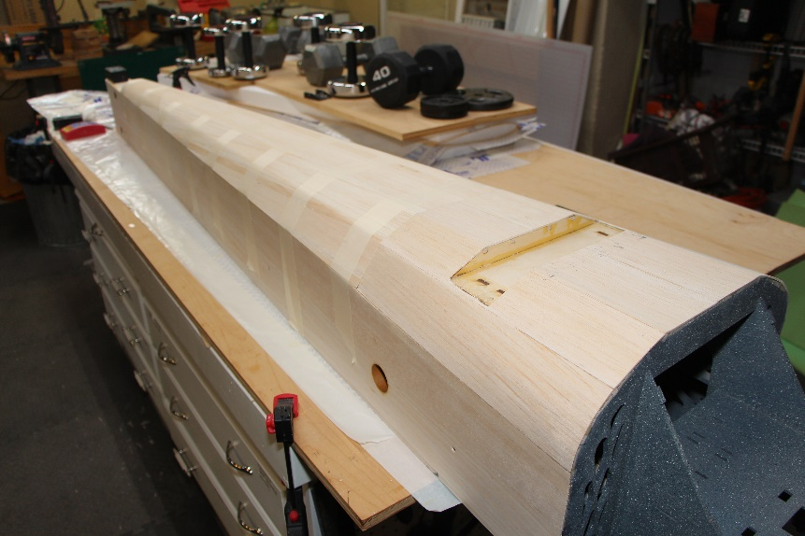
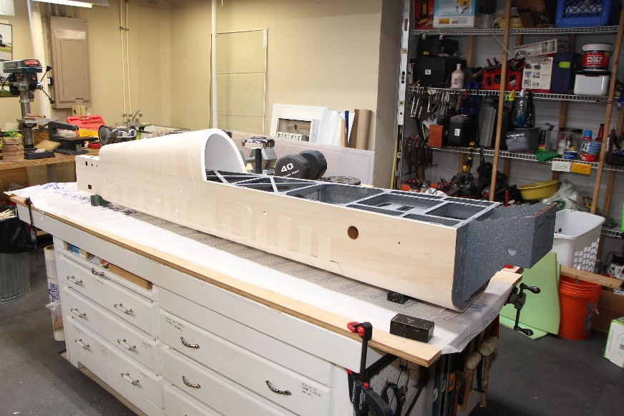
Glue in the wing phenolic and stab phenolic. Be sure to keep them parallel to each other and square to the centerline of the fuselage.
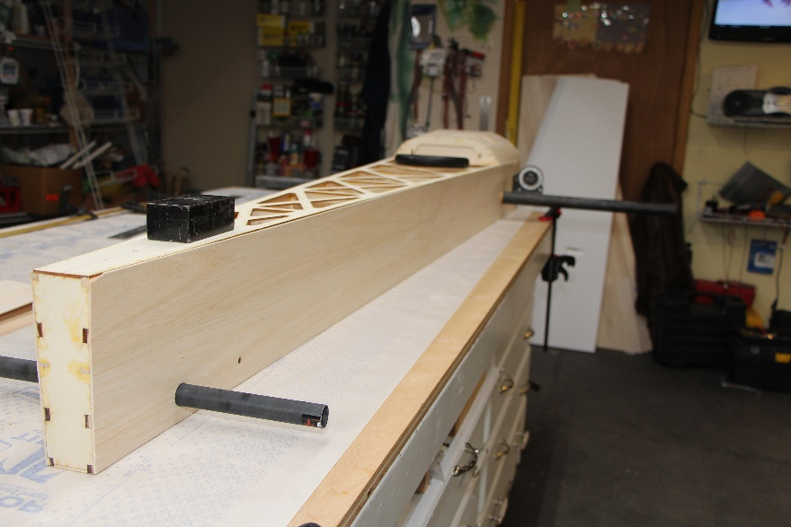
Test fit the stab and wing cores to the fuselage and adjust root angle as needed for a good fit then glue on the root caps for the stabs and wings. On the wings there are dowel hardpoints that should be embedded in the root before gluing on the root cap. Once the root caps are dry sand flush with the foam leaving the two tabs on the bottom of stabs for mounting.
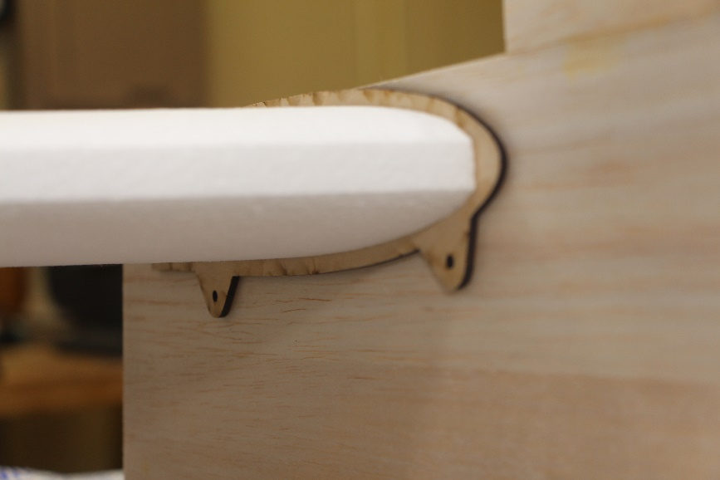
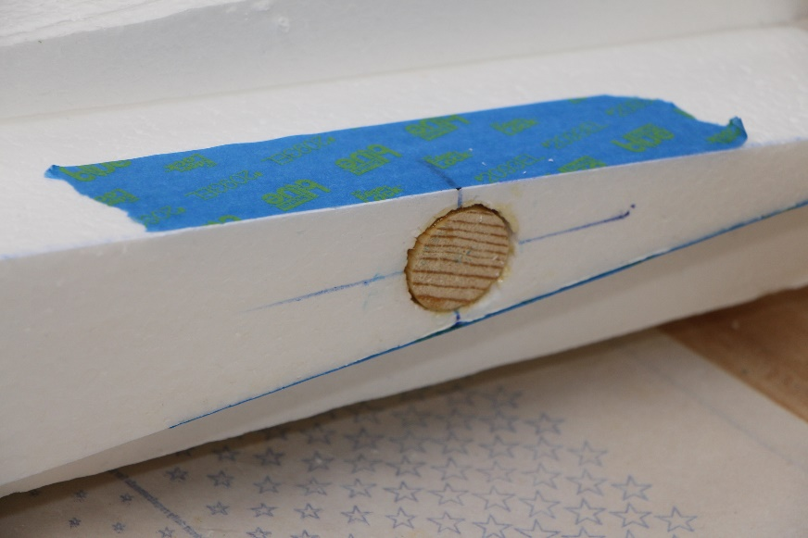
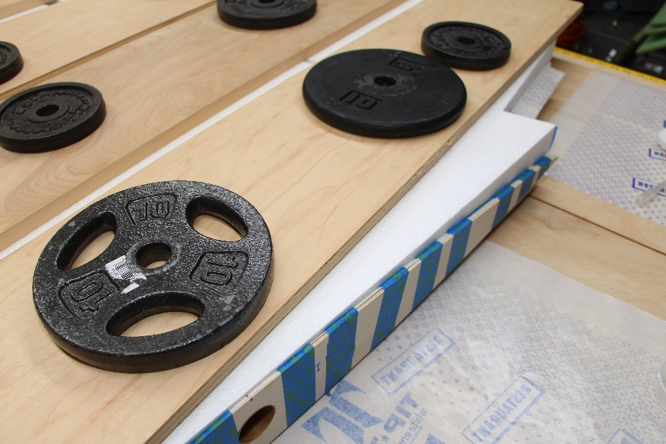
The fuselage can now be set aside while you complete the sheeting for all the flight surfaces.

Wing Construction
There are a few methods for sheeting foam and both work great. The most economical way is to use a flat board on top of the wing to help distribute the load of approximately 300 lbs of weight. You can use just about anything you have around the house such as tool boxes, concrete blocks, or buckets filled with water. Vacuum bagging is another method which requires a vacuum pump and bagging material. If not familiar with vacuum bagging there is lots of information on the internet. Both methods work and I have used the weighted method for years without issue.
The wings can be sheeted using 13 sheets of 1/16 x 10 x 48 if you follow these instructions. Any deviation from these instructions my result in not having enough sheeting. I start by taking 3 sheets and cutting them down to 16” lengths giving you 9 pieces. Next take 8 full length sheets and scarf joint a 16” piece to a 48” piece. I use an angle of about 70 degrees. Just measure along the trailing edge of the wing to see what length you need. Once those 8 sheets are ready you can start making your sheeting by running your first sheet parallel to the trailing edge of the wing and then work your way forward. Keep all scarf joints towards the wing tip. For one side, you will use 2 of the long sheets you joined together and then on sheet at 48” long. Start this sheet at the root and let the excess run off the leading edge of the wing. The scrap piece from this sheet will be trimmed off and used on the other side of the wing. Each wing panel should use 4 long sheets that you made up and one 48” sheet.
Locate the sheet of carbon fiber tow and cut four strips 2” tapering to 1” and 60” long. These will be used between the sheeting and foam and run from the root (2”) to the tip (1”) side over the wing phenolic. Also cut two ½” by 60” strips to rum along the trailing edge. Only one strip per wing panel is necessary and you can put it between the top sheet and foam core or the bottom, it does not matter. Sheet wings top side facing up. After the wing has cured trim all sheeting flush with foam core.
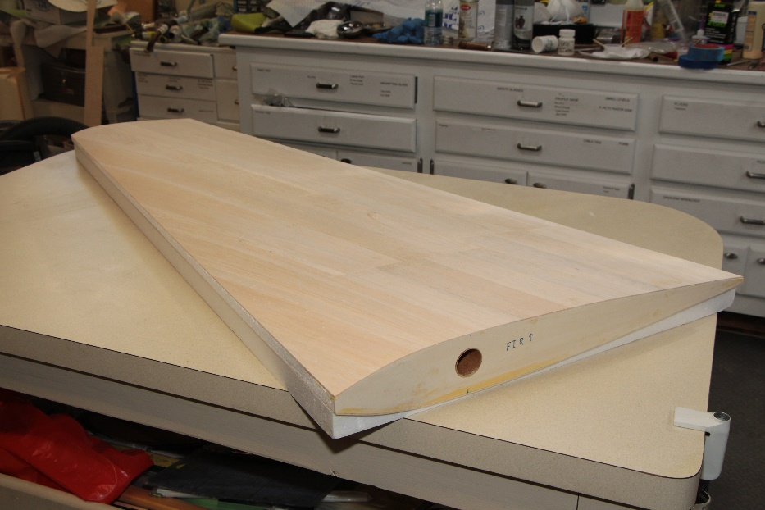
Using the plans provided mark and cutout the ailerons for both wings. Note if using a bandsaw to make your cuts mark your cut lines on the top for the left wing and on the bottom for the right.
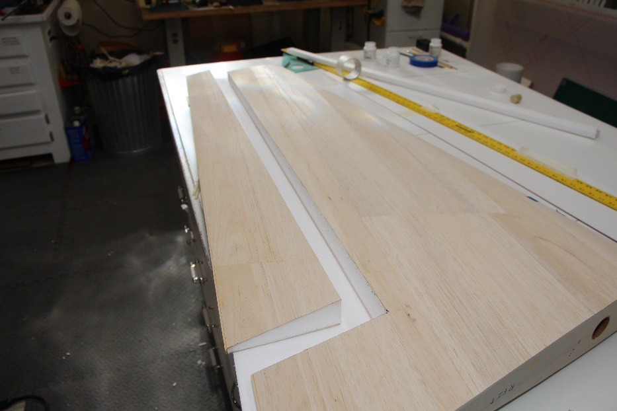
Make up the leading and trailing edges out of ½” balsa stock and glue in place. Use 1/16” scrap balsa to cap the ends of the ailerons and wing tip.
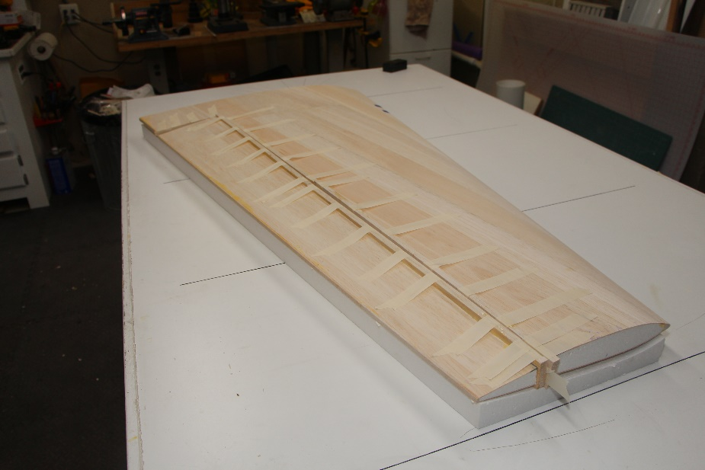

Once dry trim and sand all balsa flush with sheeting.
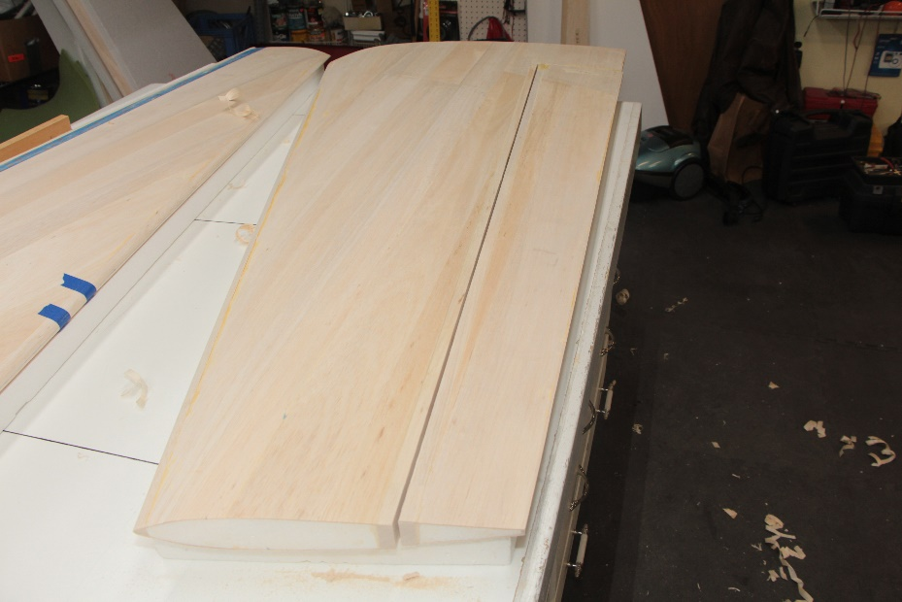
Mark servo location on the underside of wings and cutout holes to accept the servo boxes.
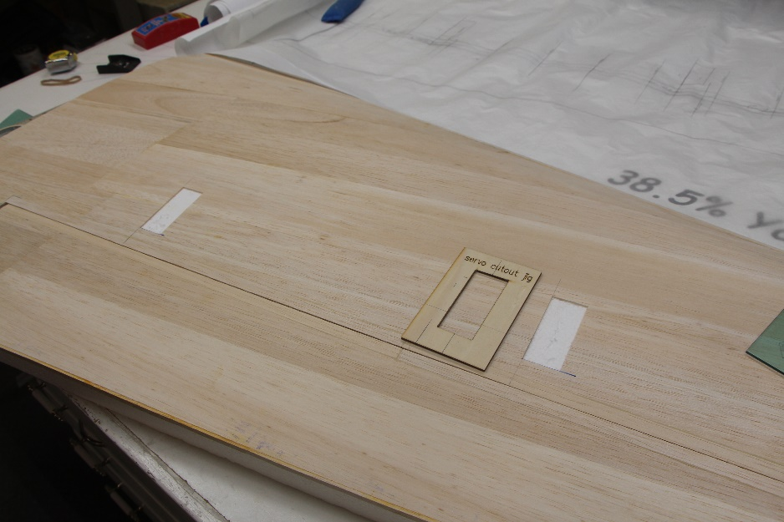
Using a length of copper tube heat one end with a torch and then burn the hole from the root into each servo opening. It is best to try and run the hole close to the top sheeting of the wing.
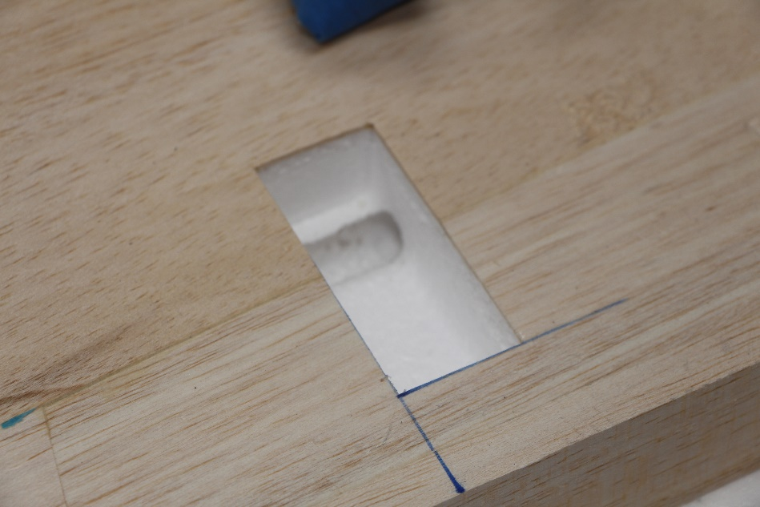
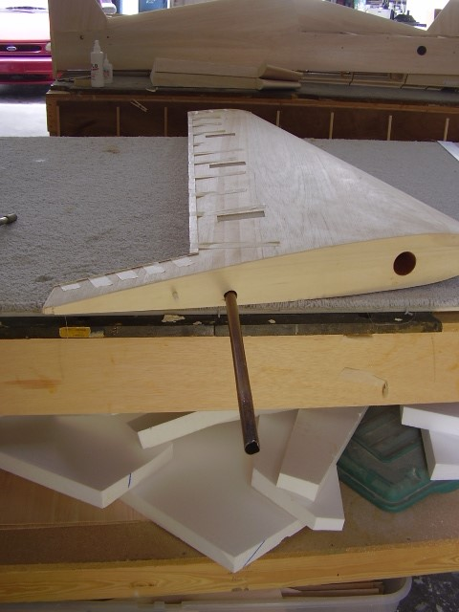
Mark center lines on the leading and trailing edge of the wing and ailerons. Also mark locations for the hardpoints for control linkage from servos. I like to use a hinge 1.5” on either side of the hardpoints and space the rest out roughly 5” apart. Once you have drilled or slotted for your hinges sand the bevel.
Set the wings aside until you are ready to set the incidence.

Horizontal Stab Construction
Three sheets of 1/16” x 10” x 48” are used to make the horizontal stab sheeting. Start you first sheet parallel to the trailing edge and work forward. No carbon reinforcement is needed in the stabs. Sheet the stabs same as you did the wings. Be sure to keep the top side facing up during sheeting. Before cutting out the elevators its best to set the incidence for the stabs and wings. For the wings install the anti-rotation bushings to keep the threaded rod from wearing out the fuselage side. Use the top plate of the fuselage as your datum line. Wings and stabs should be set at zero degrees.
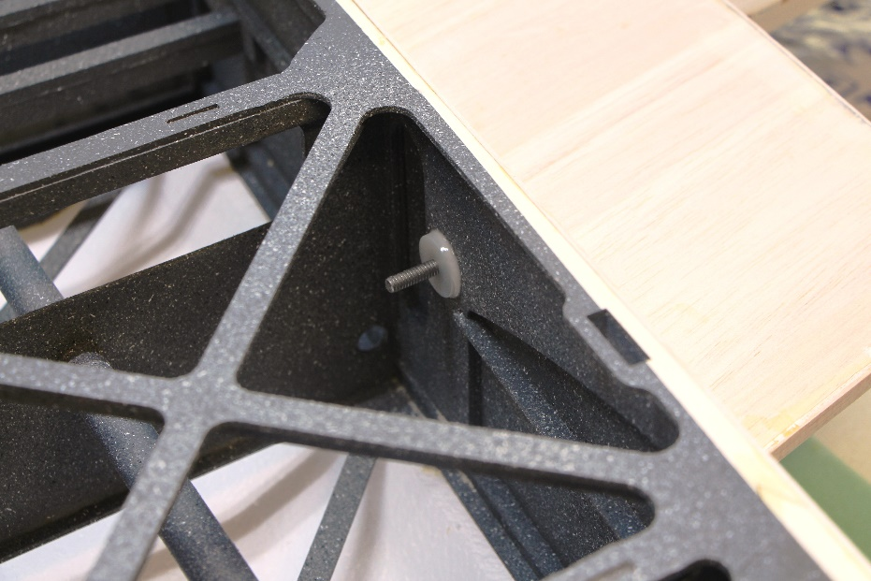
Once that is complete finish the stabs using the same methods for doing the wings. Note that the stabs can be made with a counter balance like the one pictured below. For IMAC flying I prefer no counter balance.
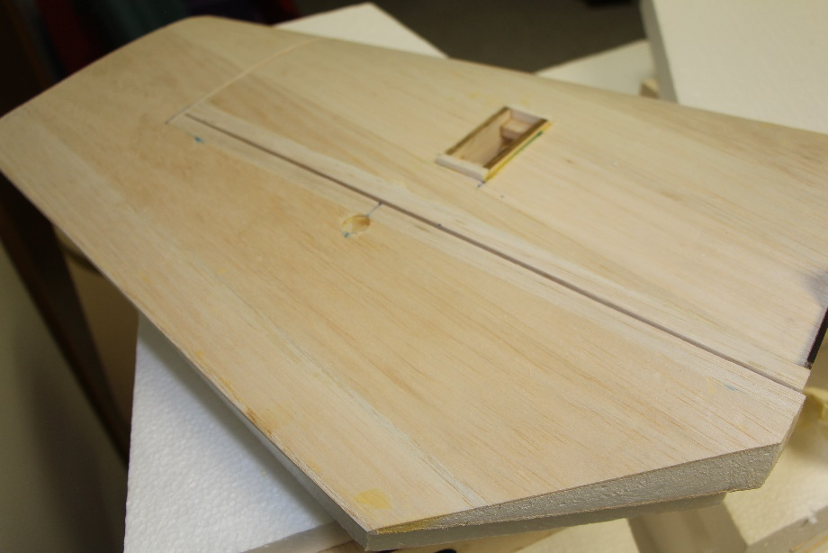

Rudder Construction
Using three sheets of 1/16” x 10” x 48” balsa make up the sheeting for the rudder. Start your first sheet parallel to the trailing edge and work forward.
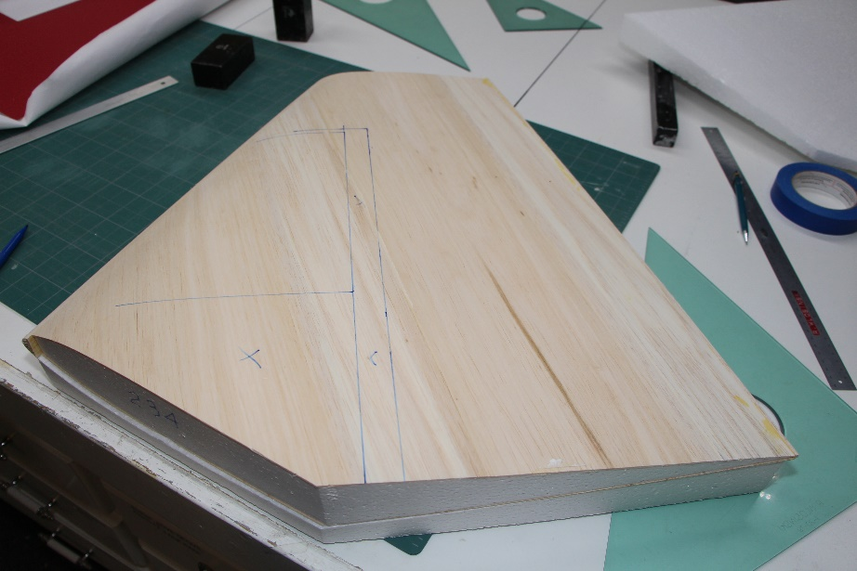
Once dry mark the location per the plans for the rudder cutout. Note if using a bandsaw to make your cuts mark on the right side of the rudder.
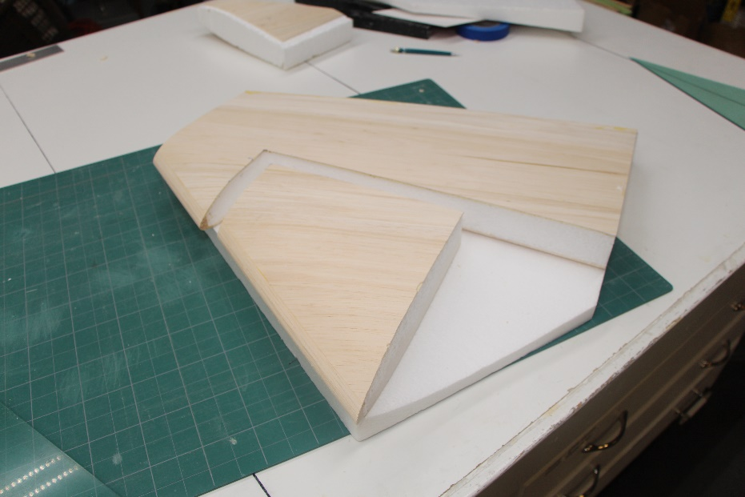
Use ½” balsa to make up the leading edge of rudder hinge line and trailing edge. Be sure the training edge extends down to the bottom of the fuselage. Do not glue the fin to fuse at this time.
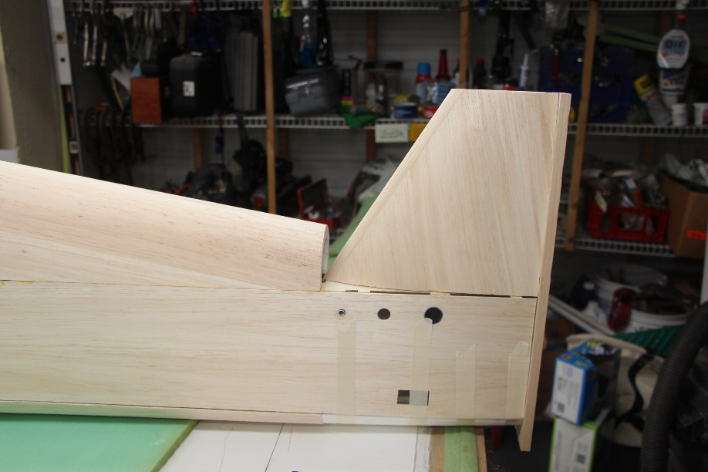

Fin fairing and tail block
Using scrap foam from the cutouts of the turtle deck and belly sand to shape the fairing for the fin and tail block. You will want these pieces to be a bit undersized as they will get sheeted with 1/16” balsa.
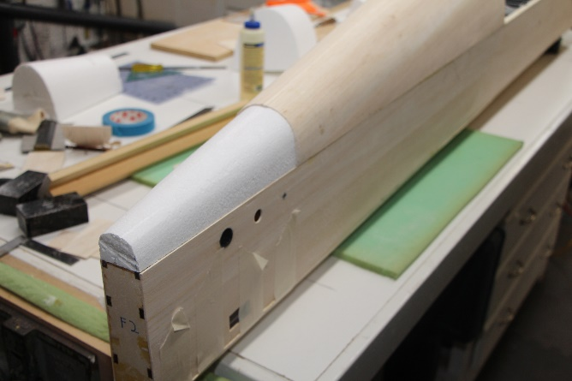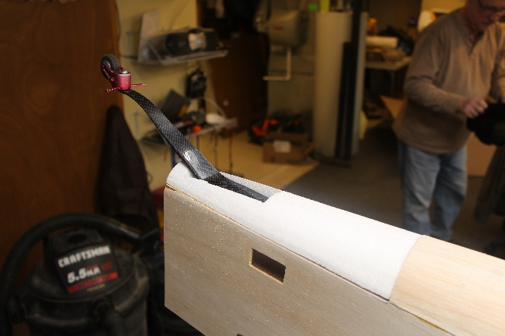
Once satisfied with the tail block sheet the foam piece and then glue in place.
Using the cutout on the plans start adjusting the fin fairing until you get a good fit with the fin installed. Once satisfied glue on the fin and fin fairing.
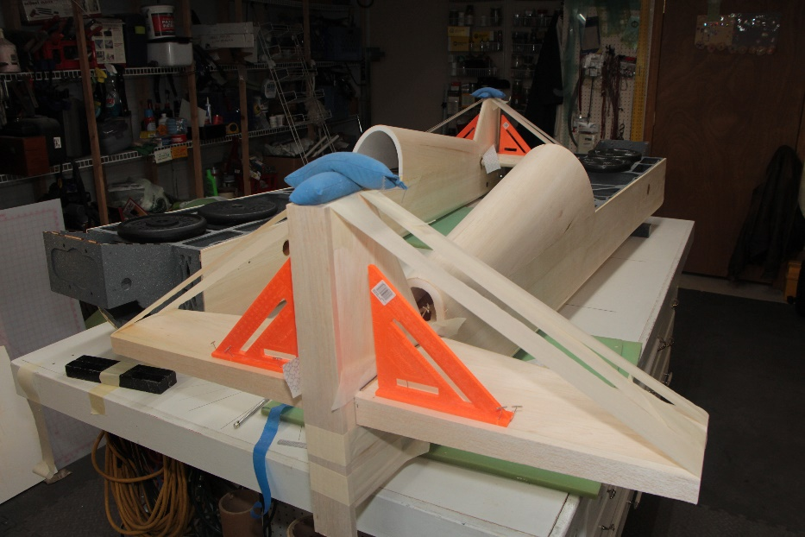
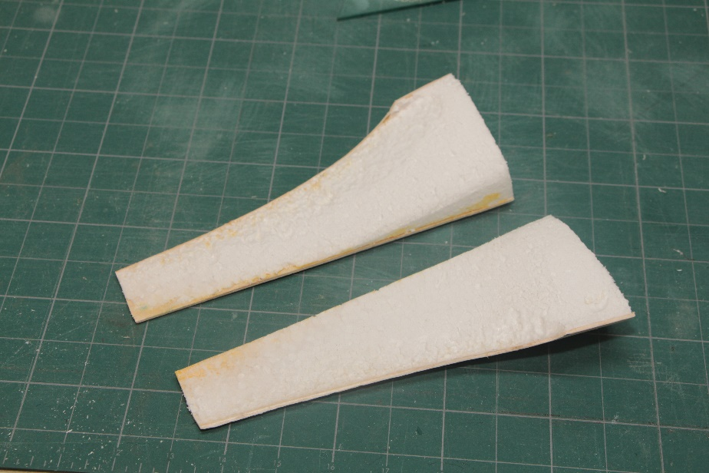

Drill or slot for rudder hinges and bevel leading and trailing edges.
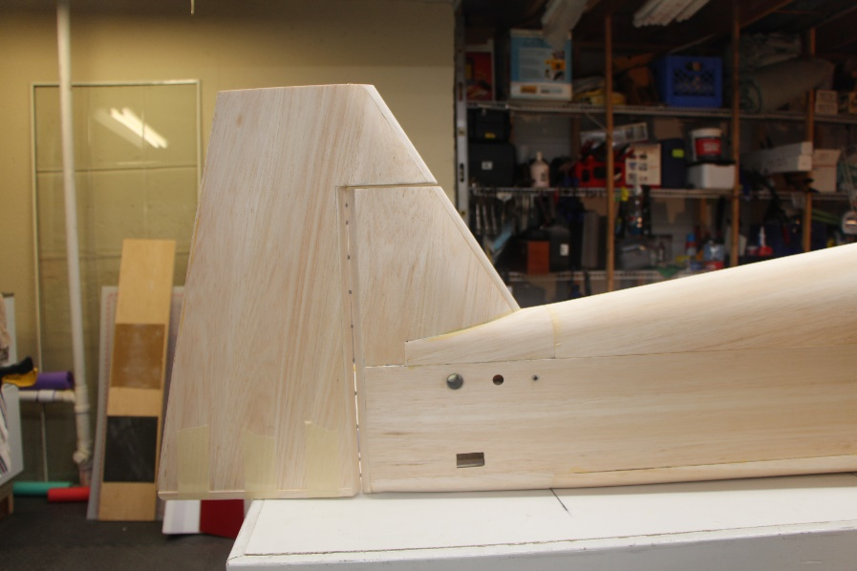

By now you should have something that looks like this.
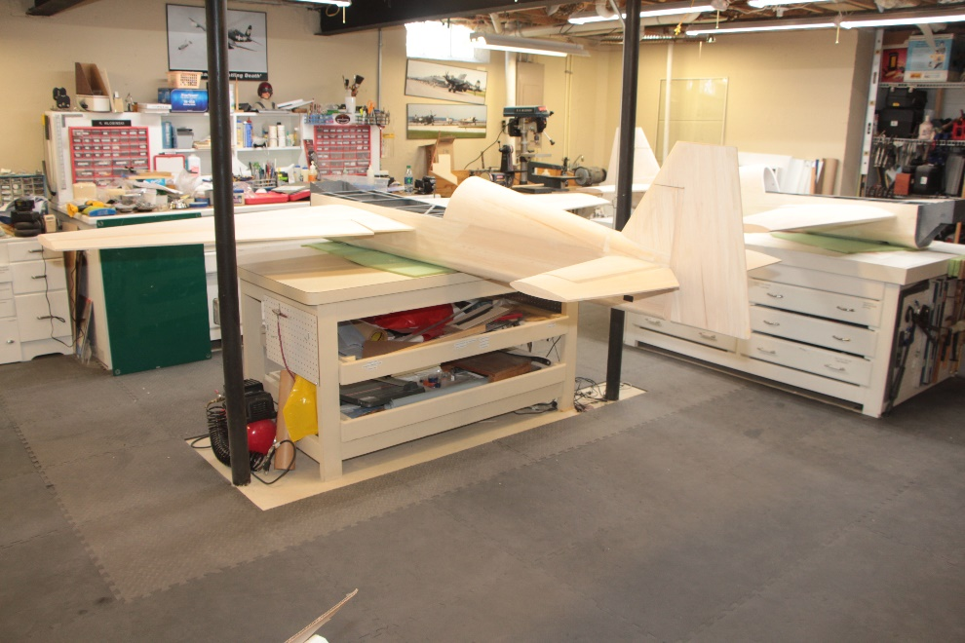

Hatch and canopy
Attach the six hold down mounts to the canopy hatch frame.
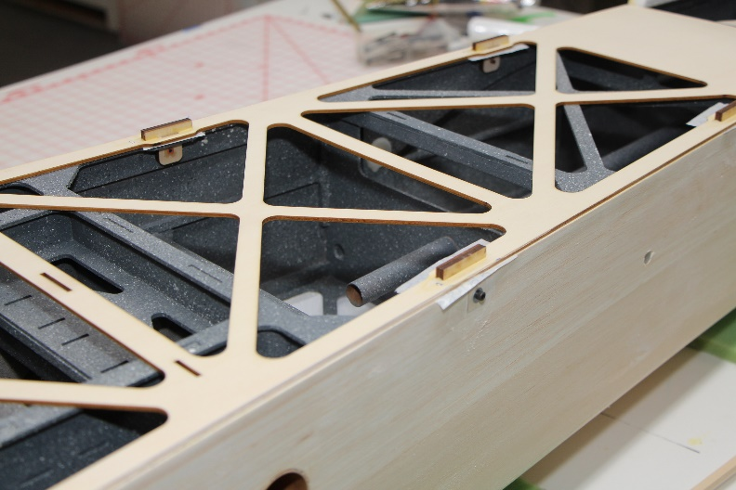
Using 3/32” x 4” x 24” make up the hatch sheeting. I prefer to glue the foam to the canopy frame first and then sheet the hatch. This will hid the joint where the foam glues to the frame as the sheeting will go over it.
Using ½” balsa make a ledge for the canopy to glue to. Once the canopy is glued in place it should be flush with the hatch sheeting.
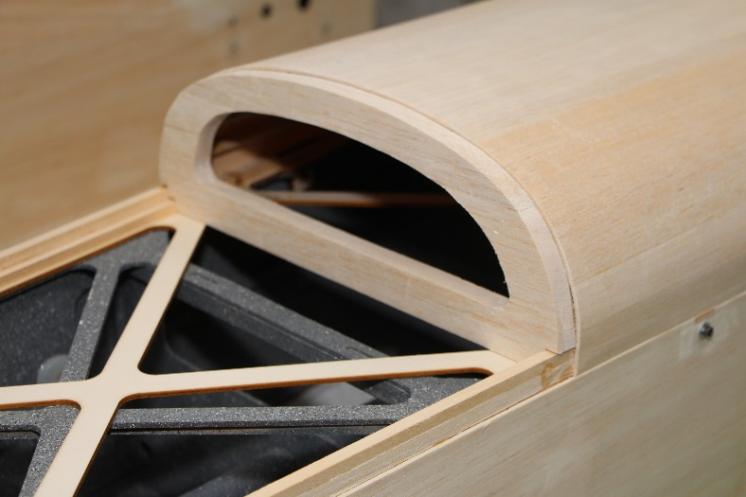

Glue the plywood doubler to the backside of the canopy back support as well as the lettering and then glue to the canopy frame.
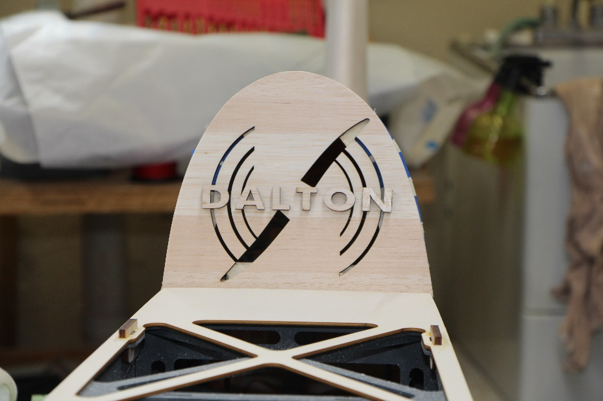
Using ¼” x ½” by 24” balsa sticks glue on each side running from the back of the hatch to the front side of the canopy back support. This will give more area for the canopy sides to glue to. Once dry tape off any areas and paint the canopy interior. After all is dry mount the assembly back to the fuselage using wax paper between the frame and fuselage.
Trim and glue canopy in place.
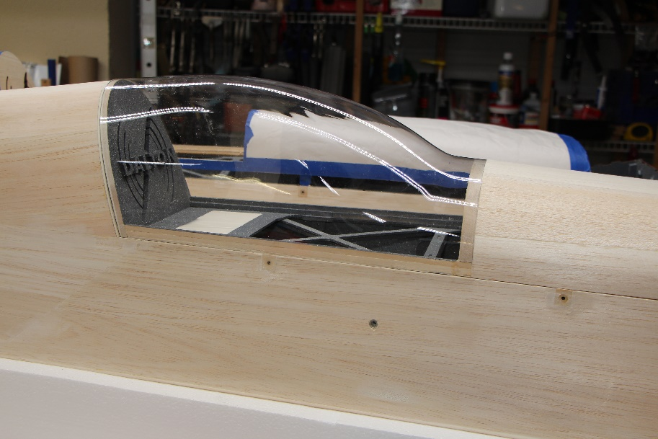

Cowling assembly

Note the follow shows a Yak 54 cowling but the procedures for the 300sp cowling is the same.

Locate the 4 laser cut cowl mounting rails and plywood hooks.
Using the rail as a guide mark and cut out the slots for the hooks to slide through in the top and bottom cowl parts. The slots can be slightly oversized but make sure they are close to matching top and bottom.
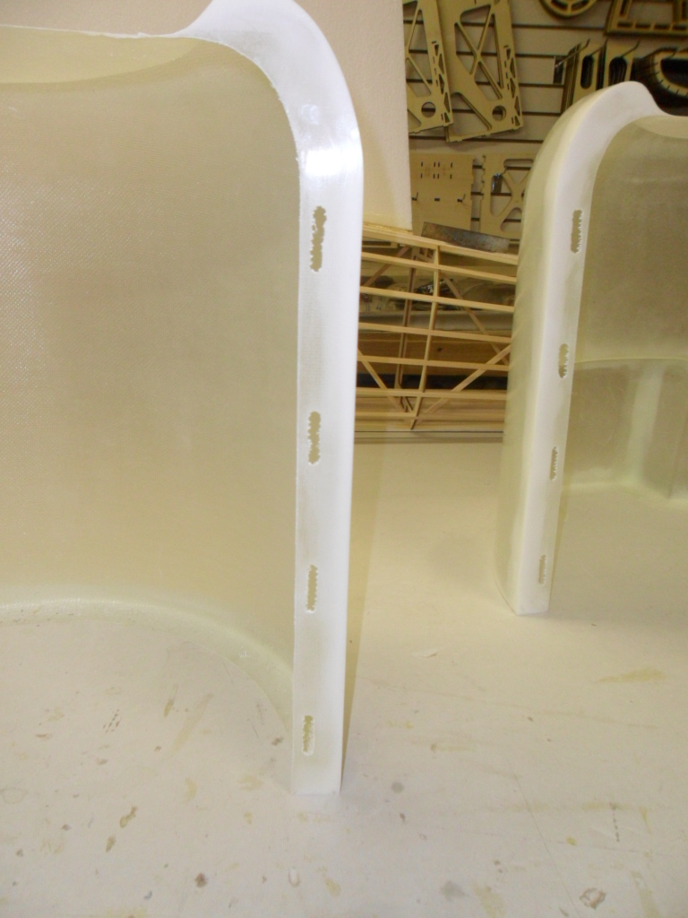
Next glue in the plywood rails to the bottom of the cowling only.
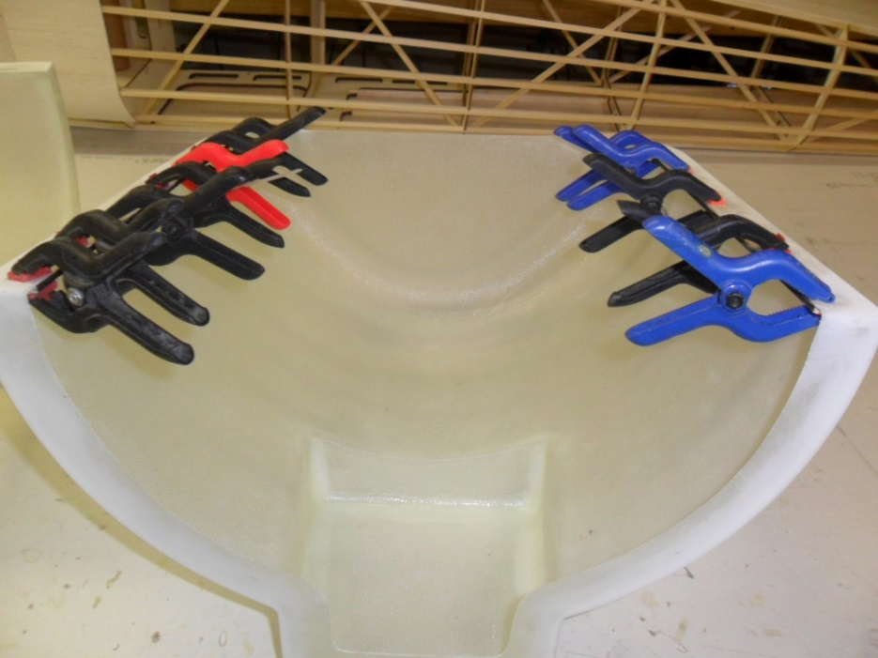
Once dry we are ready to fit the top to the bottom. I recommend using a slow set epoxy for this to give you time to make adjustments. Dry fit the rails into the top cowl and clamp it in place to the bottom. Make sure that your slots line up and make adjustments as needed. Once satisfied with the fit epoxy the rails in place. DO NOT GLUE ANY OF THE HOOKS IN AT THIS TIME. You can slide them in place to check alignment during installation of the rails.
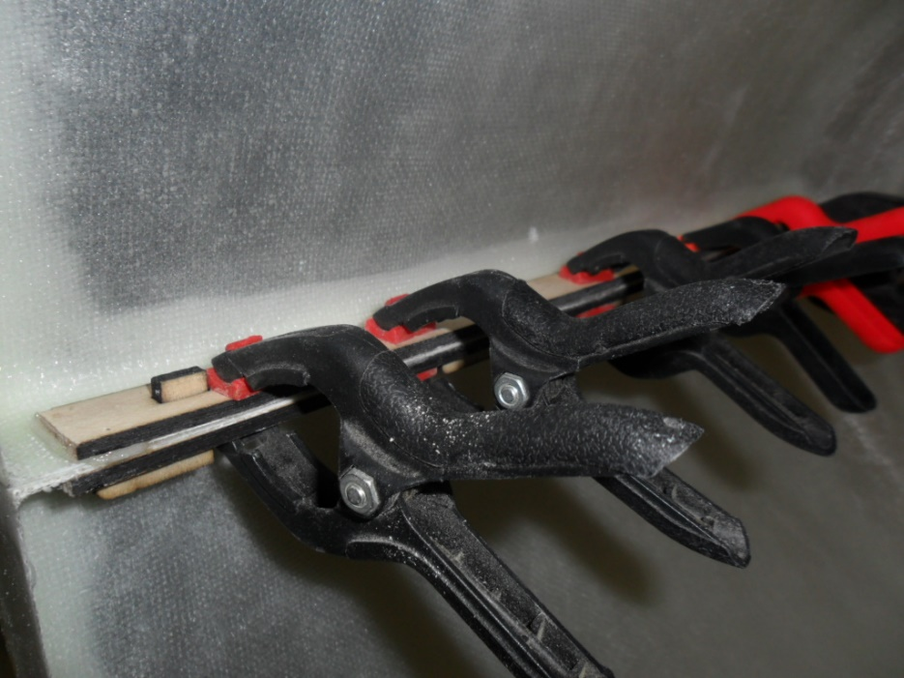
Once the rails are dry we are ready to glue in the hooks. Apply a light coat of wax or mold release to the matting surface of the top and bottom flange on the cowling. This will keep them from sticking together just in case any glue runs through during the hook installation. Clamp the top and bottom together and make sure it is flush along the back and sides. Next glue in the hooks. I use a thick CA for this. They should point backwards to allow the top of the cowl to slide forward about a ½” to be removed while the bottom will stay attached to the fuselage.
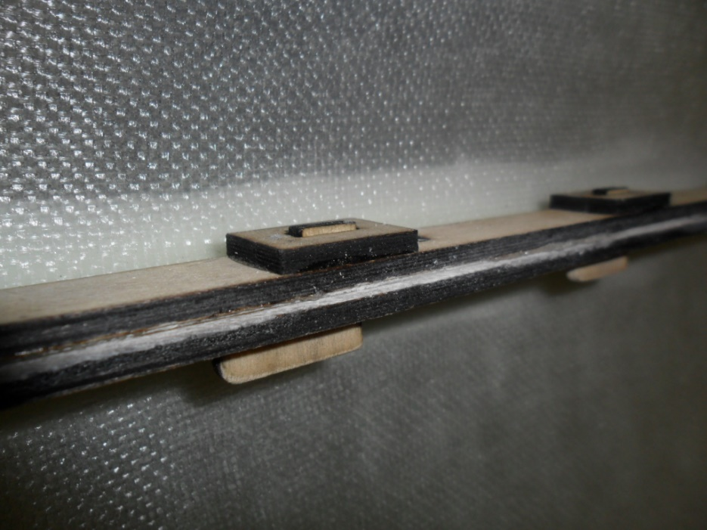
The hooks are glued to the top of the cowling only along with the hook doublers. The picture below shows the top slid forward and ready to be removed.
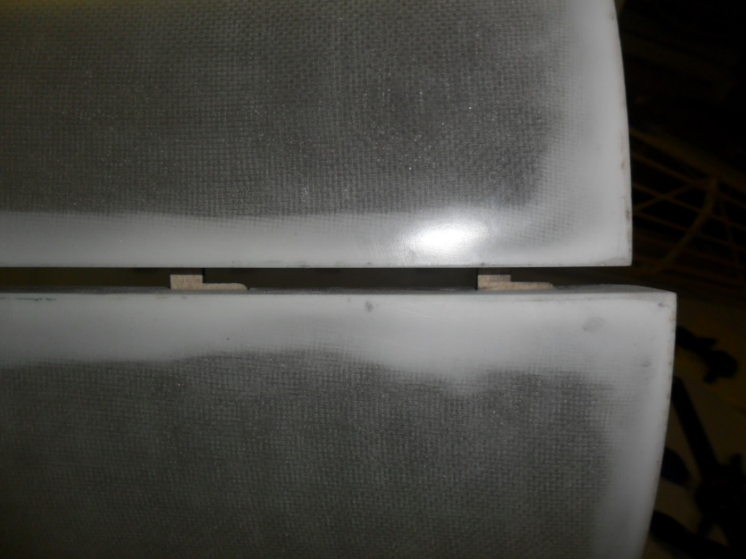
You can use a small screw on each side at the front of the cowling to keep it from sliding forward during flight.
Tape the cowling in place on the fuselage and once satisfied with the fit attach the bottom of the cowling to F1 former using 6/32 hardware.
