Dalton Aviation
P.O. Box 18051
Tucson, Arizona 85731-8051 (520) 425-5155
tony@daltonaviation.com
INSTRUCTION MANUAL
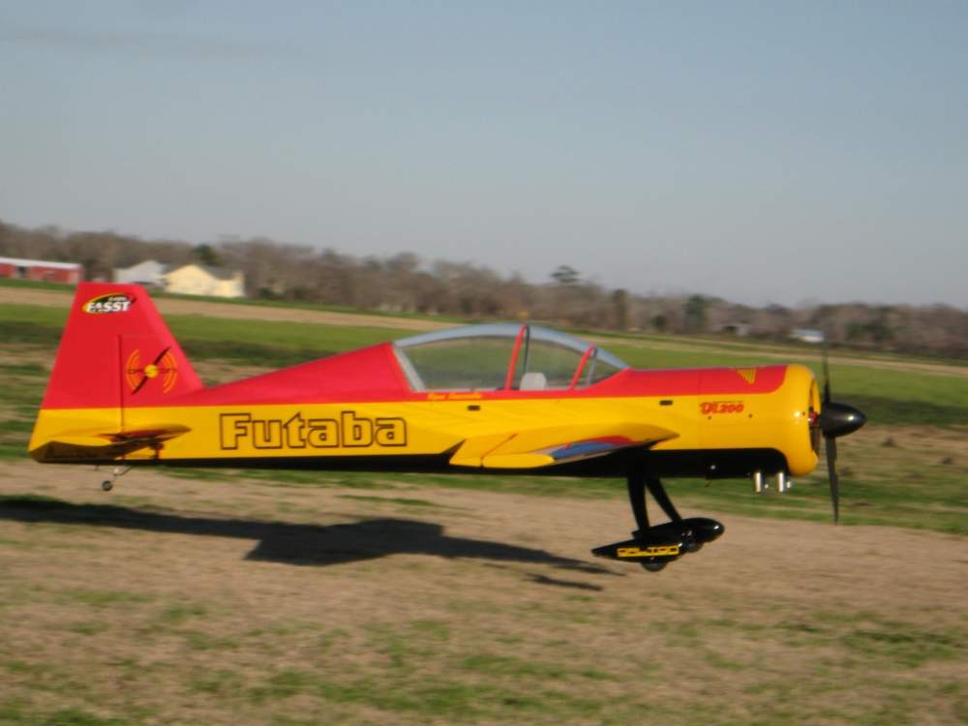
38.5 % Dalton Aviation Yak 54
Wingspan 123.7”
Length 114.3”
Weight 39 lbs +/-
Engine 150cc/200cc
INTRODUCTION
Thank you for purchasing the 38.5% Dalton Aviation Yak 54. The builder of this model should be experienced in giant scale model building. If you are not experienced please seek the advice of a qualified builder. The materials and techniques explained in this instruction manual have been flight tested thoroughly. However, the builder of this kit must make the final determination of the construction of his/her aircraft. The pilot of this model should be a member of the Academy of Model Aeronautics and experienced in RC Model Flying. Please read through the instruction manual before starting construction so you can get an idea of how the airframe is constructed and the construction sequence.
Before starting construction it is a good idea to figure out what equipment you intend to use.
The Yak 54 has been engineered to use 2 servos in the tail to drive the rudder. When using this setup it is important to keep the tail as light as possible. It is recommended that you use a lightweight tail wheel assembly.
The following is the adhesives that I use.
For most of the fuselage construction I use Titebond Original wood glue.
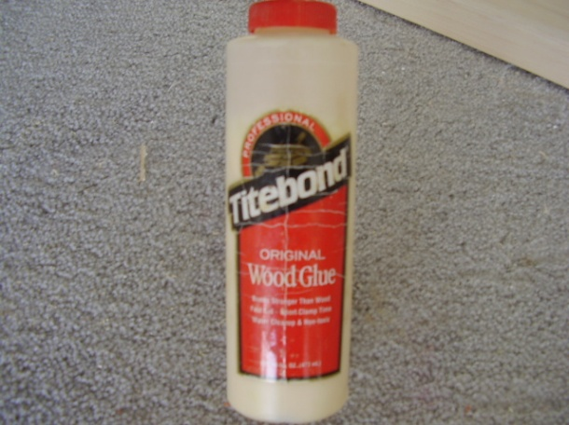
For edge gluing all of the sheeting together and also gluing on all leading and trailing edges I use Titebond white glue. This glue will dry clear and makes a nice invisible joint for the sheeting.
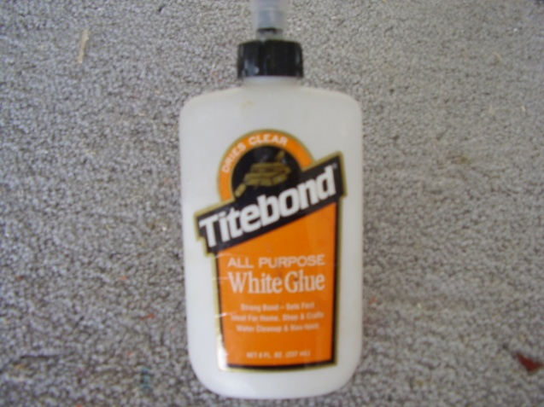
For gluing all of the sheeting to the foam cores I use a polyurethane glue called Ultimate glue. There are a couple different manufactures of this such as Probond or Gorilla glue and all work just as well.
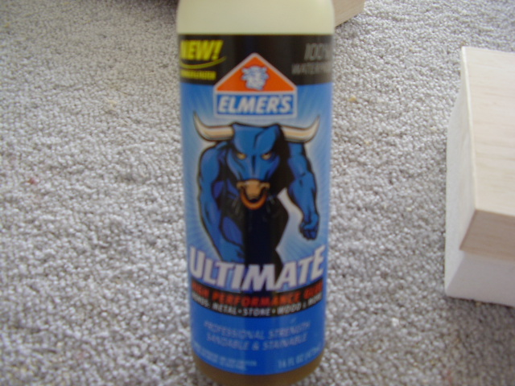 PARTS LIST

FOAM PARTS
QTY DESCRIPTION
(2) Foam Wing Cores
(2) Foam Stab Cores
(1) Foam Rudder Core
(1) Foam Turtle deck

QTY DESCRIPTION
(1) Cowl Bottom
(1) Cowl Top
(1) Wheel Pant Left
(1) Wheel Pant Right

MISC. PARTS
QTY DESCRIPTION
(2) Wing Tube Supports
(3) 1.5” Phenolics
(2) Aluminum Brackets
(2) Carbon Stab Brackets
(1) 5/8” x 24” Dowel
(2) ½” Square x 9” Hardwood
(1) Instruction Manual
(1) Full Size Plans
(4) 1” X 1” dowel
- 3.75” aluminum tube
- ¼” X 3” dowel
(1) Aluminum landing gear
(1) Canopy
(1) 52” aluminum wing tube
(1) 14” aluminum stab tube

BALSA PARTS
QTY SIZE DESCRIPTION
(12) 3/32” x 3 x 48” Fuselage Side Sheeting
(51) 1/16” x 4” x 36” Wing, Rudder, Turtledeck Sheeting
(18) 1/16” x 4” x 24” Stab Sheeting
(2) 3/32” x 4” x 36” Hatch Sheeting
(11) 1/8” x 3/8” x 48” Balsa Stringers
(22) ½” x 4” x 24” LE & TE stock
(2) ¼” square x 48” Top Former Doublers
(1) ¼ ” Tri stock

SPRUCE
QTY SIZE
(24) ¼” Square x 48”

Fuselage Construction

The fuselage needs to be built upside down over the top view of the plans. It is very important that the fuselage is built straight. I recommend that the builder purchase two pieces of 1” aluminum angle from Home Depot. These pieces can be screwed down over the top view of the plans to keep the sides of the fuselage perfectly straight.

Tail Assembly:
Locate F9 and F10 fuselage formers, (2) stab side supports, and fin support. Test fit assembly and once satisfied with the fit glue the assembly together. Use tape and clamps to hold assembly together while glue dries.
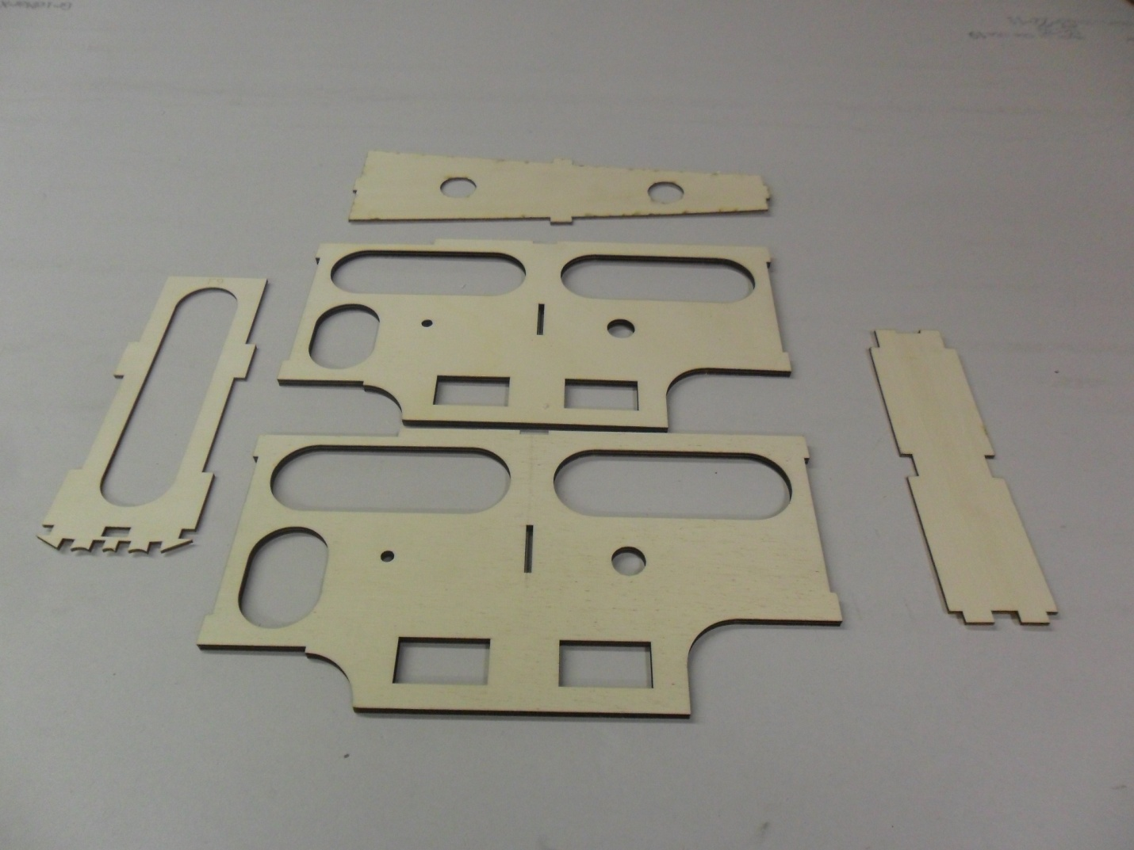
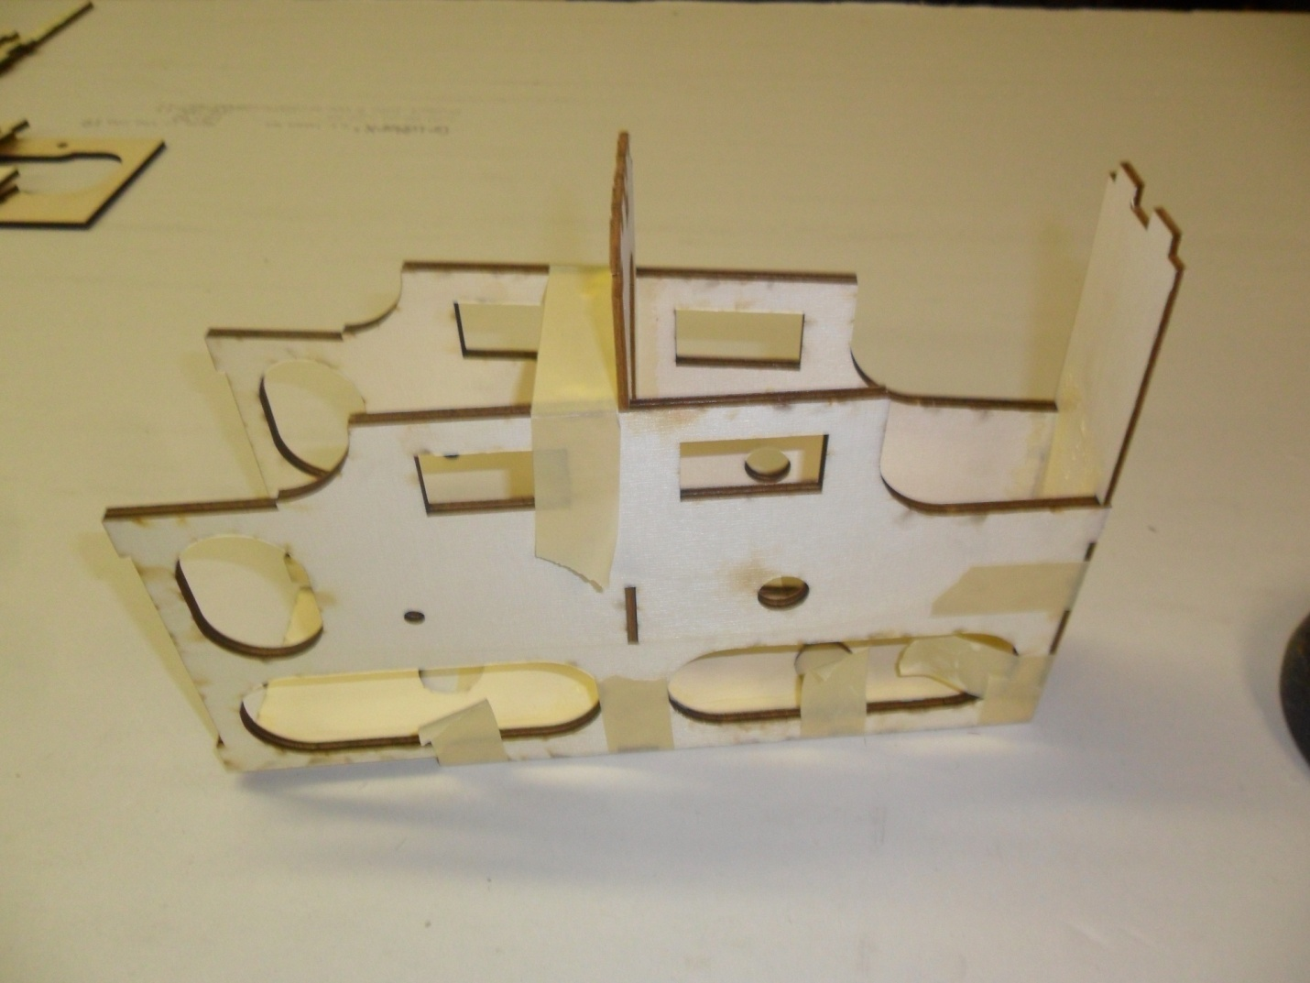
Motorbox Assembly:
Locate the left and right motorbox sides, fuel tank floor with support, F1 and F2 formers,MBB (motorbox bottom), firewall, and landing gear plate.
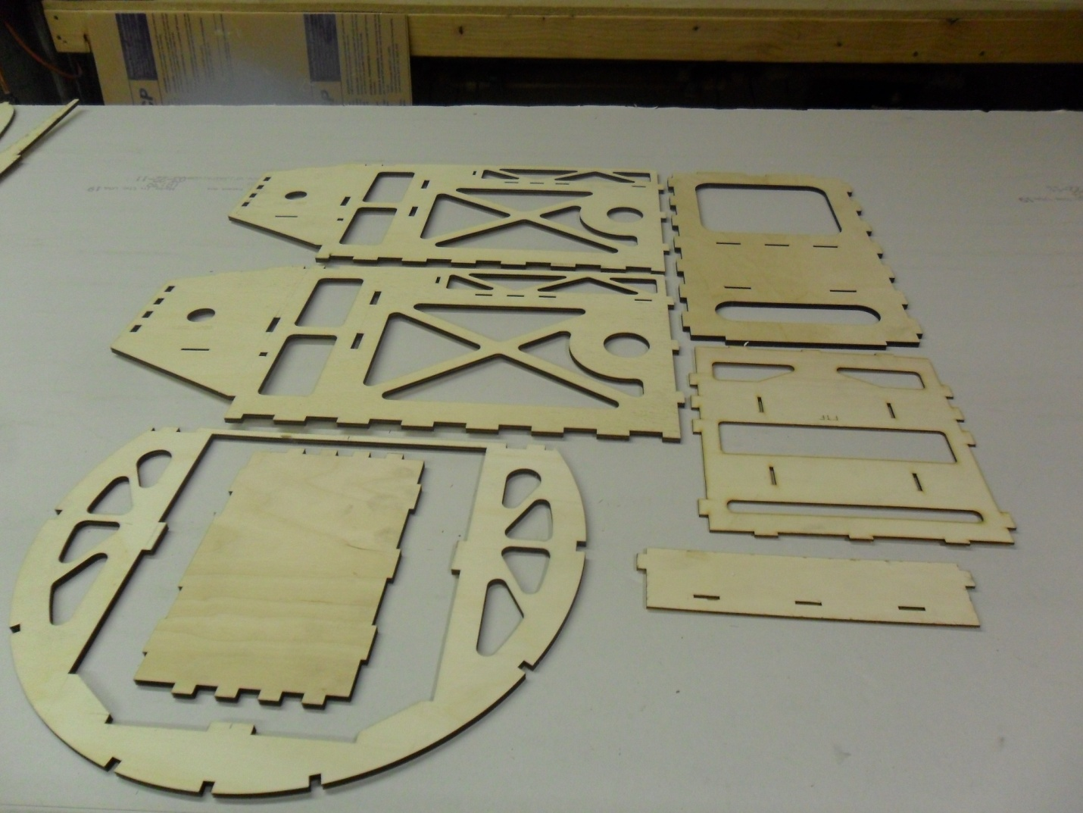
- Its best to dry fit this assembly first to familiarize yourself with the assembly order before gluing.
- The sides must be installed first into F1 former followed by the firewall ( which is taller on the right side) , MBB, tank floor and support and landing gear plate. Do not glue the landing gear plate at this time. Tape or clamp it in place only to help hold the assembly together while the other parts dry.
- 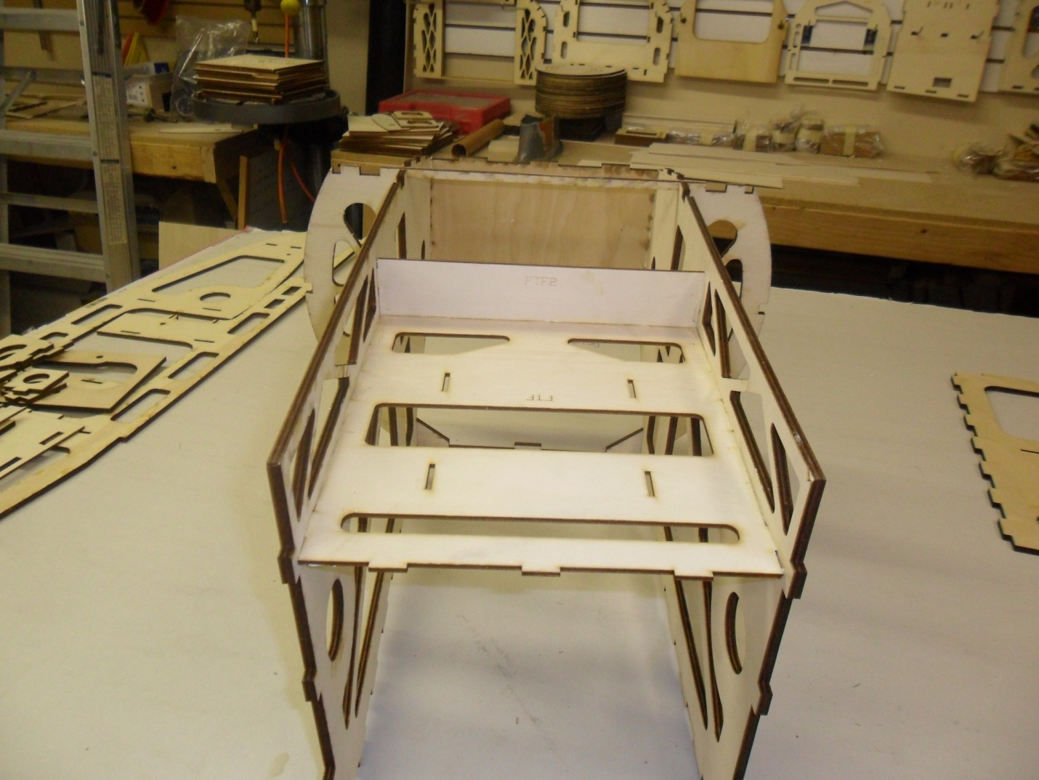
- Glue in the corner support at F1.
- 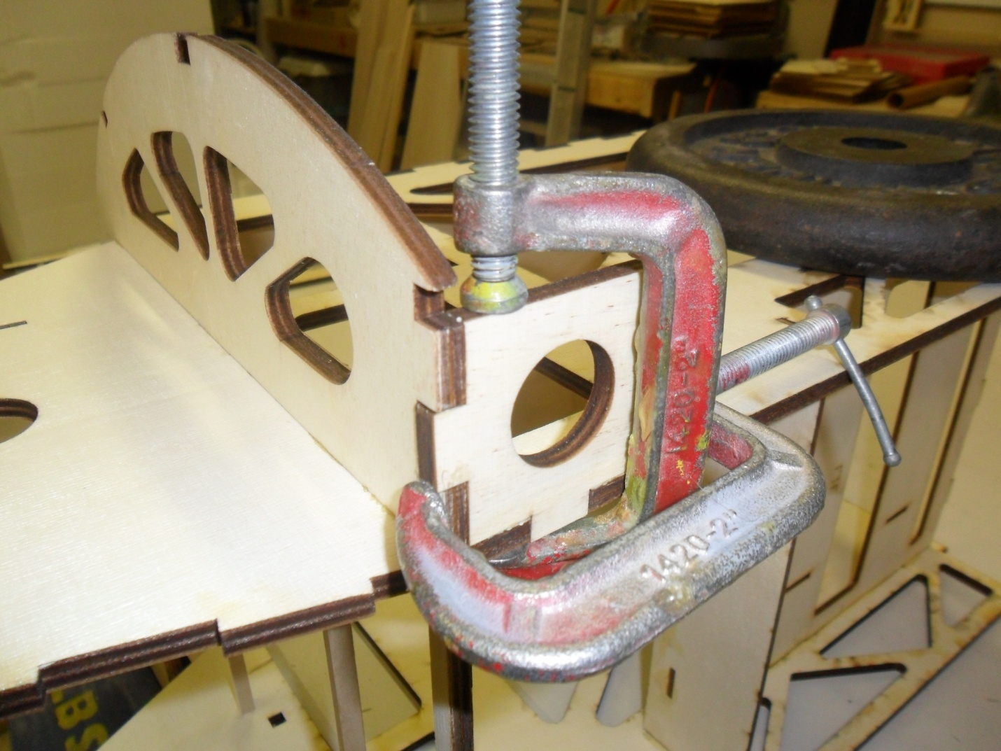
- Cut to length and glue in the ½”tri stock on the backside of F1at the motorbox joint.
- 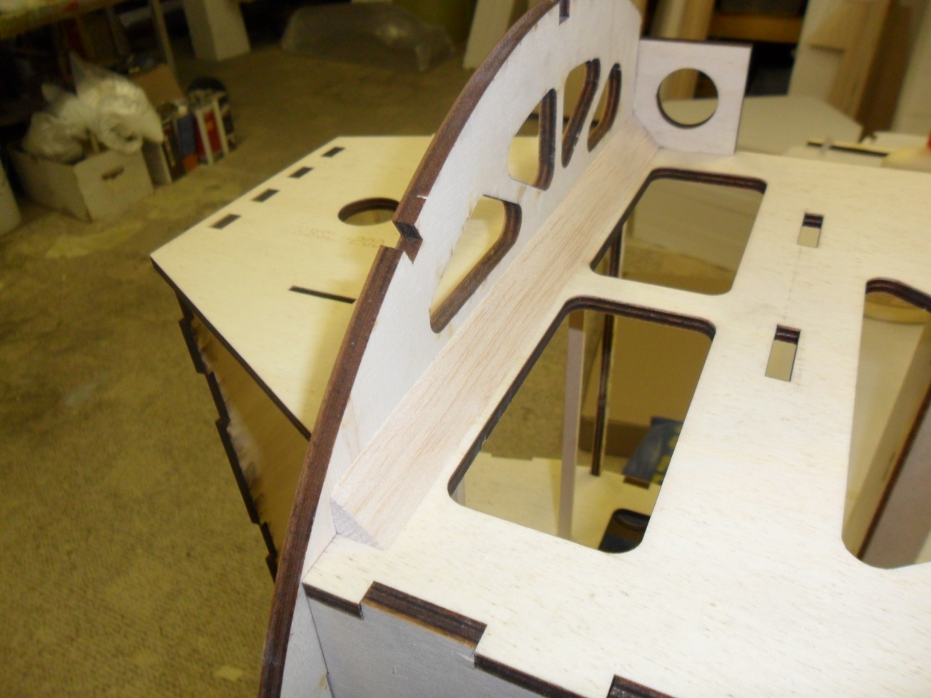
- Next glue in the landing gear plate. Make sure that the motorbox remains square. Cut and glue in the ½” hardwood at the landing gear motorbox joint.
- 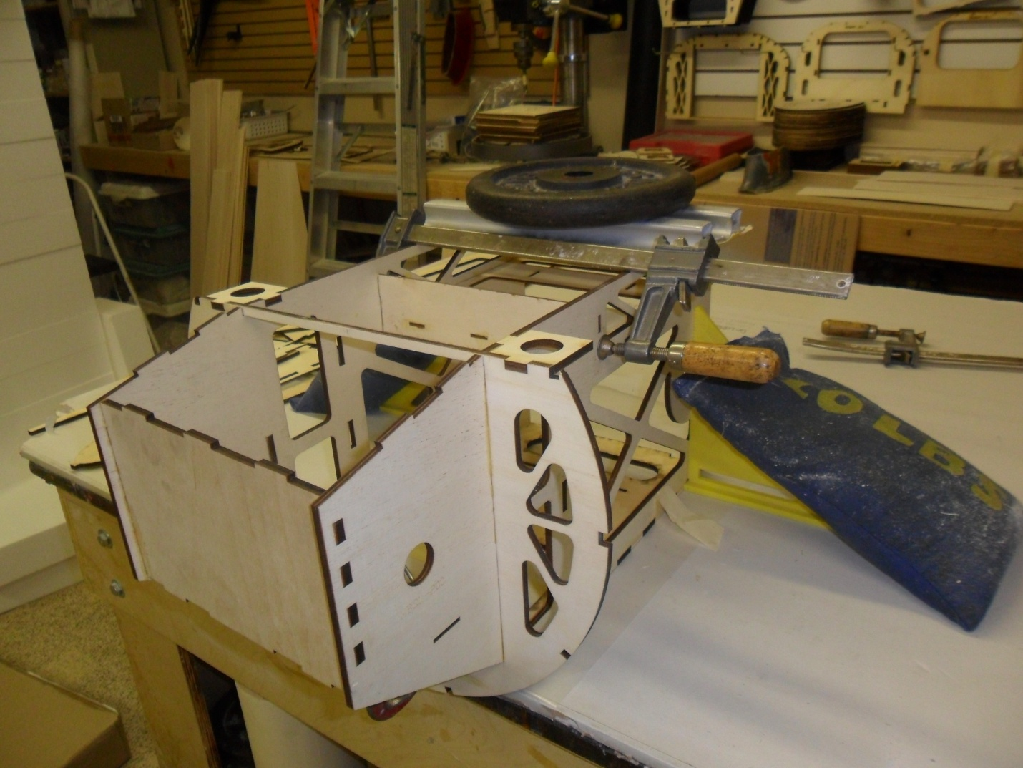
- Cut and glue in 1/4” spruce for the bottom of the fuel tank floor.
- Glue in the ½” x ¾” hardwood for the backside of the firewall.
- 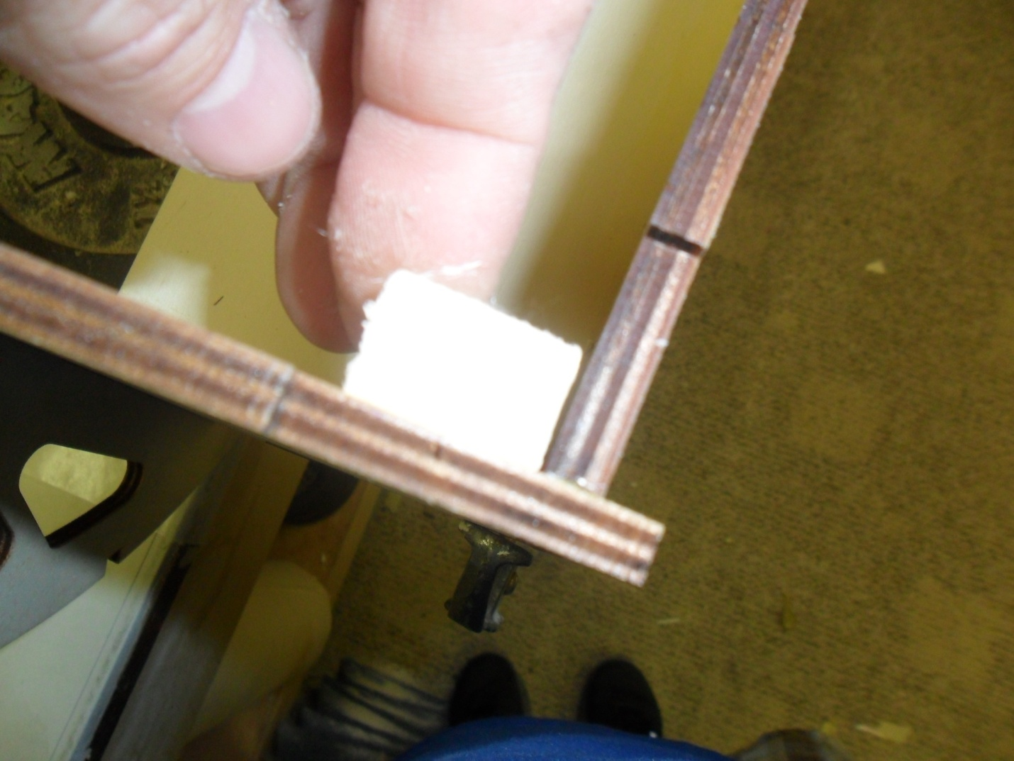
- Glue firewall doubler in place and make sure engine is offset to the left (as if you were sitting in the plane). Drill and screw firewall using #10 screws.
- 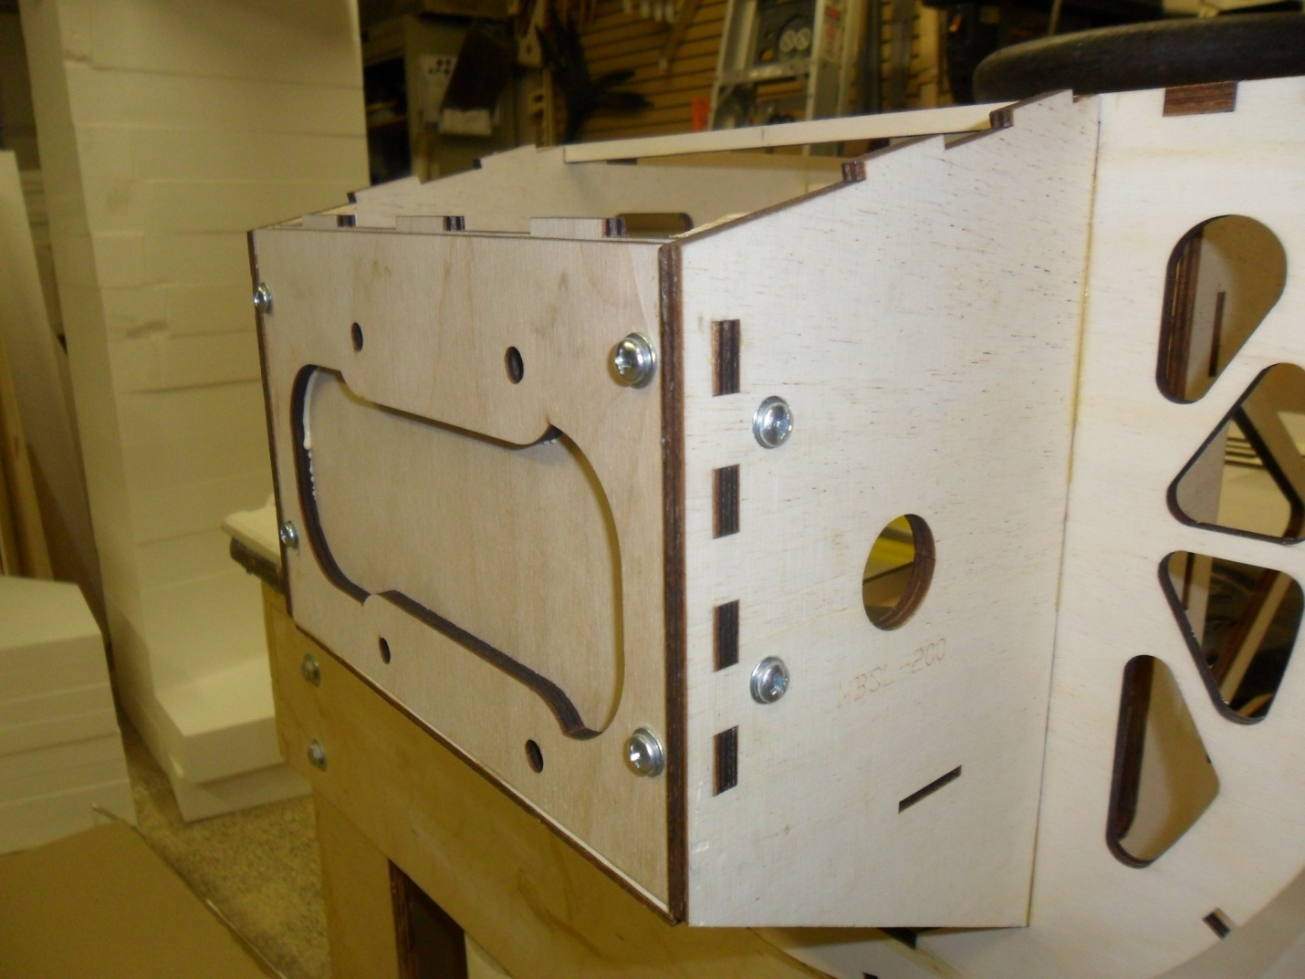
- Cut ½” tri stock and glue in MBT using the tri stock to reinforce the joint.
- Glue F2 to the back of the motorbox assembly. Glue in ¼” tri stock at the F2 motorbox joint.
- 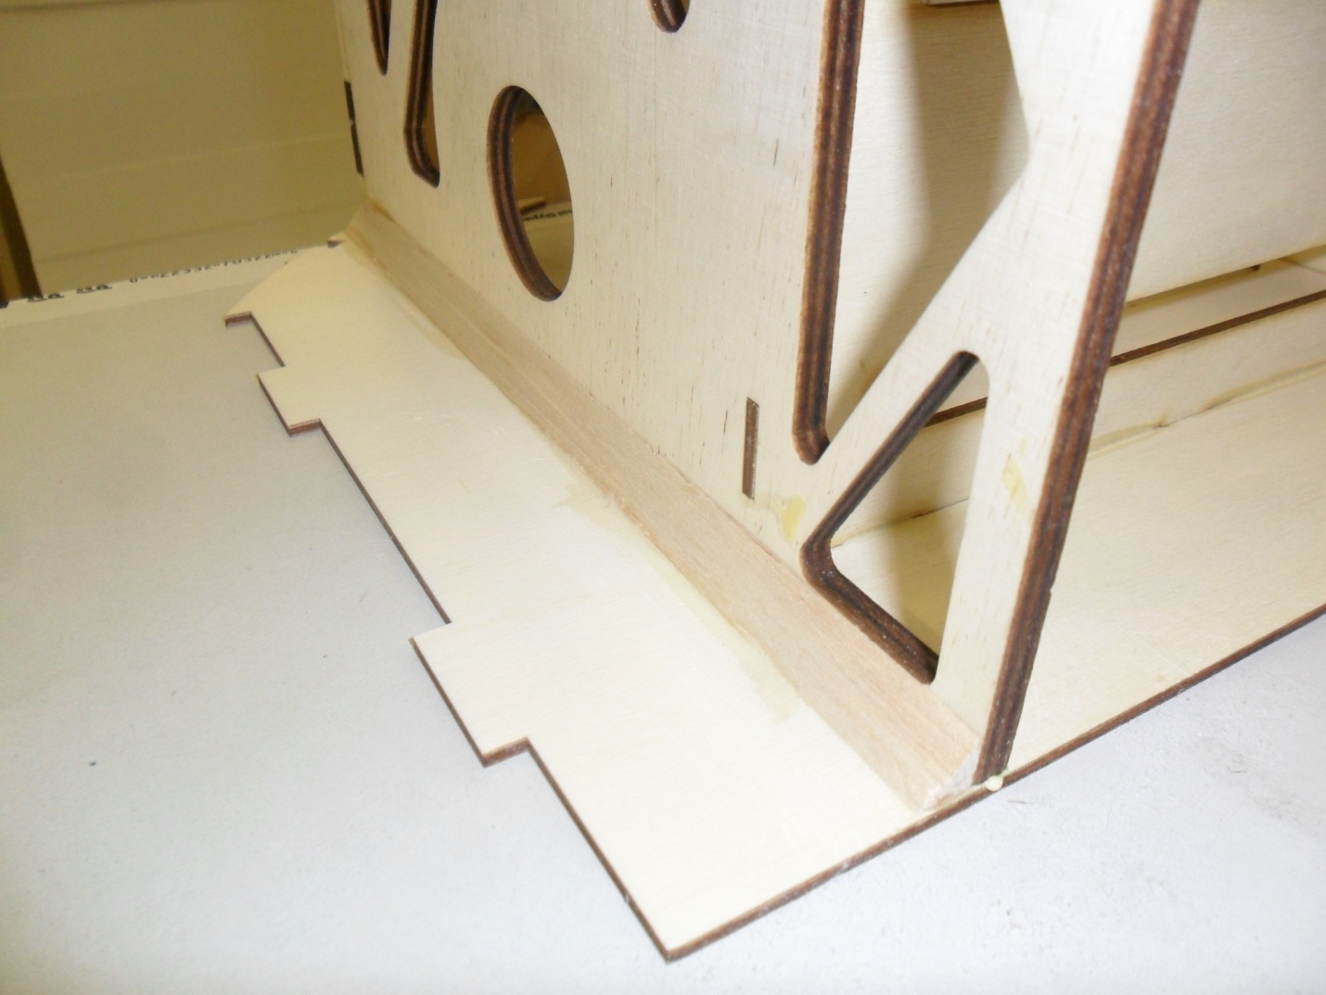
- Locate the 2 fuselage side supports. Its best to sand of the sharp corners at the front so that the fuse sheeting is not bending over a sharp edge. Refer to photos. Note in the photos below the ¼” spruce is already glued in place at the top of the fuse side. DO NOT GLUE THESE IN AT THIS TIME. They will be glued in after the fuselage side sheeting is applied.
- 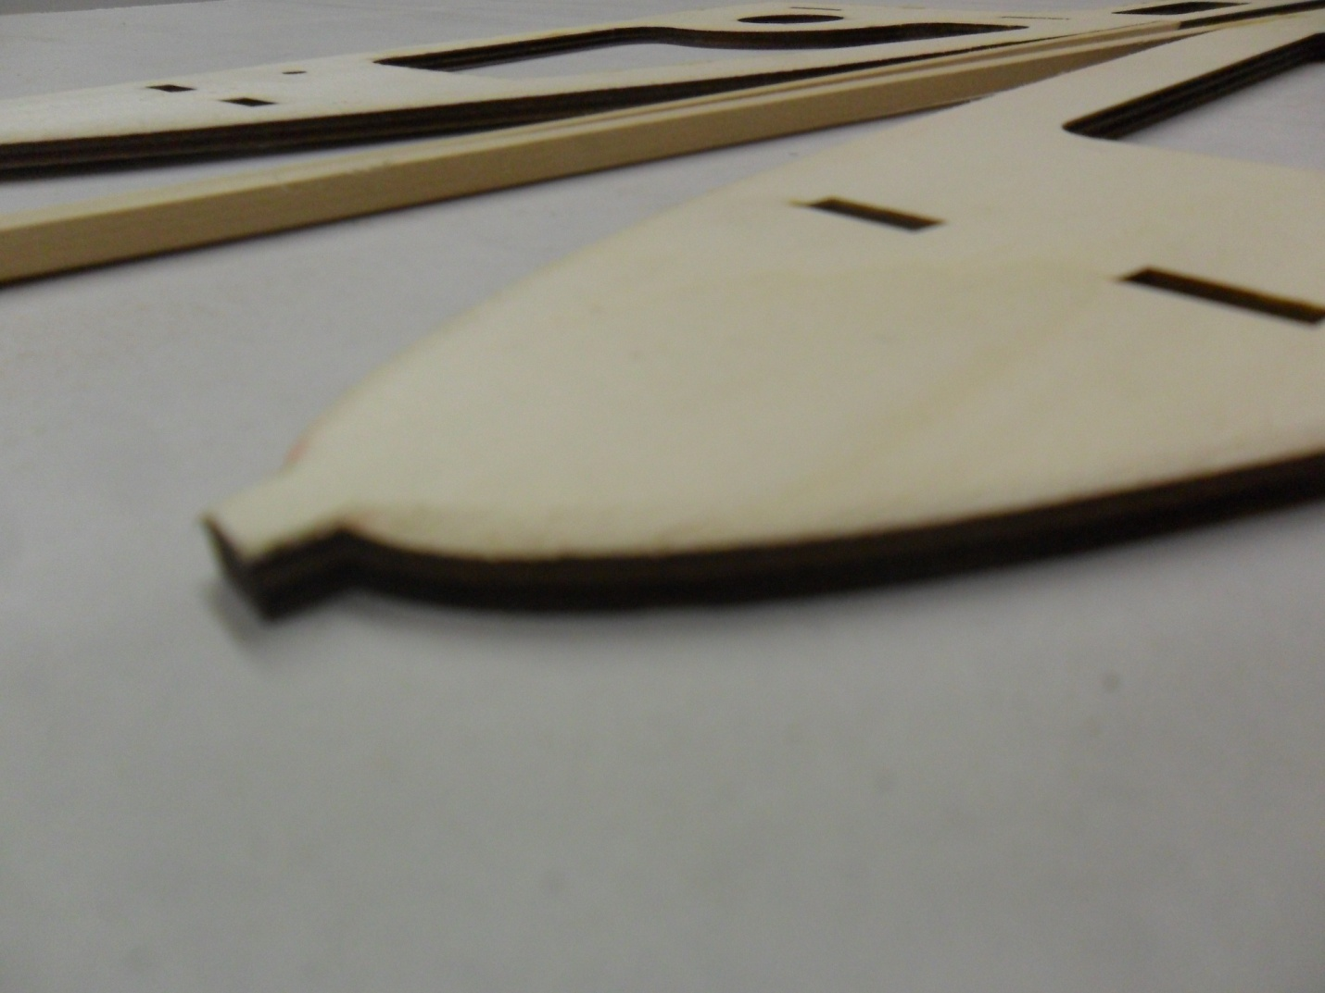
- Glue the fuselage side supports and fuselage side to motorbox supports in place. The supports are tabbed into the motorbox and fuselage sides.
- 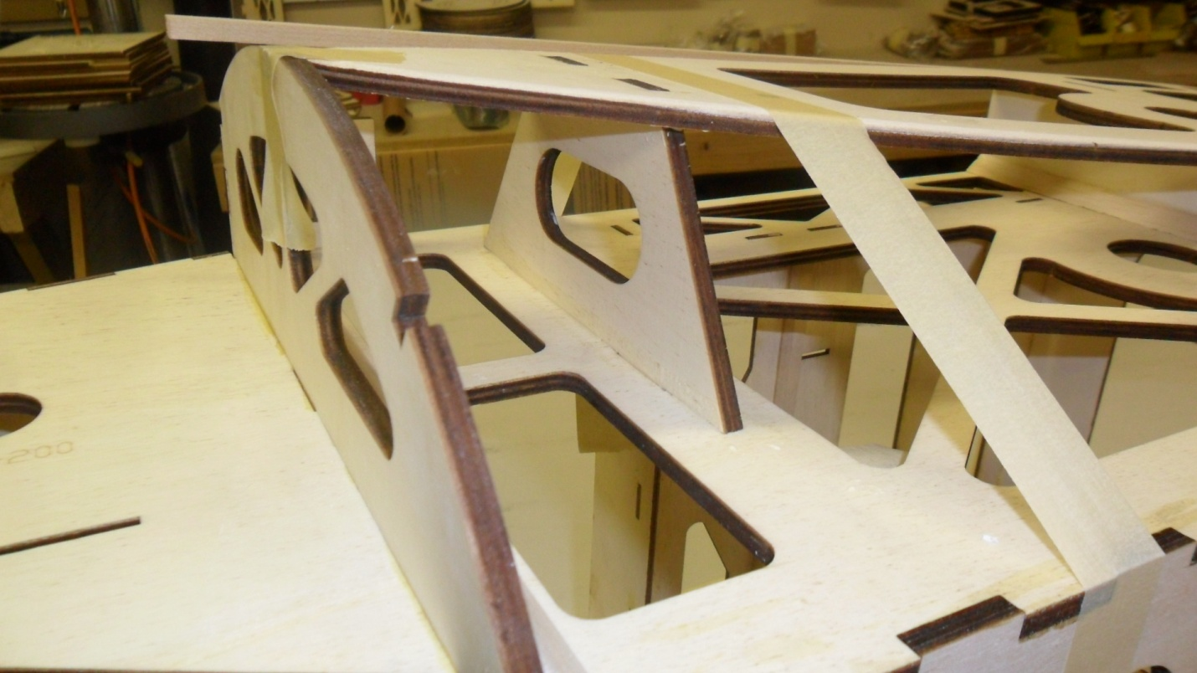
- 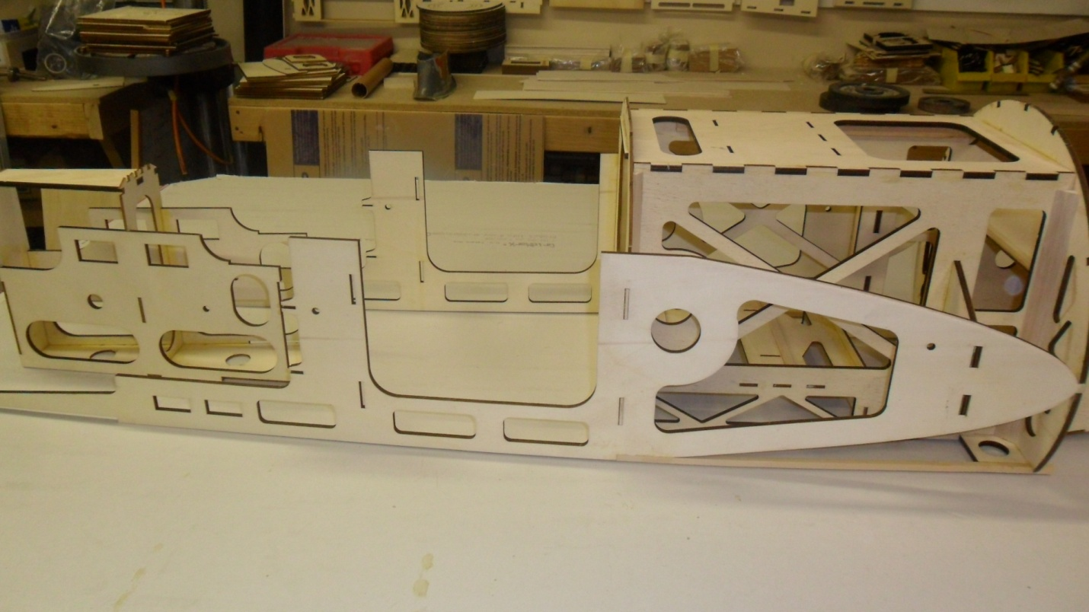
- The fuselage is built upside down over the top view of the plans. You can use 2 pieces of aluminum angle to lay over the plans and screw down to the building board. When using this method it is nearly impossible to build the fuselage crooked.
- Cut to ¼” spruce to 38.5” long. These will be used to join the motorbox assembly and tail assembly.
- 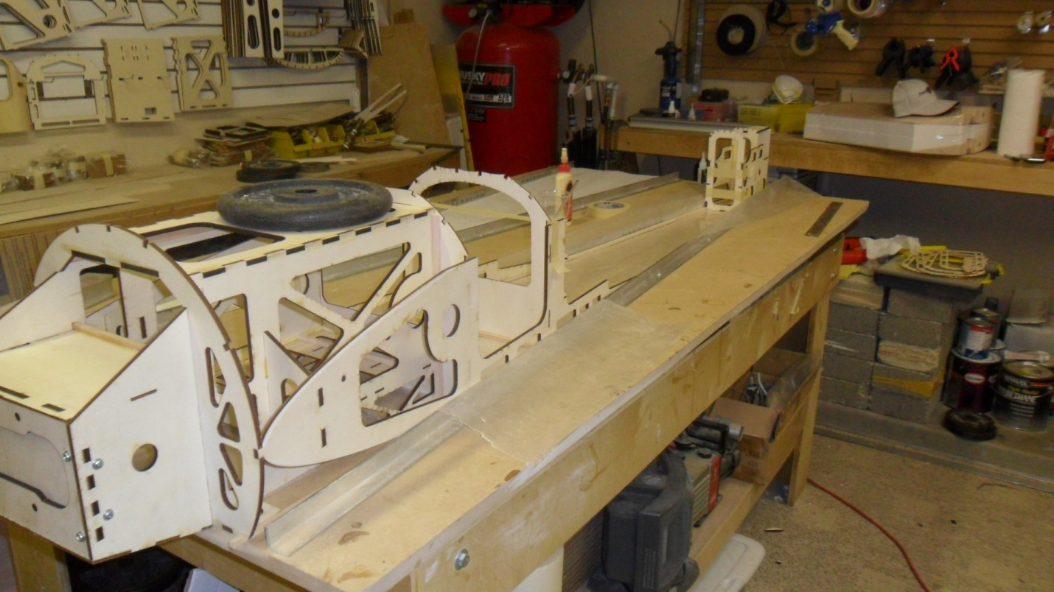
- Glue ¼” spruce to the top of each side of F3 former and the backside of F4. Sand the ends to match the angle of the fuselage side.
- 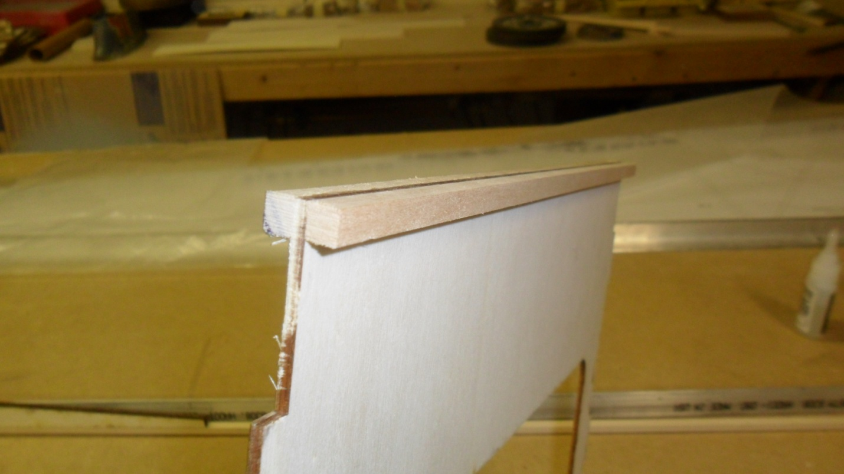
- 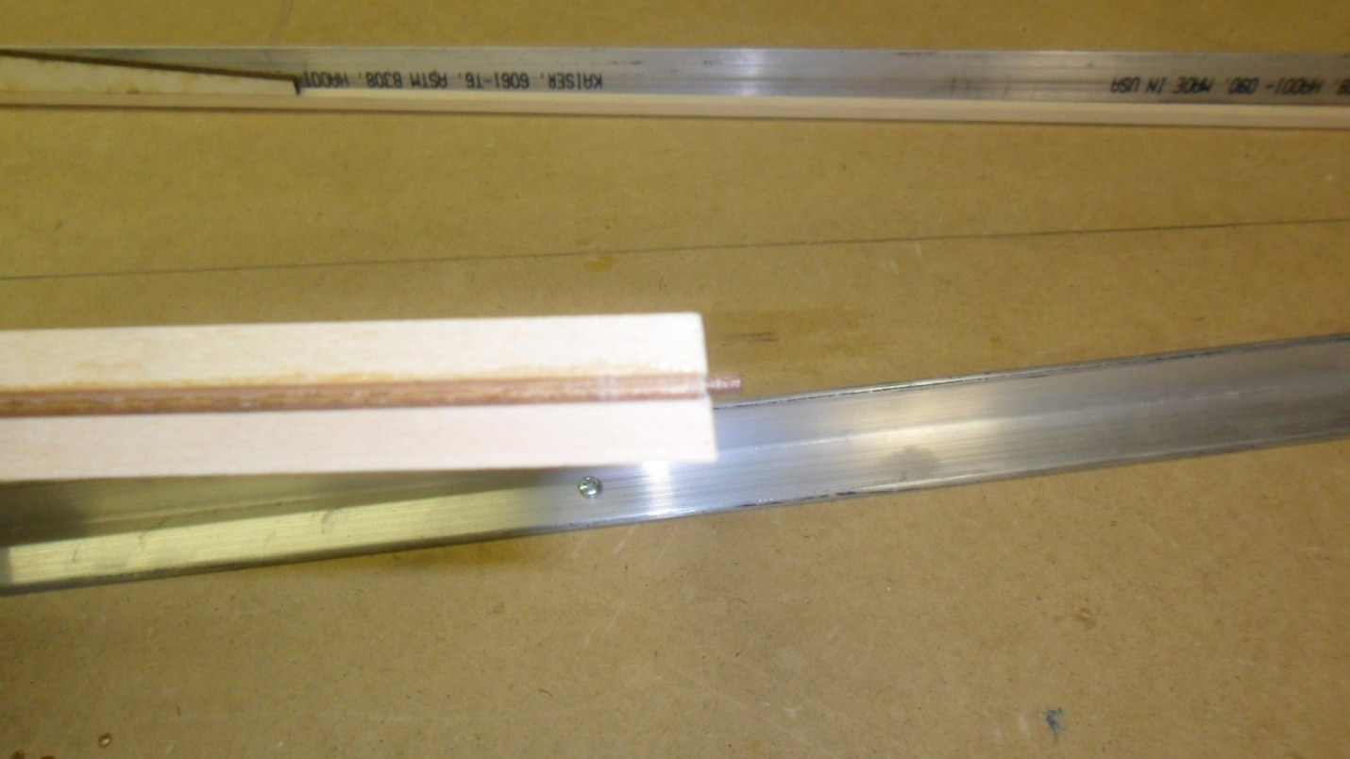
- Glue ¼” square balsa to the backside of F5 thru F8 formers and sand ends slightly to match fuselage sides.
- 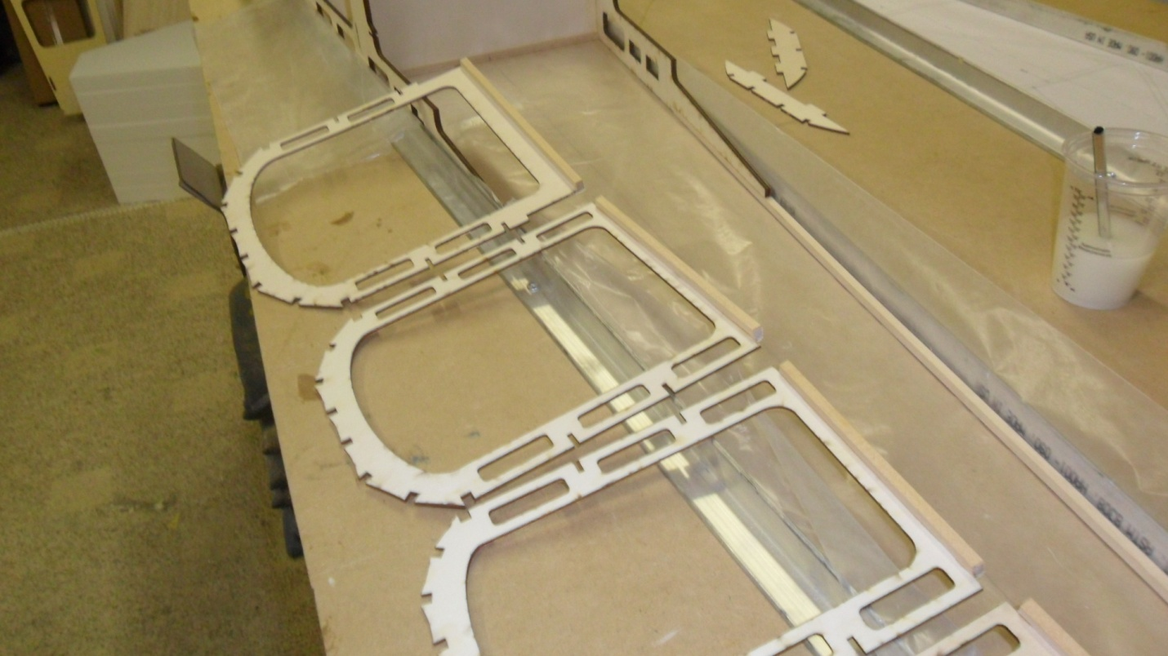
- Glue in F3 thru F8 formers keeping them 90 degress to the center line of the fuse and 90 degress to the building surface to the top longeron.
- 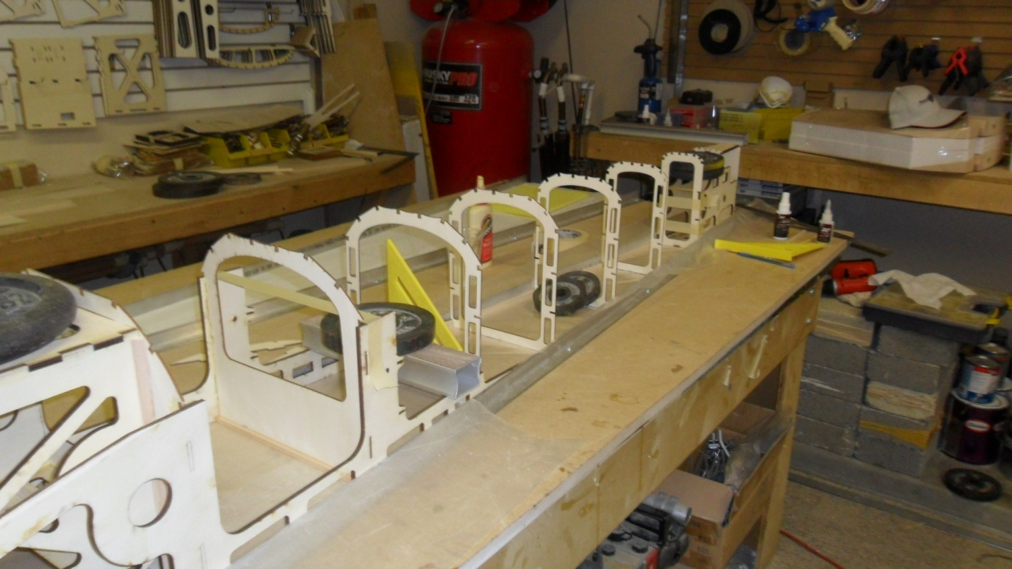
- Glue in LG1 and LG2 landing gear formers.
- Glue in all ¼” spruce stringers and 1/8” x 3/8” balsa side stringers ( 2 per side ) keeping all formers at 90 degress to the building surface.
- Cut and glue in all cross bracing top and bottom. The top bracing should run the opposite direction of the bottom.
- The fuse side sheeting is made up from 6 sheets of 3/32” x 3” x 48” balsa sheeting per side.
- 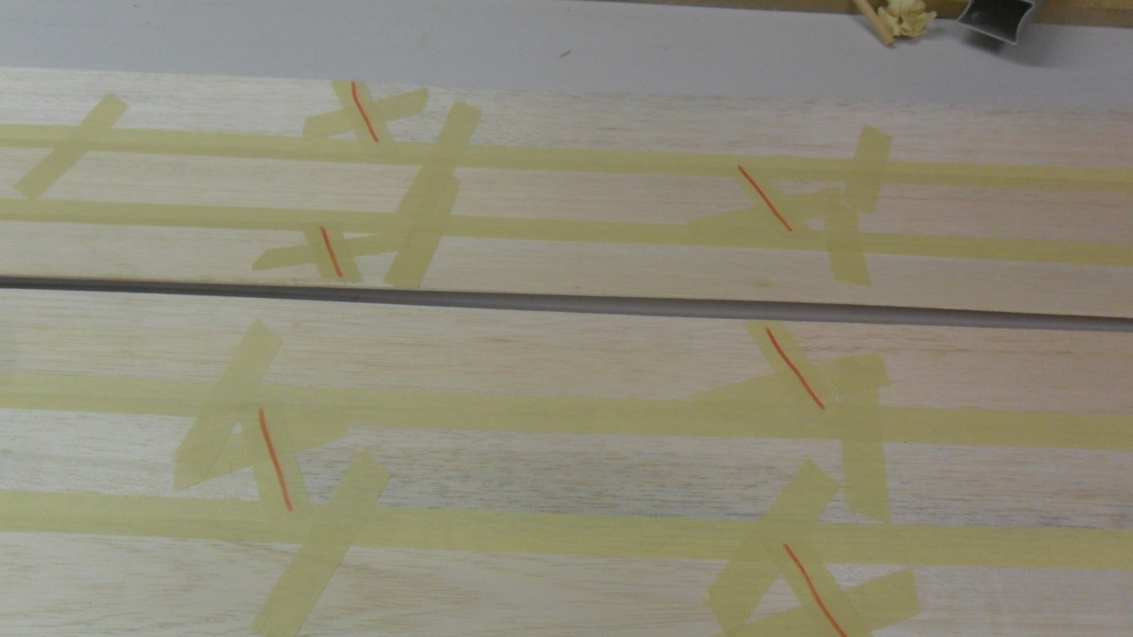
- The red lines show where I join the two sheets together to make up the total length and then stagger the joints.
- 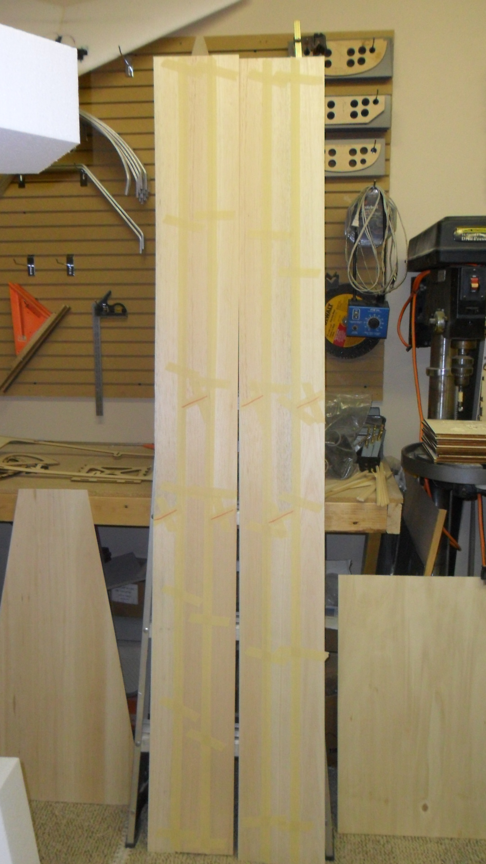
- 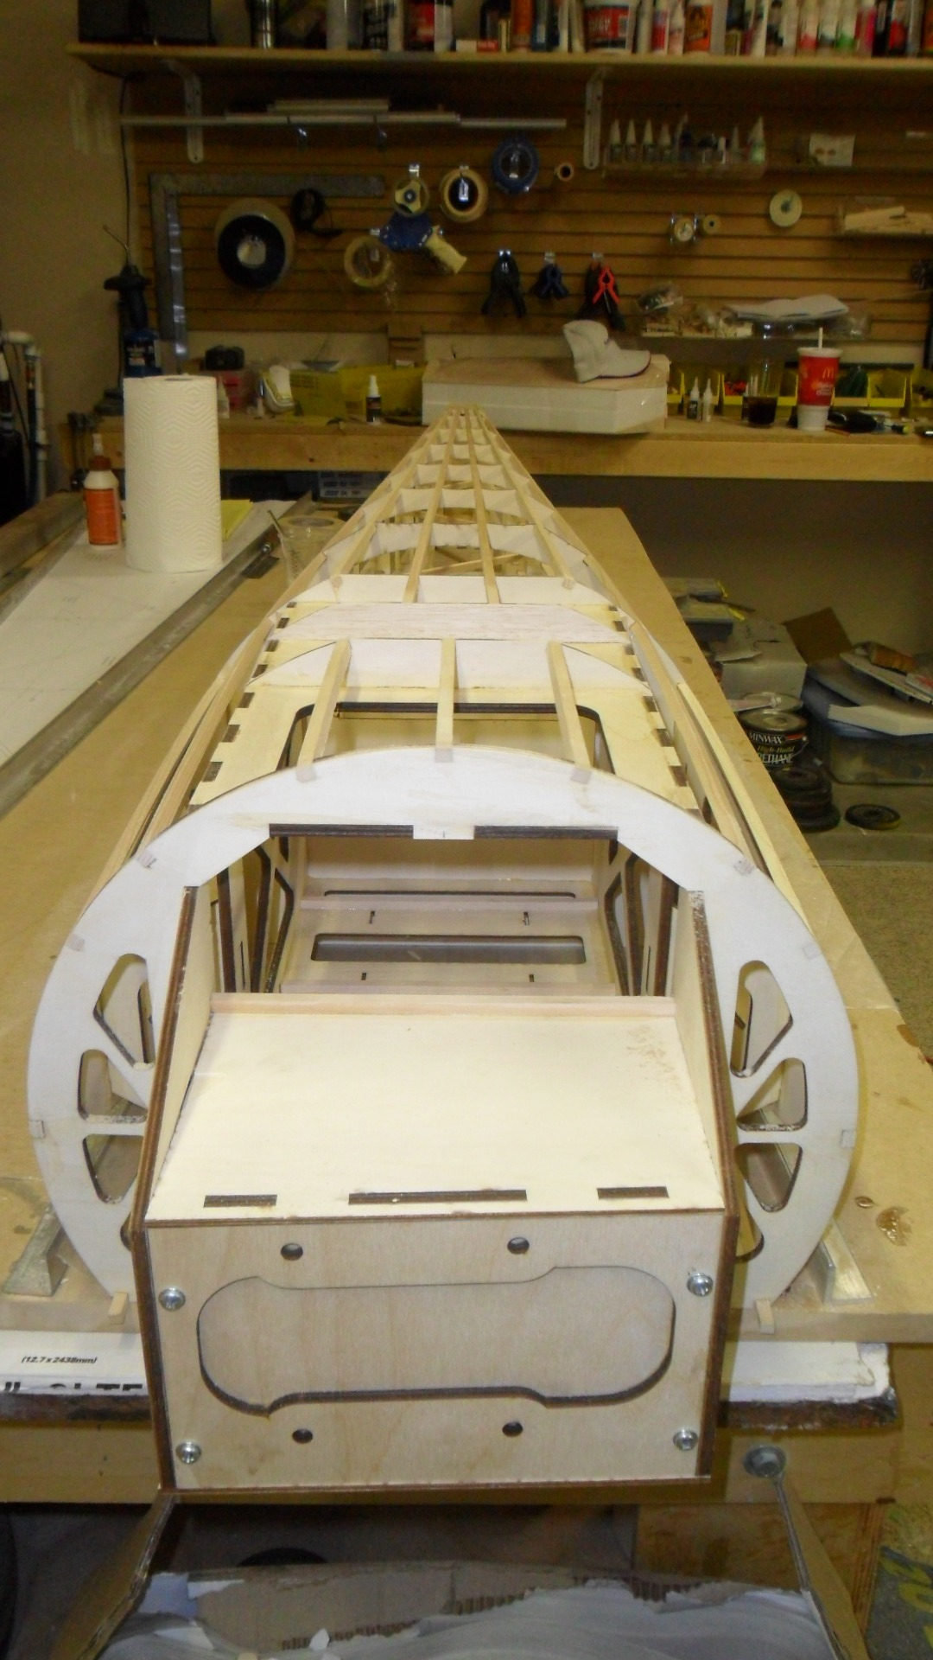
- Make sure the fuselage sides are ready to apply the sheeting. Check for anything that will keep the sheeting from making contact with any formers. The pic below shows two areas that may need to be sanded flush before gluing on the side sheeting.
- 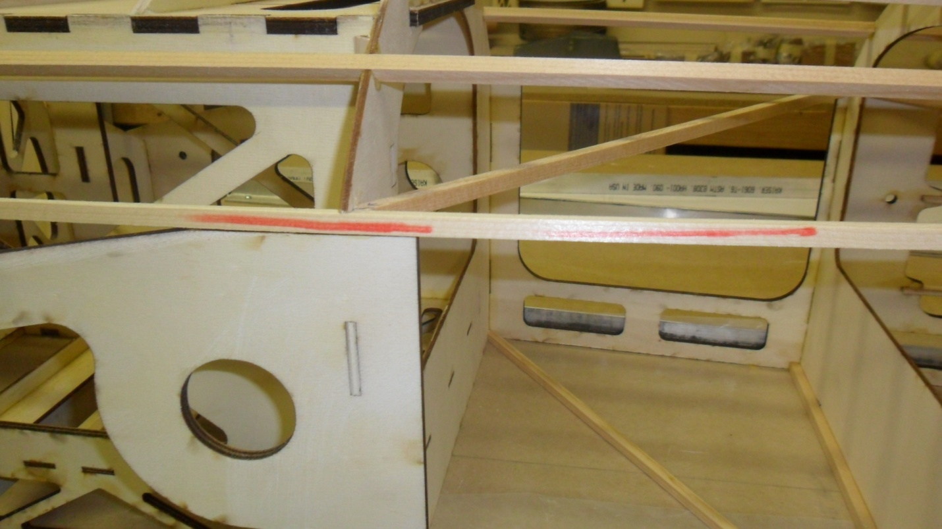
- The fuselage is now ready to apply the side sheeting. Glue the sheeting onto the flat side of the fuselage and once dry you can roll it around the front.
- Once the sheeting is dry you can cut and glue in the ¼” spruce the runs from the notch on top of the fuse side to F1. It important to keep these as straight as possible. You can glue some scrap balsa to the side of the spruce and sand to shape to provide a better surface for the sheeting something to glue to.
- 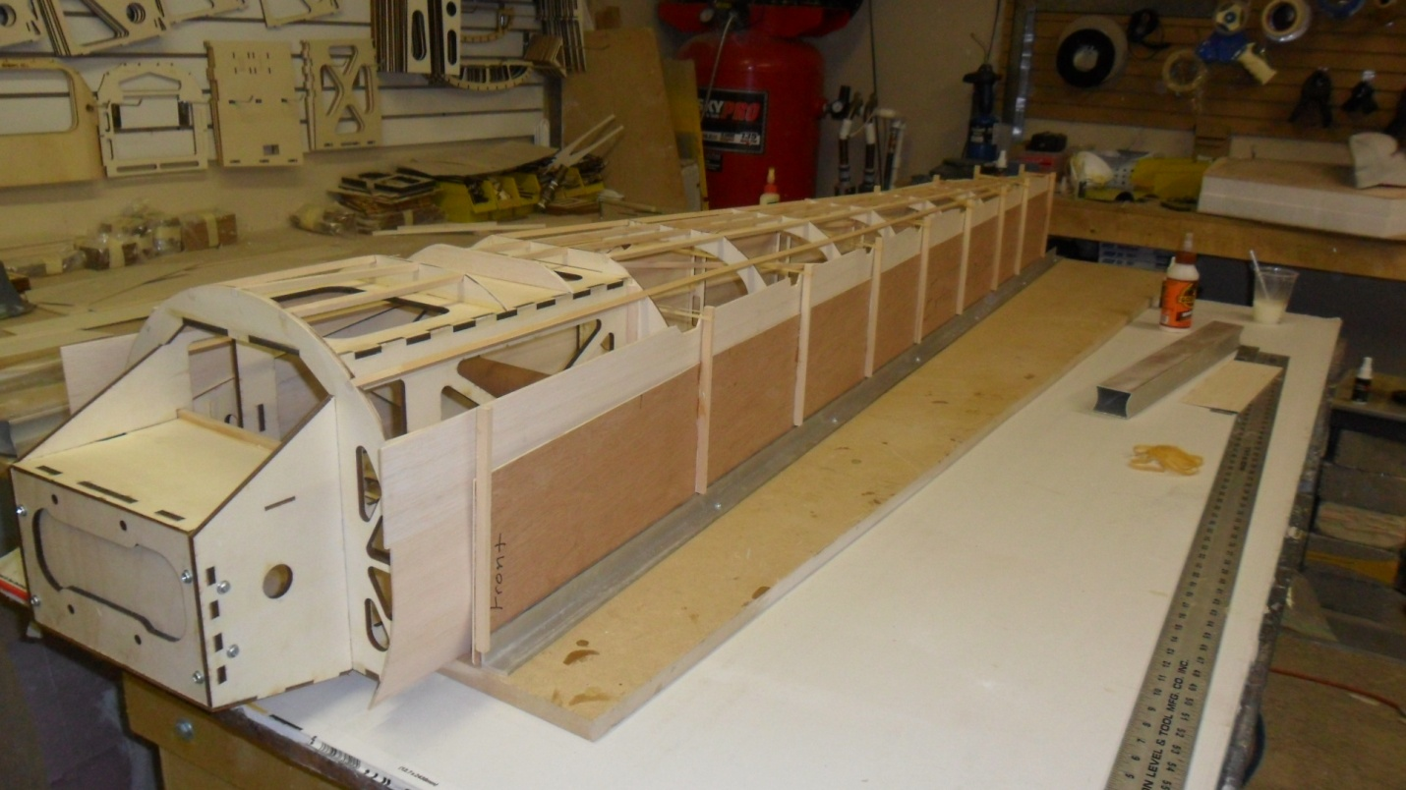
- 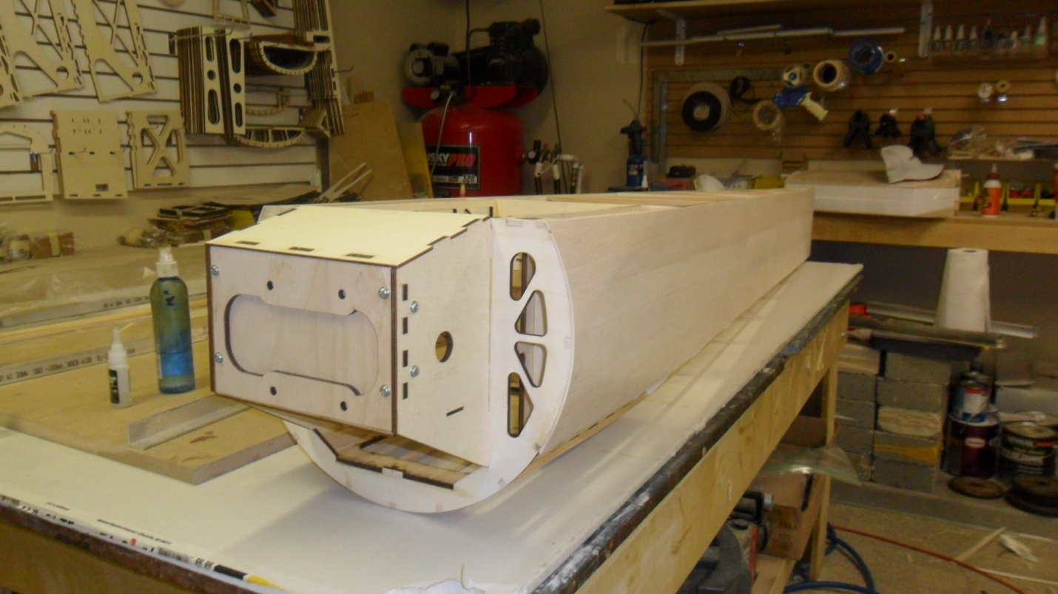
- Cut and glue in the short piece of ¼” spruce that runs from F2 to LG2.
- 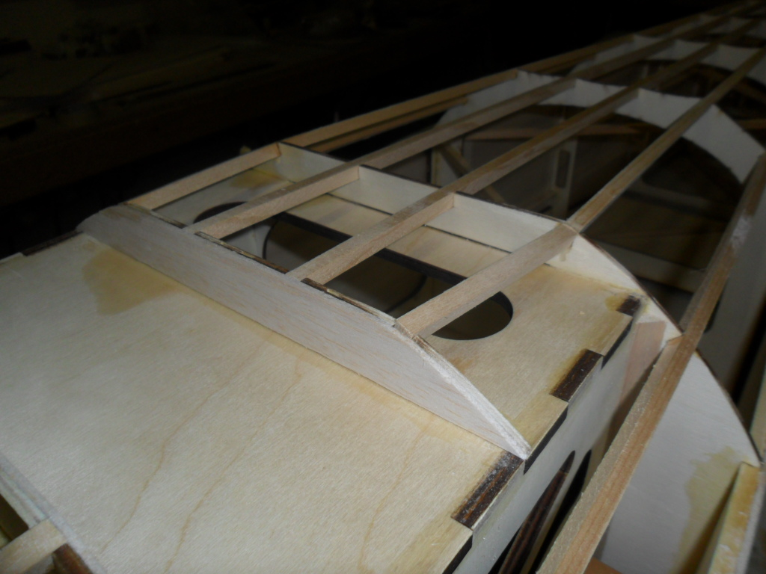
- Sheet the bottom around the landing gear plate with 3/32 balsa.
- 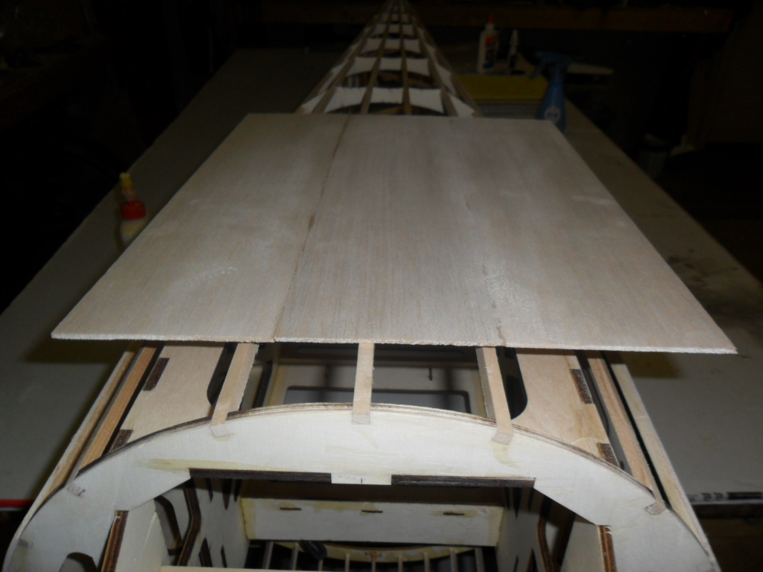
- 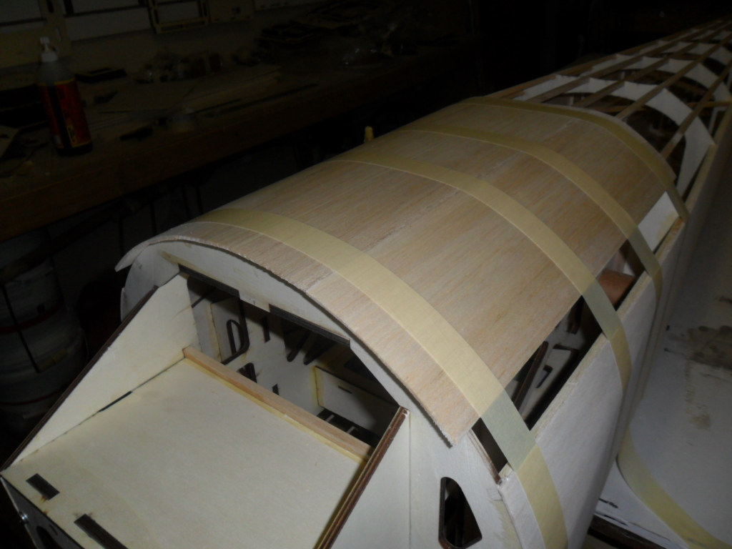
- 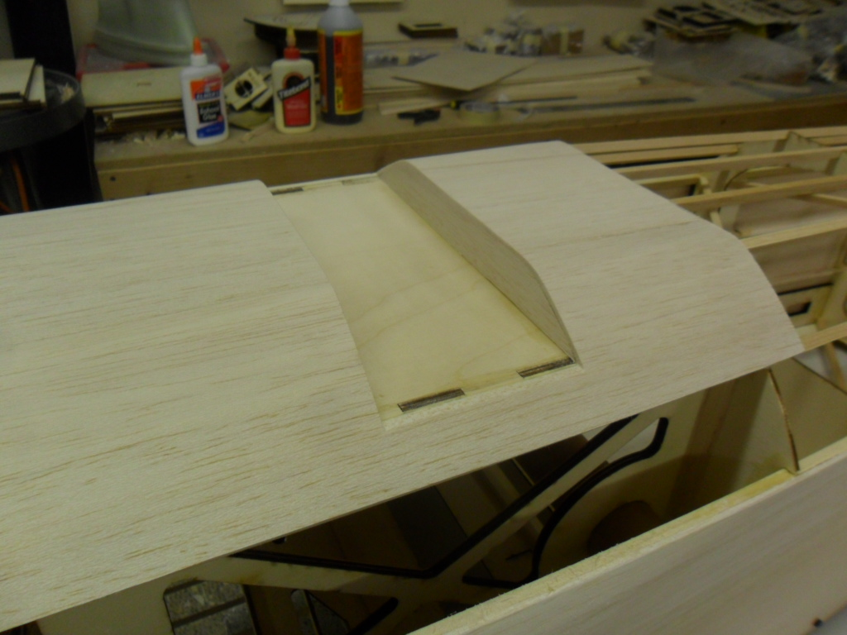
- Use scrap balsa to fill in around F1.
- 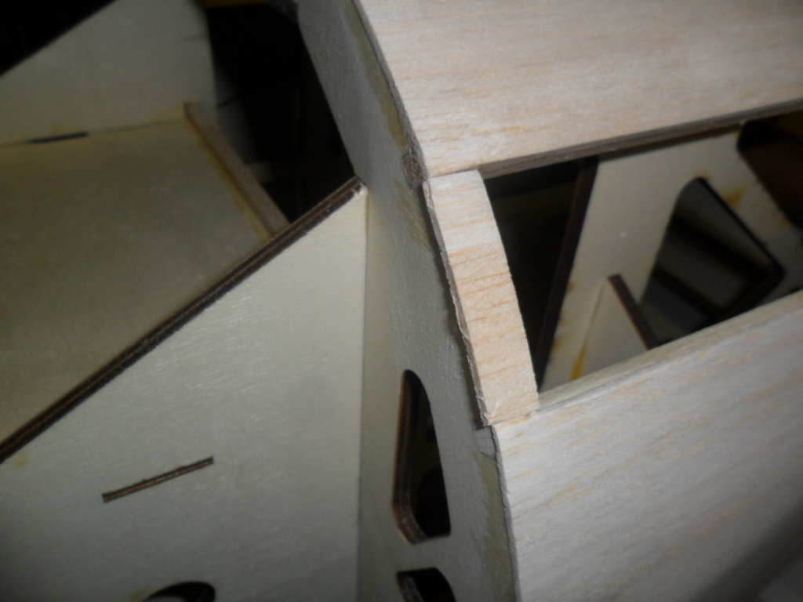
- Locate and drill the four holes for the landing gear. The mounting holes should go into the ½” hardwood inside the motorbox.
- 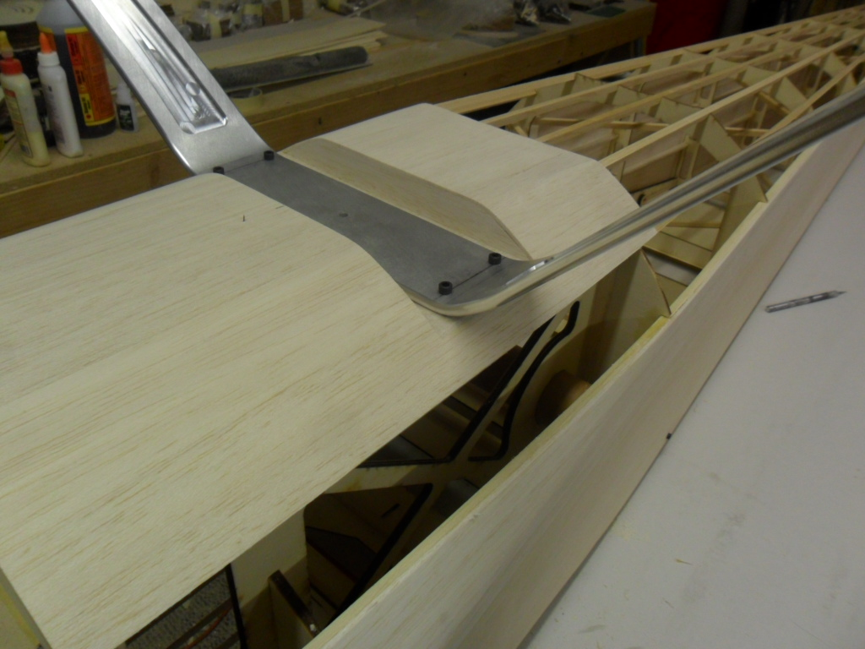
- Glue in the phenolics for both the wing and stab. Keep the tubes parallel and square to the fuselage.
- You can now trial fit the wings and stabs to the fuselage and make sure you have a good fit. The root may need to be adjusted due to the variances in cutting the foam.
- 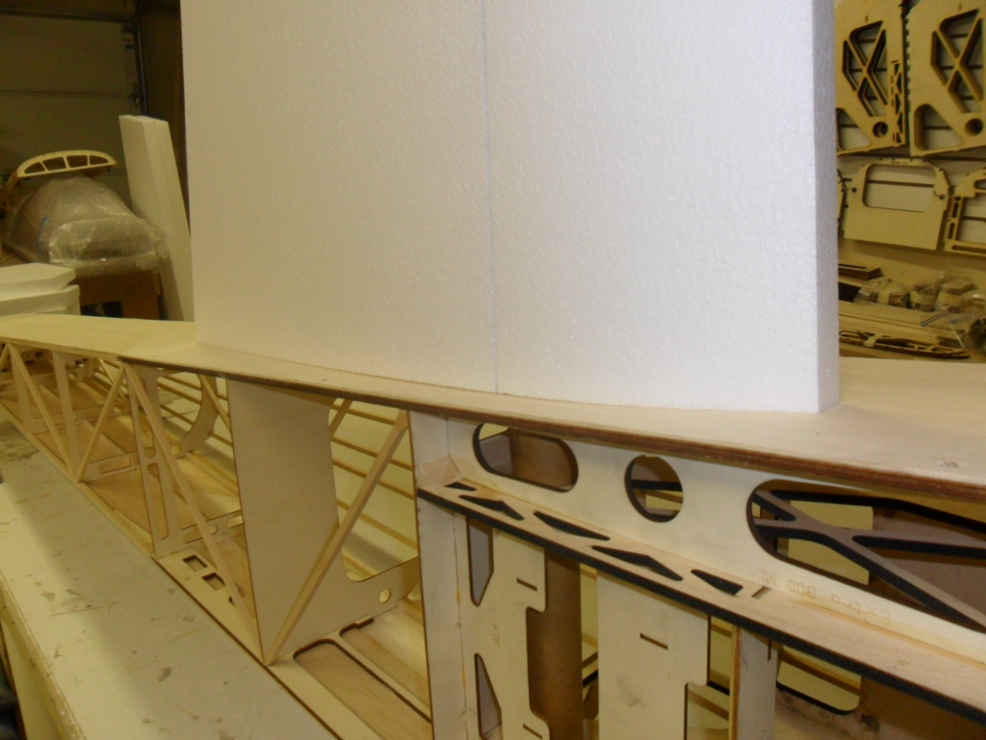
- 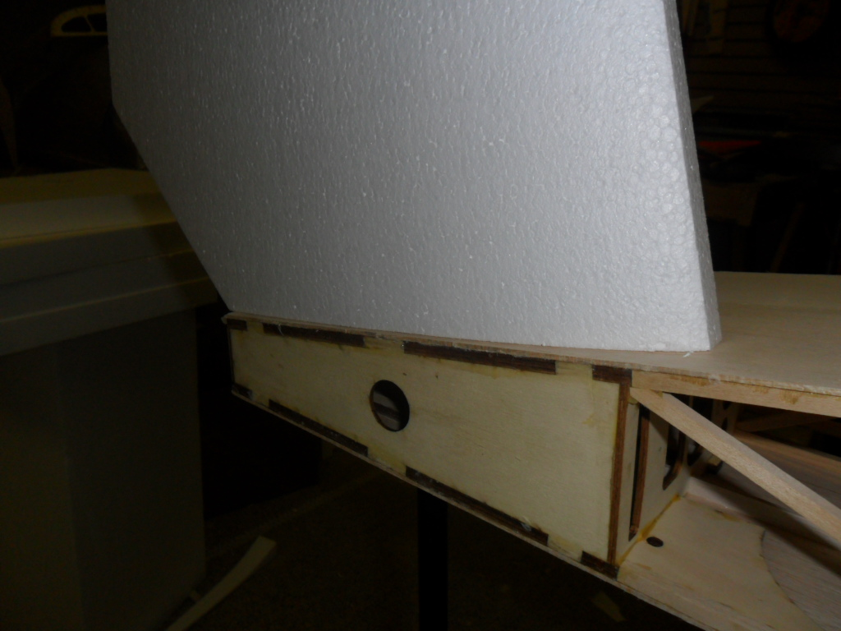
- Once satisfied cut to rough shape the plywood root caps. Leave a little extra that will be sanded flush the foam once it is glued to the root.
- 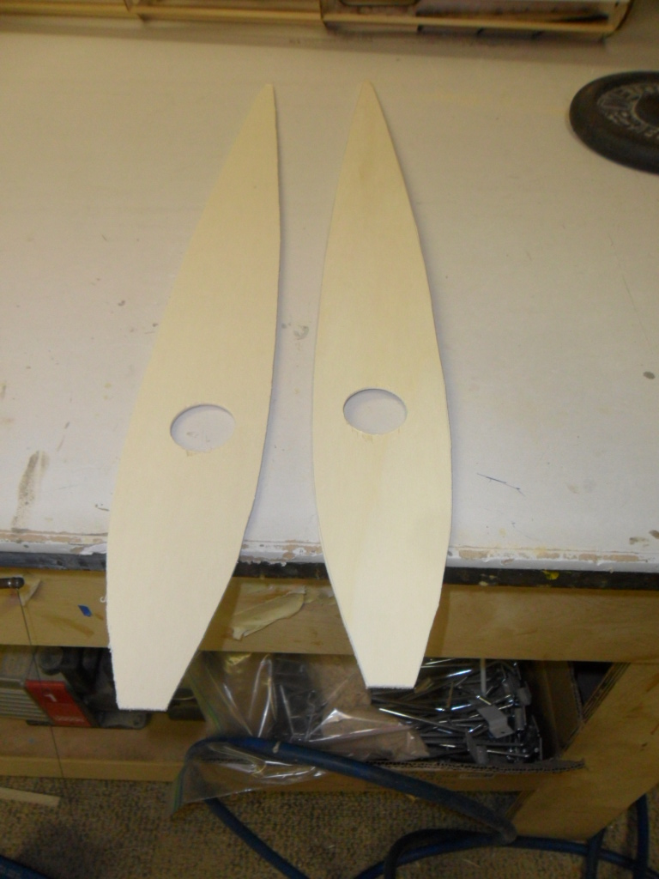

- Glue the plywood root caps to a sheet of 3/32” x 4” x 36” balsa. Make sure to make a right and left side.

- 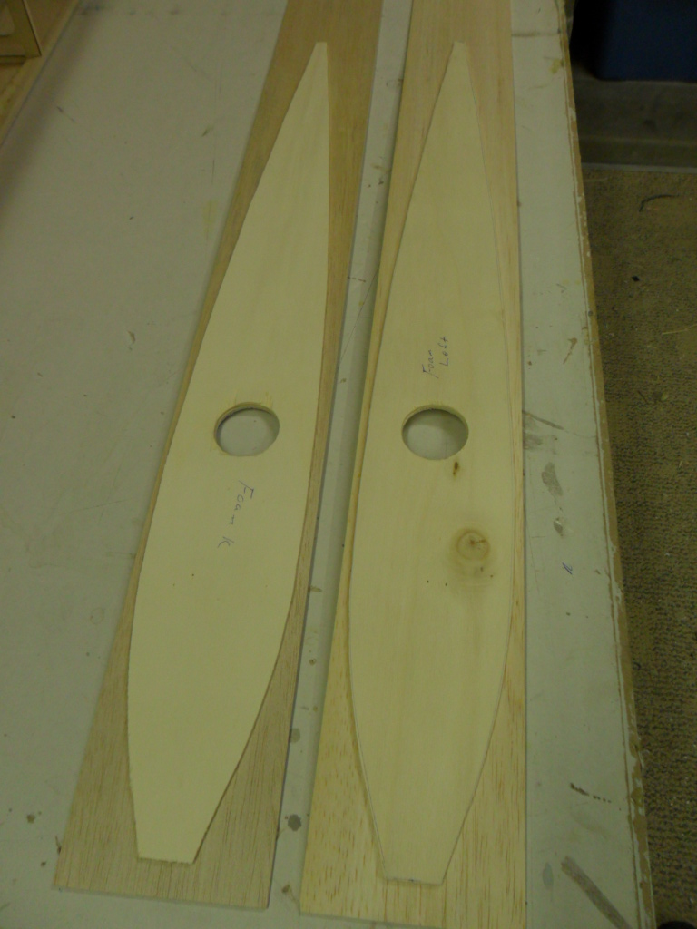
- Locate to four anti rotation pins locations and counter sink the 1” dowel hard points into the foam.
- 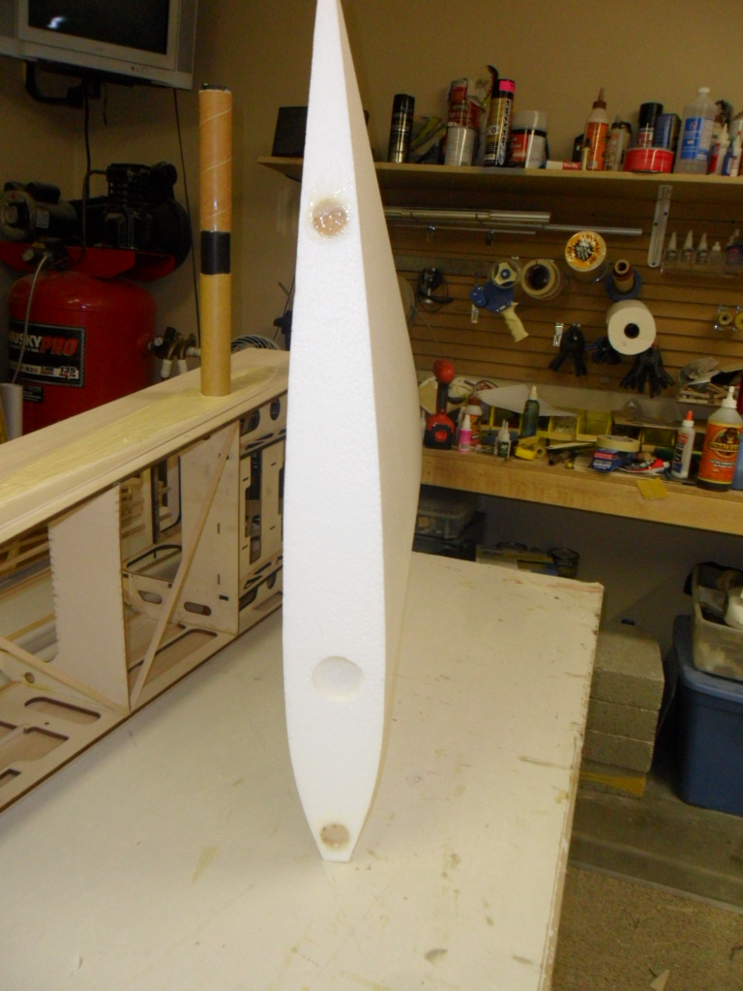
- You are now ready to glue on the plywood root caps and hard points. I use a slow setting epoxy mixed with a little cab-o-sil for this. You can use weights and t- pins to hold the root cap to the fuselage while the epoxy cures. Once dry trim and sand the balsa /ply root cap flush with the foam. Set these aside for sheeting later.
- 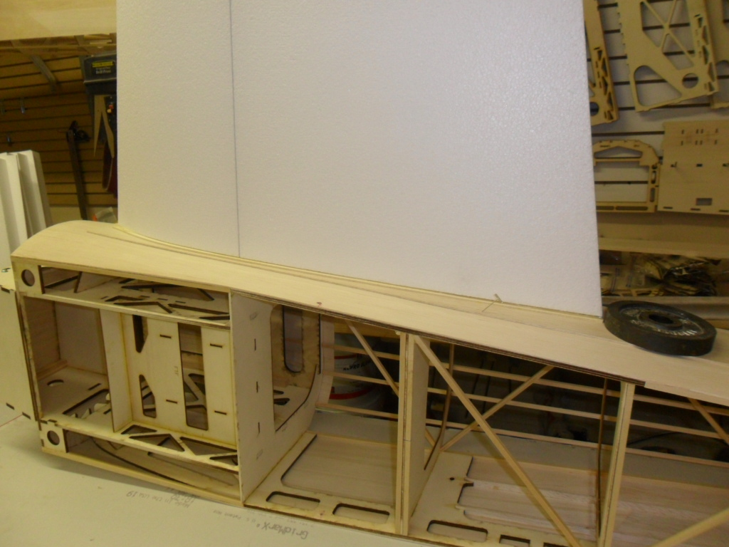
- 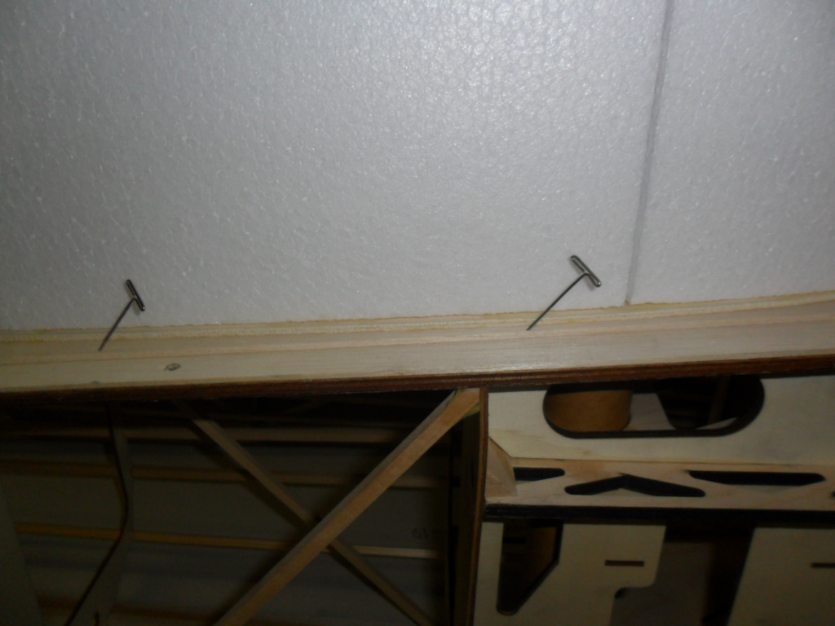
- The turtledeck sheeting is made up from 4 sheets of 1/16” x 4” x 36” balsa sheet.
- 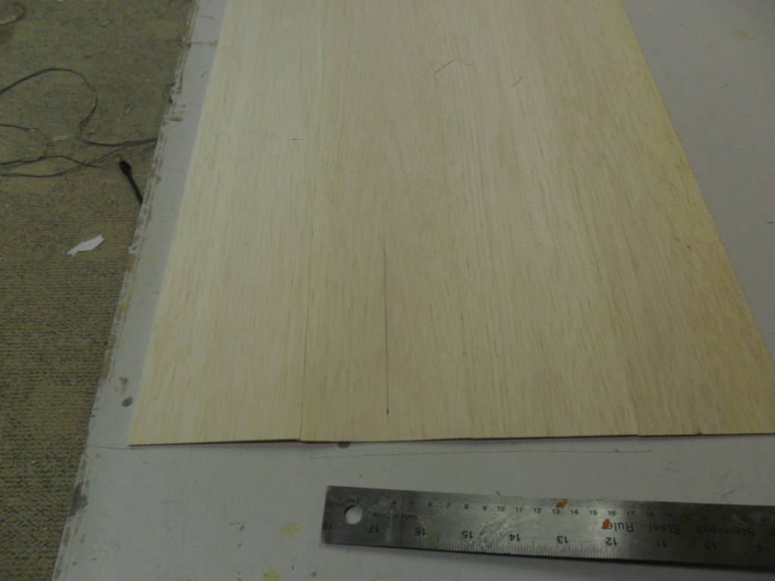
- 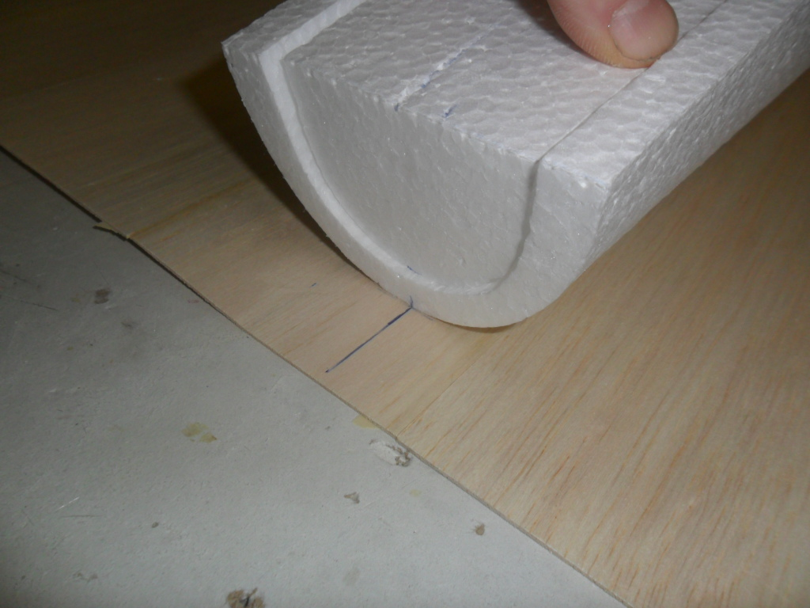
- 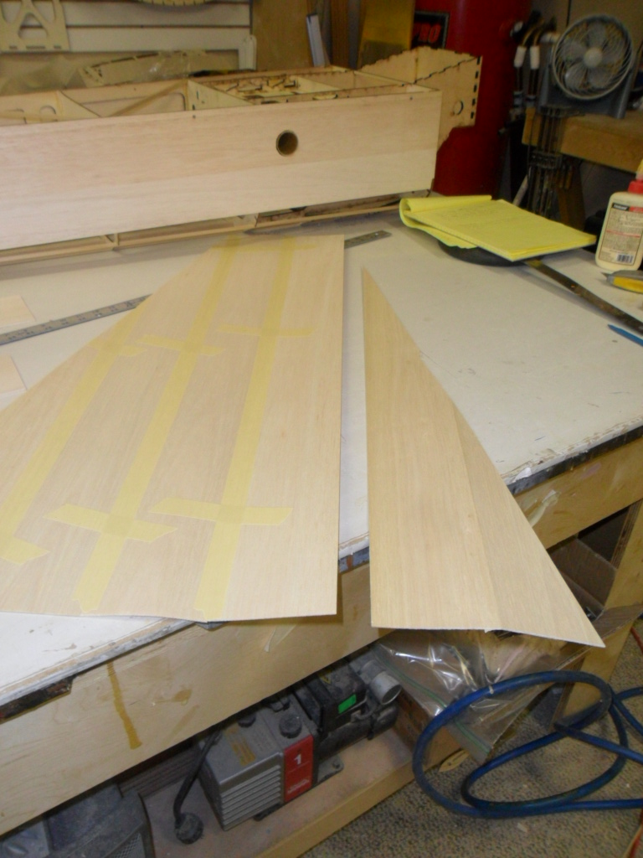
- 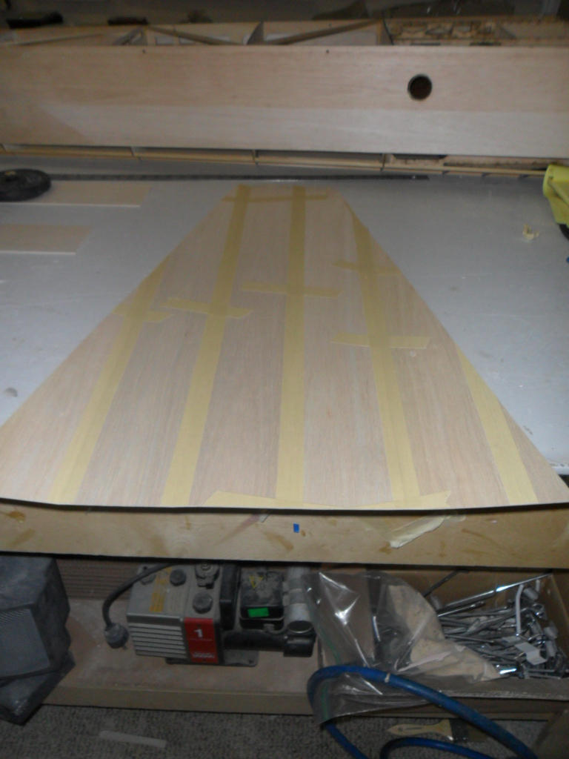
- I like to glue two strips of 1/16” balsa about ¾” wide to the fuselage. This gives a nice surface for the turledeck to glue to.
- 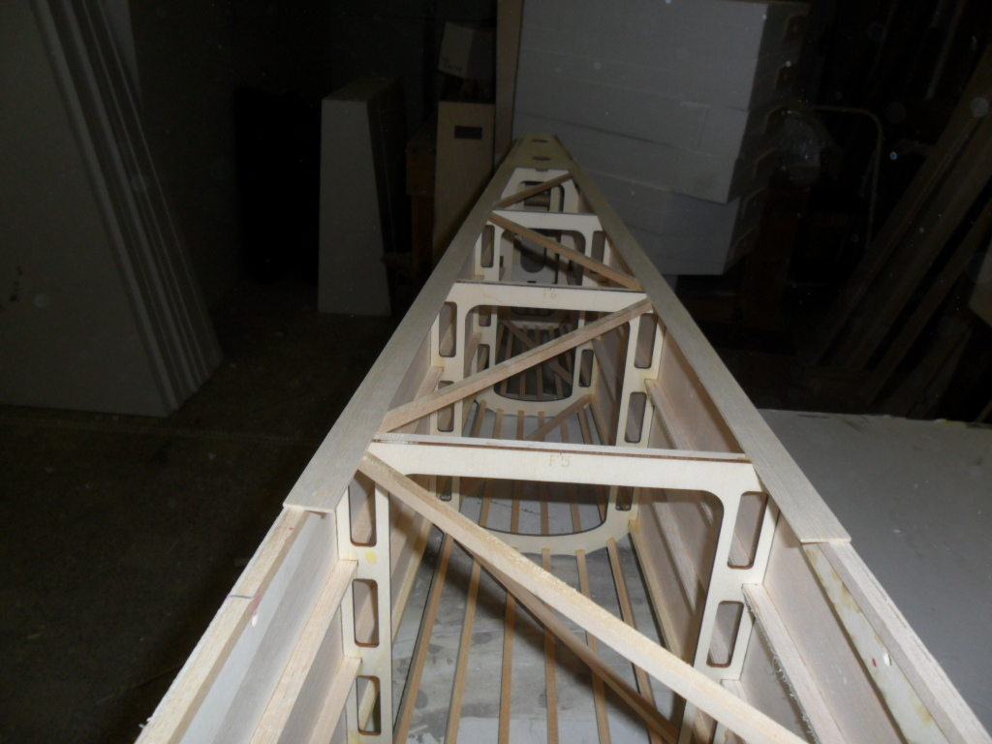
- 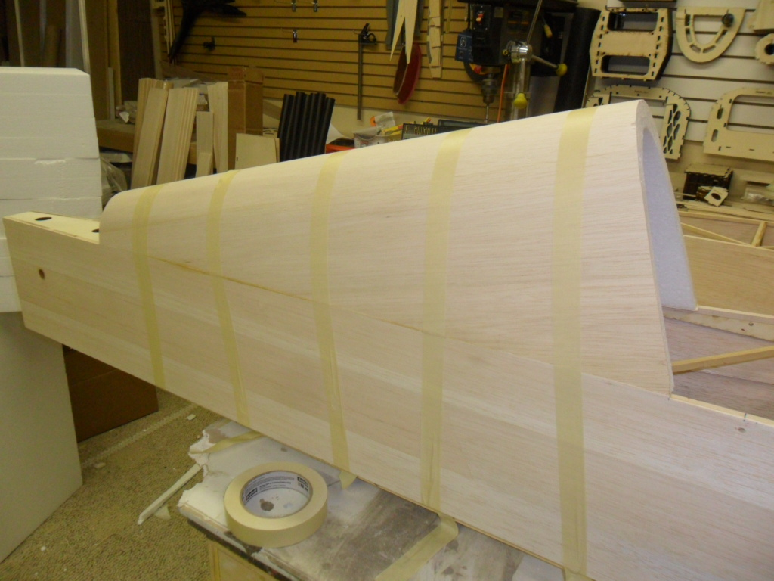
- Locate and glue on the laser cut turtdeck cap. Note that it is slightly oversized. Once dry sand flush with the turtledeck sheeting.
- 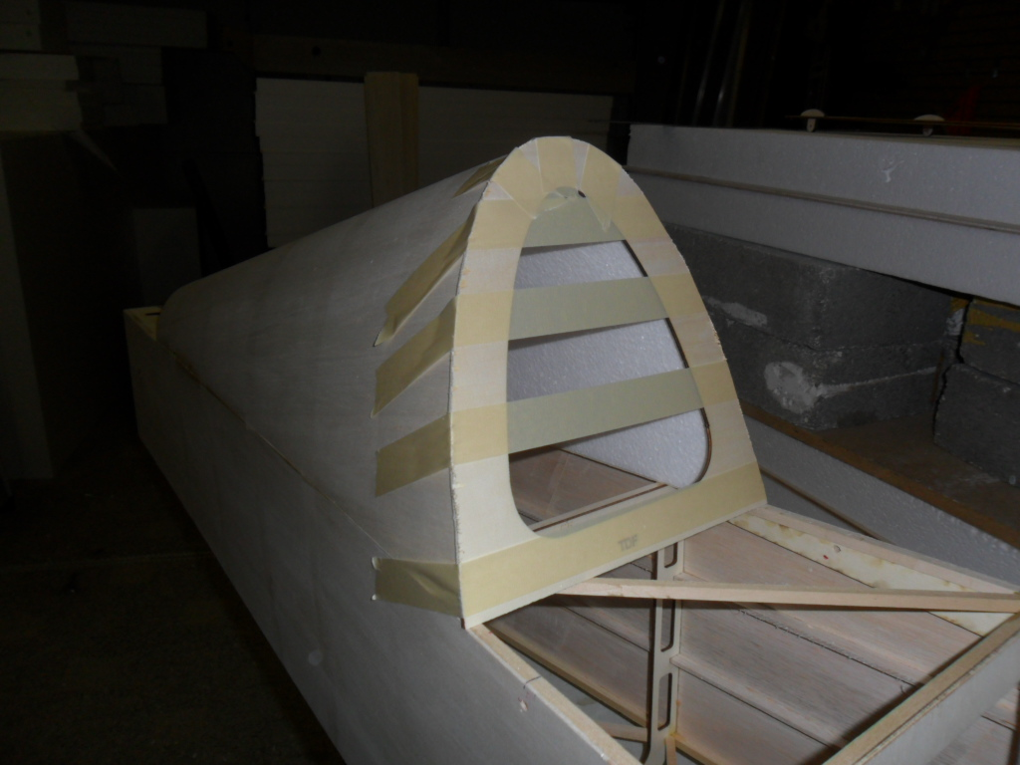
- Locate the hatch/canopy frame floor and 4 hold downs. Glue in the hold downs and attach the assembly to the fuselage with 6/32 hardware.
- Next glue in the front hatch former only
- 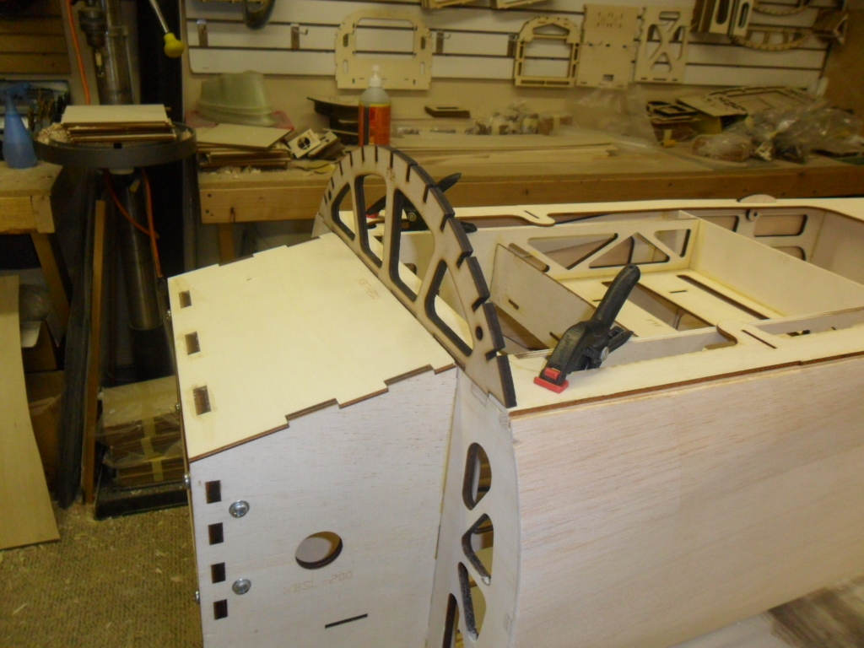
- Next trial fit the top and bottom cowl together. It may be necessary to sand slightly and flashing left from the mold to get a perfect fit. You can clamp the top and bottom together for now.
- Using tape to hold in place position the cowling on the fuselage to drill the to hatch pin holes. These holes do not need to be perfect but you want them close. We will do the final fitting after the hatch is sheeted. Drill the 2 ¼” holes into the top cowl flange using the former as a guide.
- 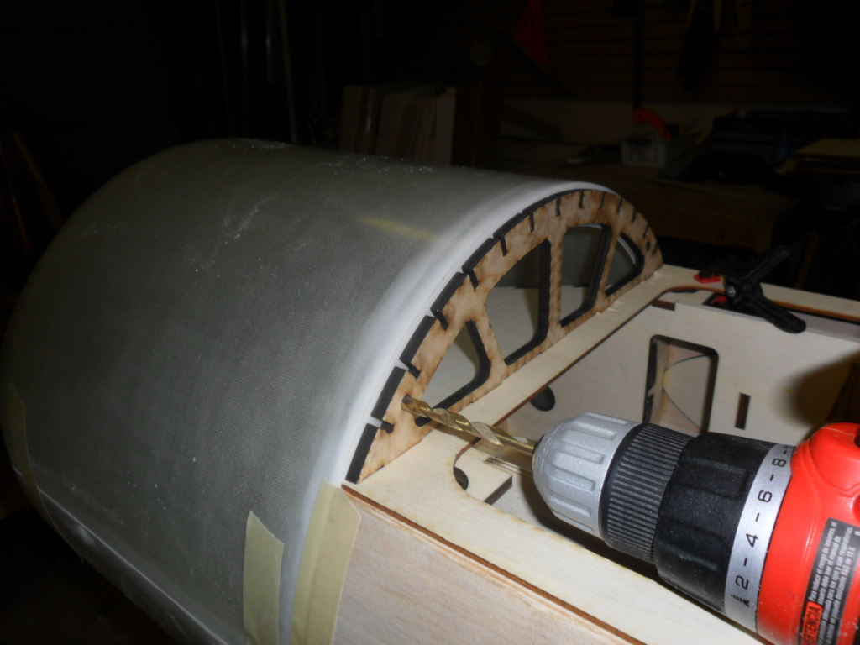
- The the cowl aside until the hatch is complete.
- Glue in the second hatch former and all 1/8” hatch stringers.
- 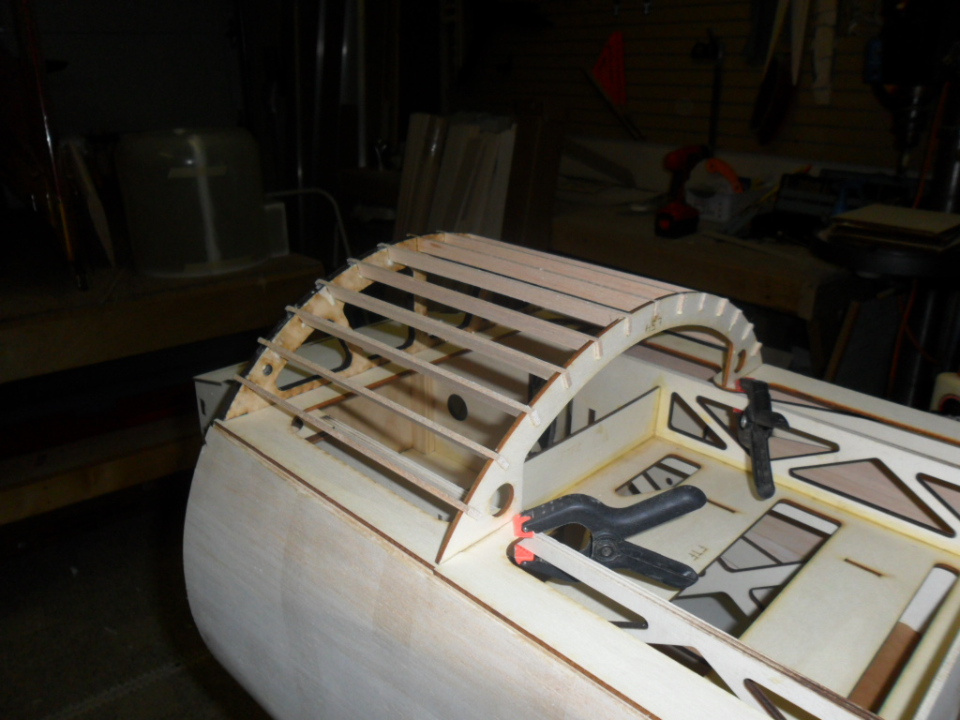
- Sheet the hatch using 3/32” balsa.
- Locate the 4 laser cut cowl mounting rails and plywood hooks.
- Using the rail as a guide mark and cut out the slots for the hooks to slide through in the top and bottom cowl parts. The slots can be slightly oversized but make sure they are close to matching top and bottom.
- 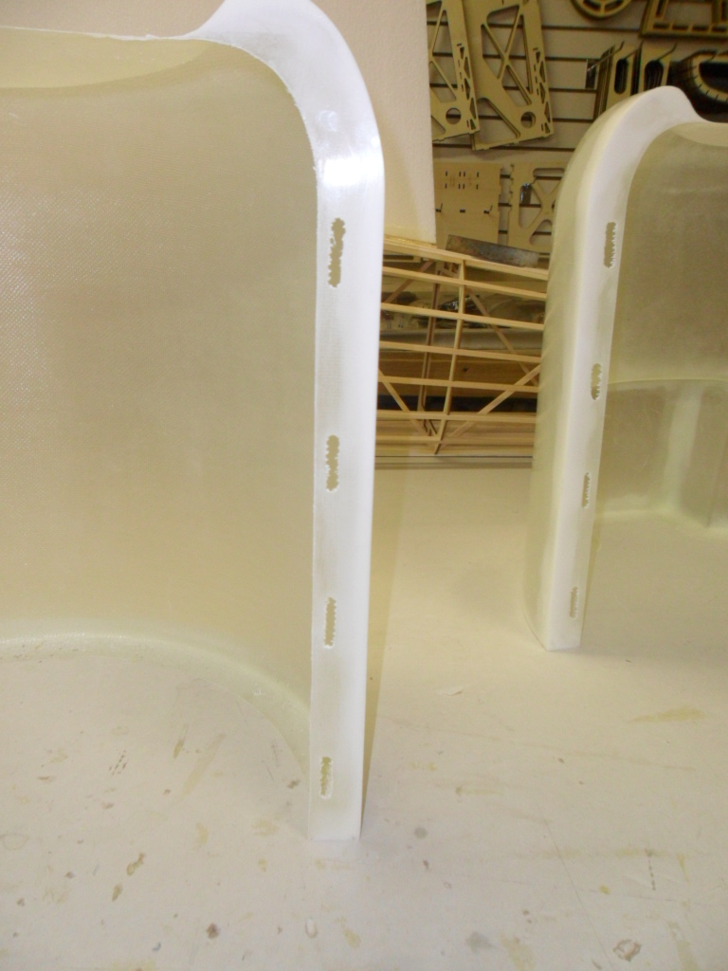
- Next glue in the plywood rails to the bottom of the cowling only.
- 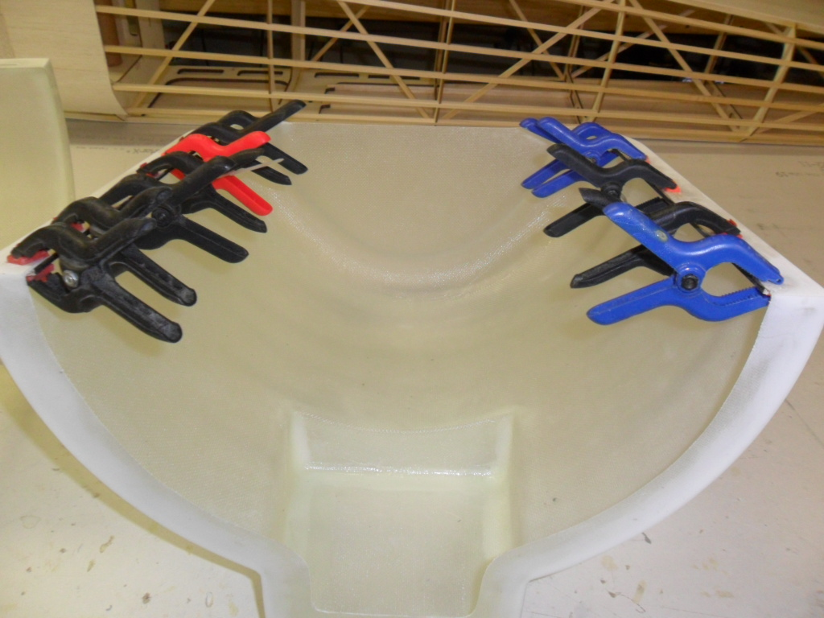
- Once dry we are ready to fit the top to the bottom. I recommend using a slow set epoxy for this to give you time to make adjustments. Dry fit the rails into the top cowl and clamp it in place to the bottom. Make sure that your slots line up and make adjustments as needed. Once satisfied with the fit epoxy the rails in place. DO NOT GLUE ANY OF THE HOOKS IN AT THIS TIME. You can slide them in place to check alignment during installation of the rails.
- 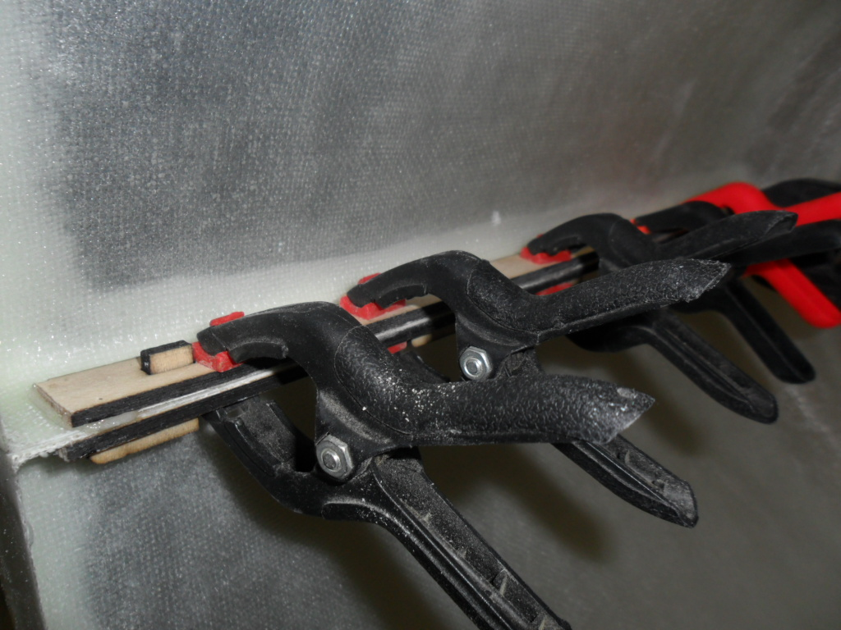
- Once the rails are dry we are ready to glue in the hooks. Apply a light coat of wax or mold release to the matting surface of the top and bottom flange on the cowling. This will keep them from sticking together just in case any glue runs through during the hook installation. Clamp the top and bottom together and make sure it is flush along the back and sides. Next glue in the hooks. I use a thick CA for this. They should point backwards to allow the top of the cowl to slide forward about a ½” to be removed while the bottom will stay attached to the fuselage.
- 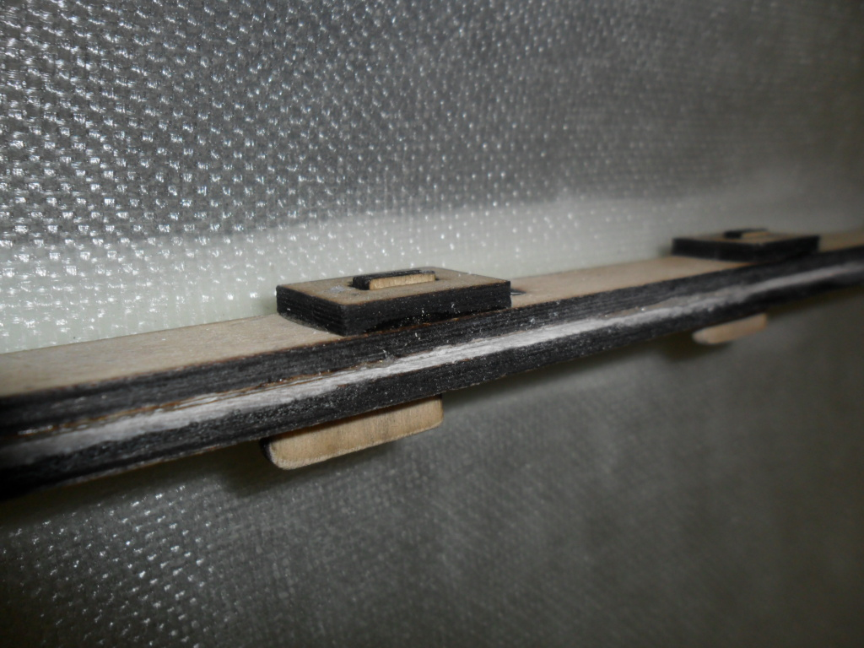
- The hooks are glued to the top of the cowling only along with the hook doublers. The picture below shows the top slid forward and ready to be removed.
- 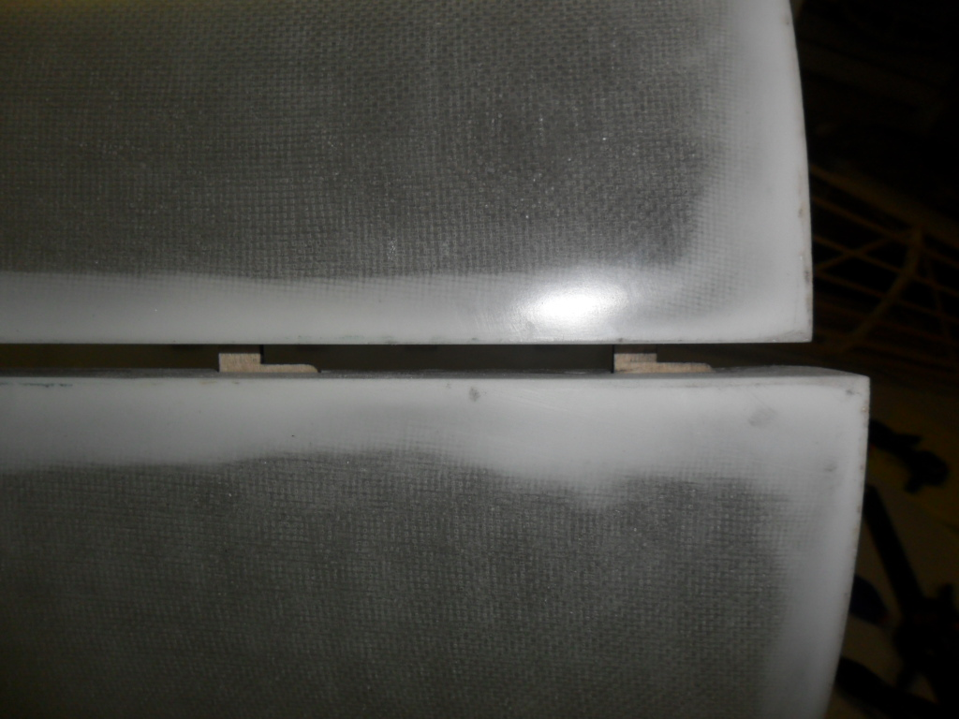
- You can use a small screw on each side at the front of the cowling to keep it from sliding forward during flight.
- Tape the cowling in place on the fuselage and once satisfied with the fit attach the bottom of the cowling to F1 former using 6/32 hardware.
- 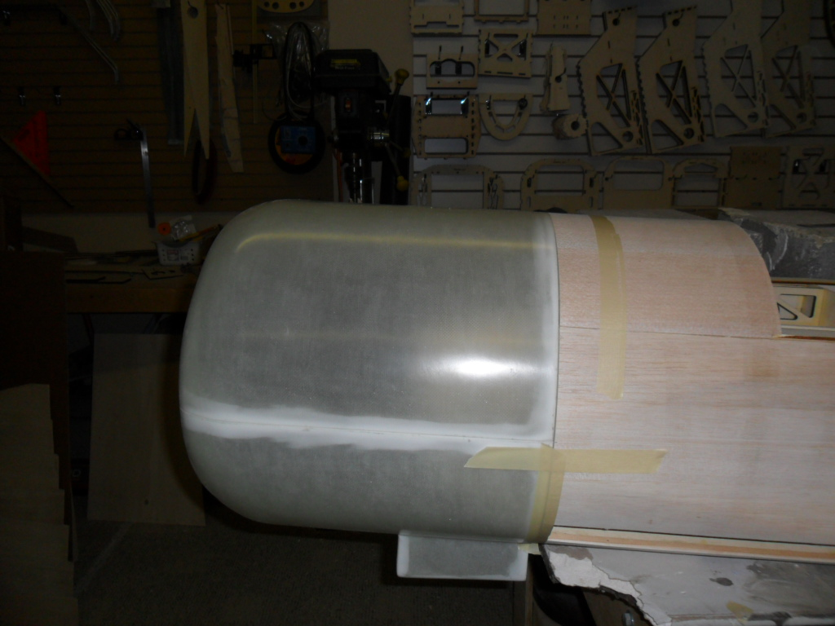
- 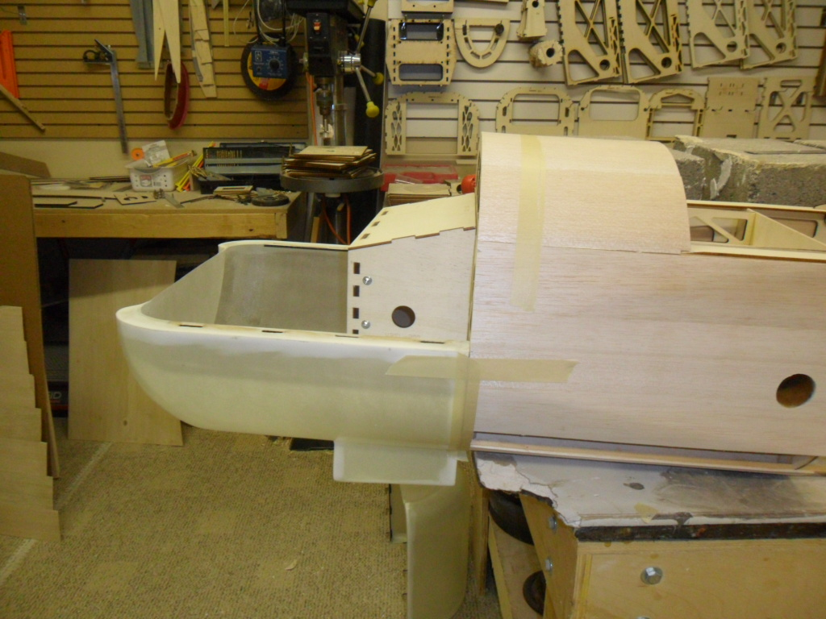

WING CONSTRUCTION

*Some of the foam cores may have ridges. This is due to the cutting wire moving at a slower speed than the root end. This is normal.
- Using 1/16” x 4” x 36” balsa sheets make up 20 pieces roughly 59” long. These should be long enough to run the length of the wing starting at the trailing edge. I use roughly a 70 degree angle when splicing the sheets together. Start your first sheet running parallel to the trailing edge of the wing and work forward. Use 5 sheets of the long balsa sheets that you made up and stagger the joints as you work forward. Then use the remaining 36” balsa sheets towards the leading edge. For you first wing skin you will need to use 2 pieces of 36” balsa and when you make the other sheet for the wing you will use 1 sheet plus the large scrap that is left from the first sheet to complete one wing panel. When you make the opposite side of the sheeting stagger the joints so that no two joints are in the same location from top to bottom.

Building Notes
Tape sheets together and use white glue to edge glue sheets together. Tape across the seam to hold the seam together and let it dry. Sand smooth on a flat surface.

- Seal one end of a 1.5” x 18” phenolic with scrap balsa and sand smooth. Lightly sand entire phenolic.
Trial fit phenolic & wing tube support. Sand wing tube support flush with the foam core on both sides.
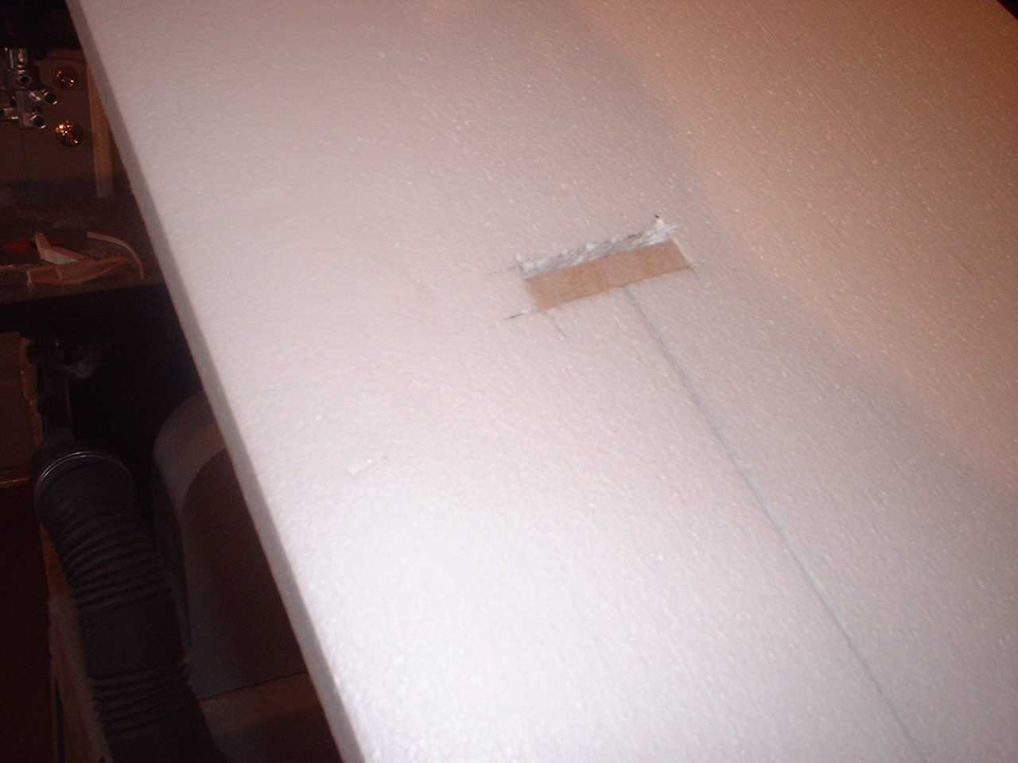
- Glue in phenolic & wing tube support. Using polyurethane glue or equivalent. Then sheet the wings. I use around 300 pounds of weight when sheeting a wing. The wing must be sheeted on a flat surface. Topside up.
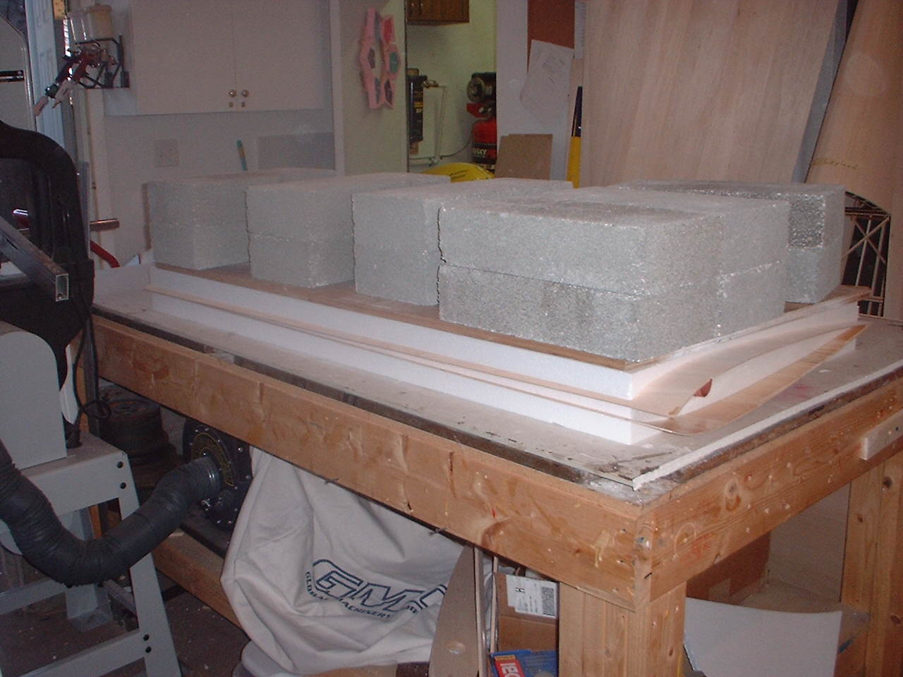
- Trim and sand sheeting flush with foam core. Cap L.E. with 1/2" balsa and T.E. with 1/8" x 3/8" balsa and sand flush with the wing sheeting.
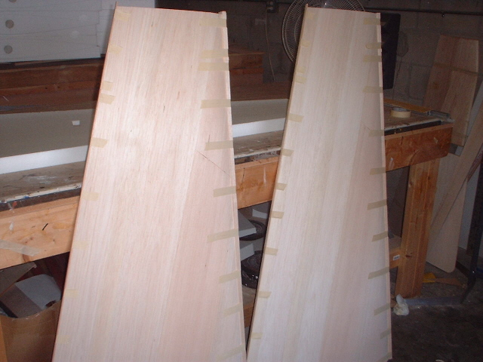

- Refer to the plans for the aileron cutout. Use ½” balsa for the wing T.E. and the aileron L.E.
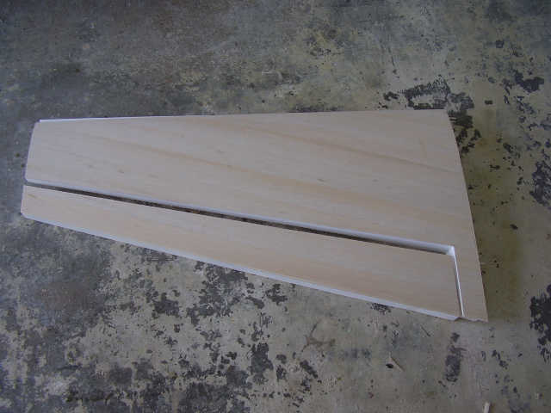
- Refer to the stab construction section on how to make the laser cut servo boxes and how to install them as well as the 5/8” dowel hardpoints. Before gluing in the servo boxes use a long piece of copper tube. You can get a 5 ft piece from Home Depot for a couple bucks and heat the end with a torch. Drill a hole in the root of the wing where you want the wire to exit. I like to burn the hole along the T.E. of the servo box hole and keep it running along the top of the sheeting. Keep track of the tube as you go from servo box to servo box.
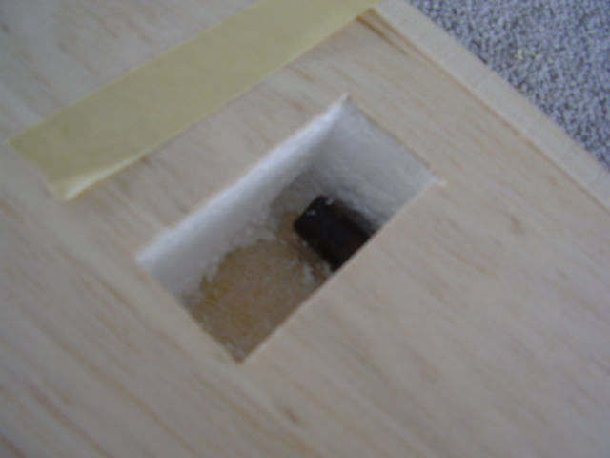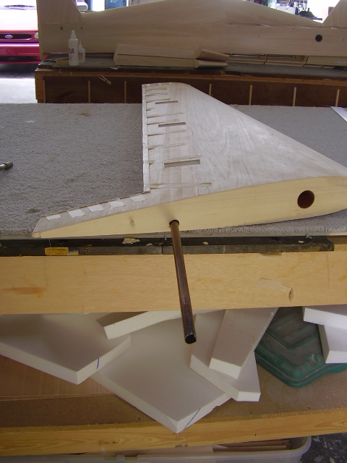
- You can now hinge and bevel the wings and ailerons.

STAB CONSTRUCTION

- Prepare stab sheeting using 1/16” x 24” balsa.
- Cut two phenolics 5.50” and seal one end using scrap balsa.
- Trial fit phenolic.
- Glue in phenolic and sheet the stabs.
- Sand sheeting flush with foam.
- Glue on the ½” balsa L.E. and 1/8” balsa T.E. and sand to shape.
- Do not cut elevators at this time. Install the hard point per plan that holds the anti-rotation bracket on the bottom of each stab.
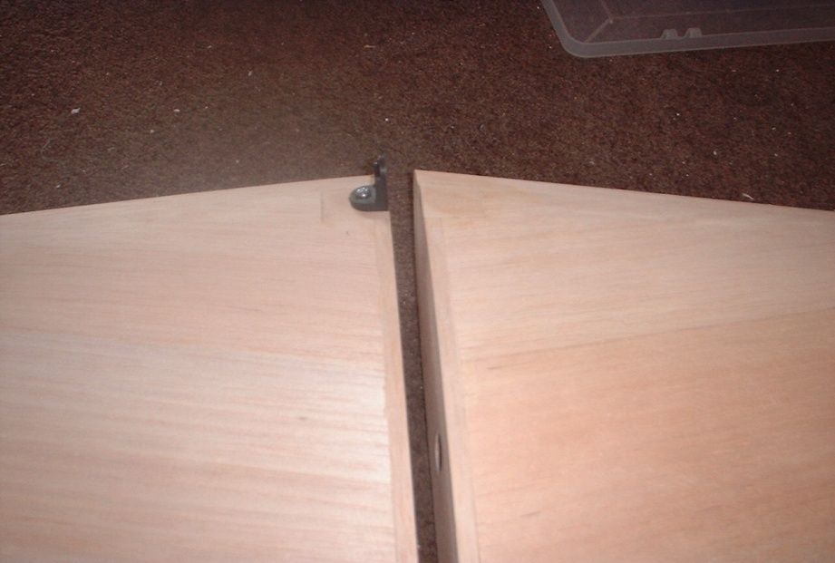

WING AND STAB INCEDENCE

- Level the top longeron of the fuse by blocking up the tail of the fuse.
- Trim the balsa side sheeting from the3/16” anti-rotation holes. There are two on each side.
- Install one wing panel and use an incidence meter to set the wing incidence at 0 degrees.
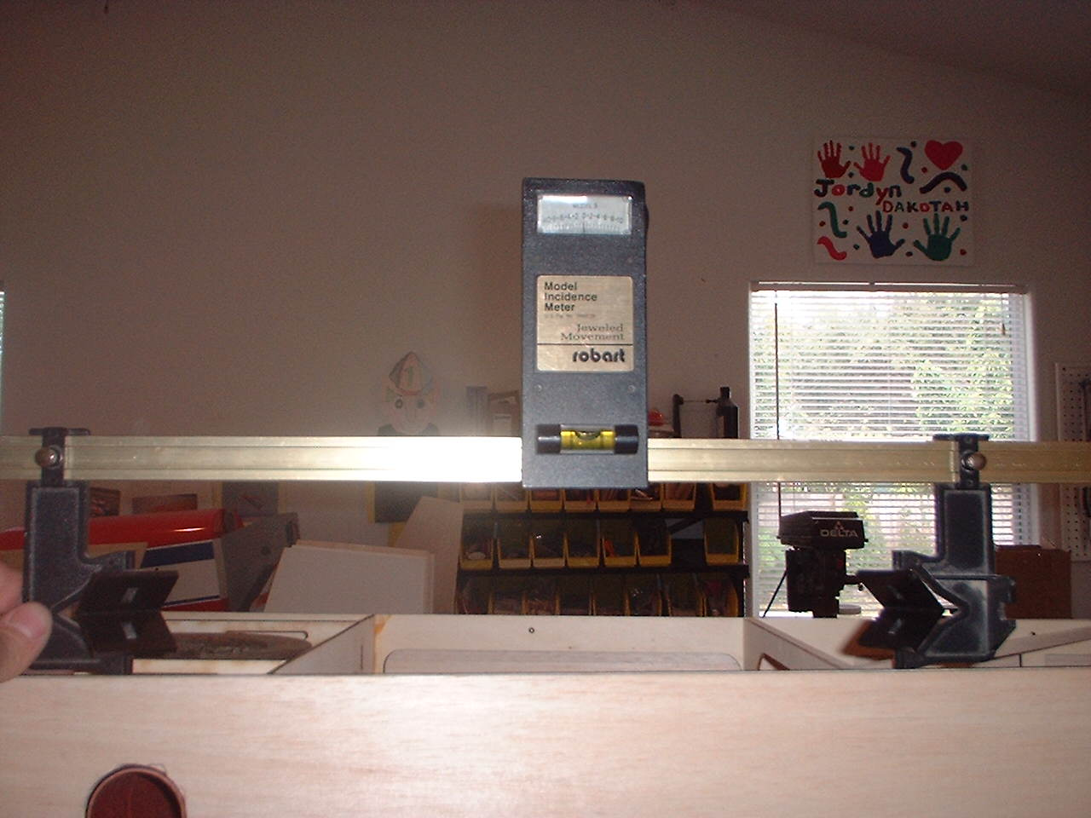
- Using a3/16” x 18” drill bit, drill the two anti-rotation holes. Go through the opposite side of the fuse and drill into the root of the wing 2”.
- Note picture shown is of a Extra 300, the process is the same for all Dalton Airframes.
- Drill and set both wings, then proceed with the stabs.
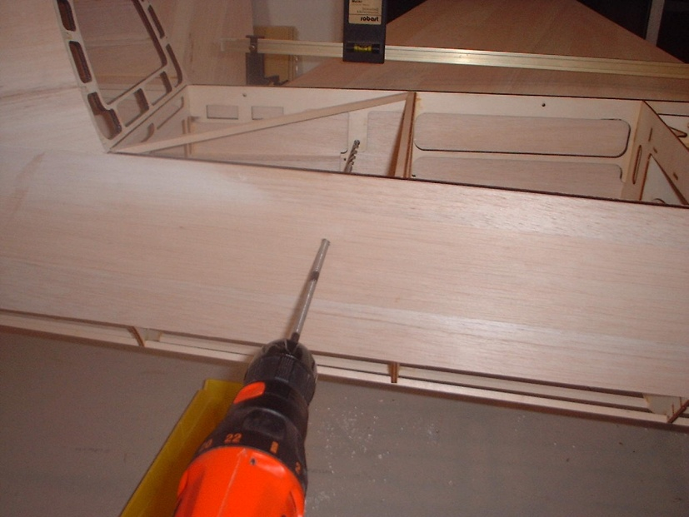
- Glue in the ¼ x 20 hanger bolts into the root of the wings.
- Install one stab to the fuse. Trial fit the stab bracket. You may need to sand the bracket a little so there are no gaps between fuse and stab.
- Use a #6 wood screw and install stab bracket to stab.
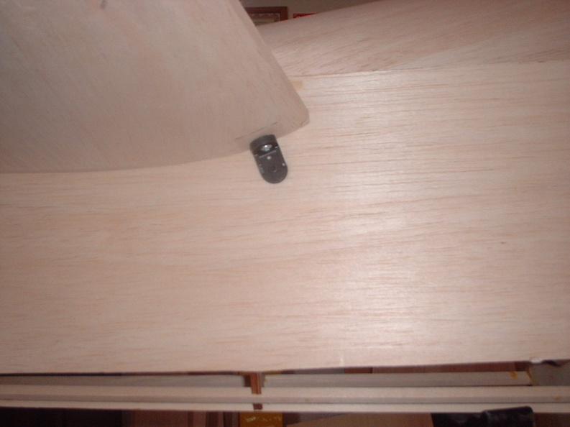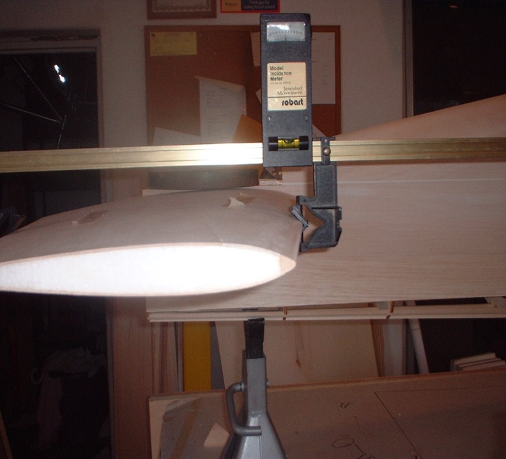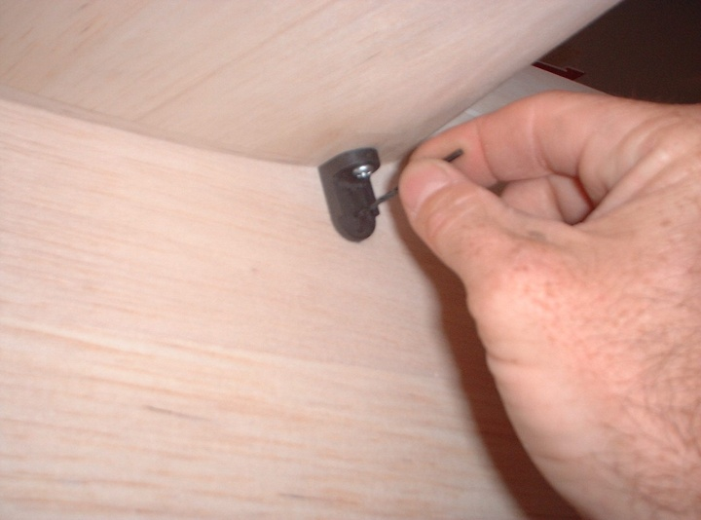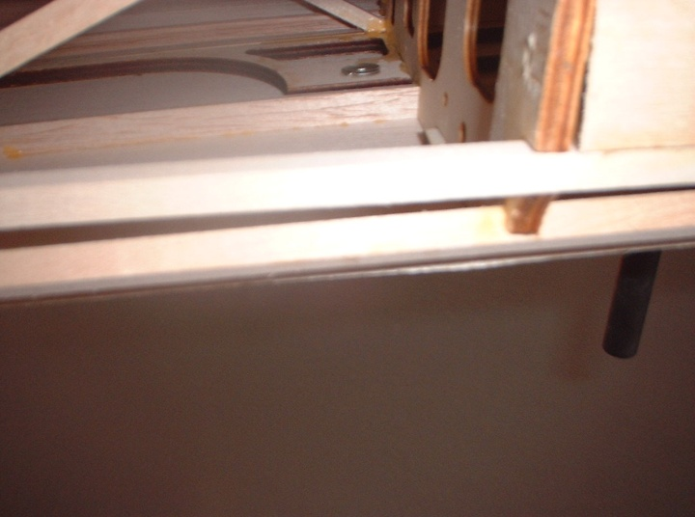
- Using an incidence meter set the stab incidence at 0 degrees. Use a 6/32 screw and blind nut to secure stab in fuse.

- Using a ¼” drill bit drill through the aluminum tube and into the root of the stab.
- Remove the stab and glue in the 3” x ¼” dowel with polyurethane glue and leave about ¾” extending out of the root. Check to make sure that the antirotation pin slides into the aluminum tube smoothly.
- Repeat steps 9 thru 11 for the opposite side of the stab.

- You can now finish stab construction and install all hard points and servo wells per plans.

- Install the laser cut 3/32-ply plate into the fuse sides. Slide the stab onto the fuse and use the bracket as a template to trace the location of the plate. Cut away the sheeting on the fuse side and glue in the ply piece. Make sure that you do not get glue into the blind nut on the inside of the fuselage. This will provide a plywood footprint for the stab bracket.
- Refer to the plans and cut out elevators from the stabs. This can be done easily with a band saw. Place the stab in one of the foam shucks. This will hold the stab at 90 degrees while cutting. Save these foam pieces for drilling the hard points in the elevators.
- Glue on the ½” leading and trailing edges and sand flush with sheeting. I use the Titebond white glue for this.
- Measure from the root and put a mark at 8” from the root Use a combination square and draw a center line approximately 2” up from the trailing edge. The cutout should start 1.5” up from the trailing edge. Use the supplied servo cutout jig and center it on the line and remove the sheeting. Make sure that you are doing this on the bottom of each stab.
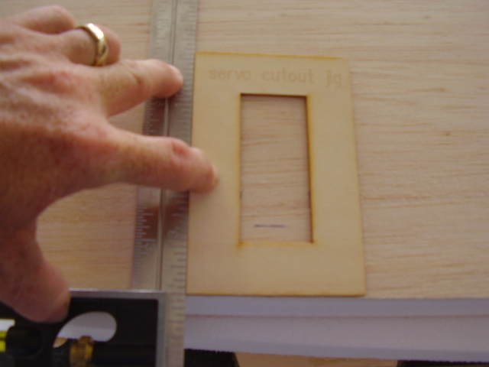
- Using a dremel with a rotozip bit remove the foam. Be sure that the bit will not cut into the top sheeting. Do this on a slow speed or the foam will melt to the bit. Remove the foam all the way up to the top sheeting.
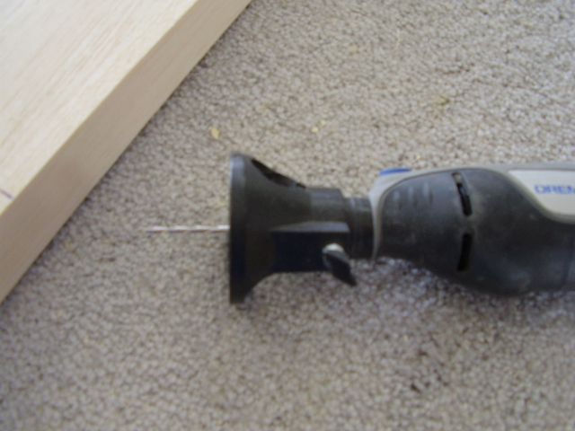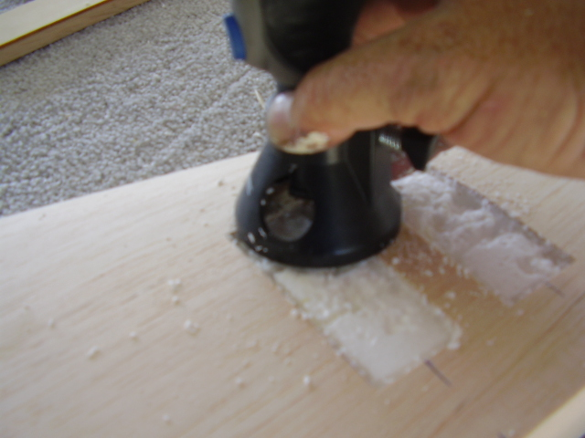
Note that the following pictures show two servo boxes for the stab but only one servo is needed unless using lower torque servos.
- Make up the laser cut servo boxes. It’s important to keep them square. They are a bit oversized on purpose so they can be sanded down and have a nice snug fit in the cutouts.
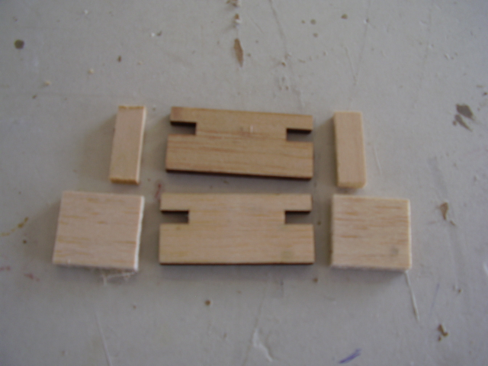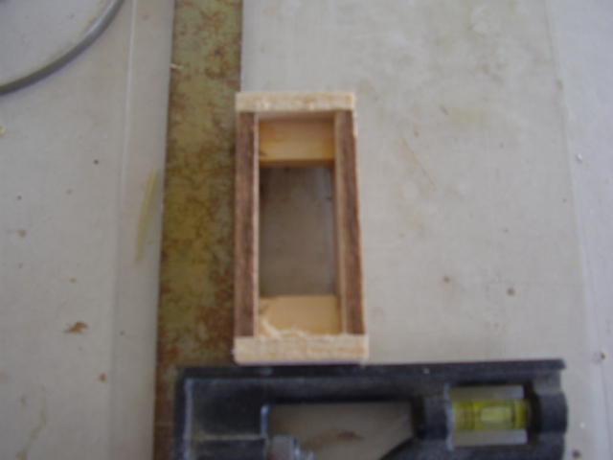
- Glue the servo boxes in using polyurethane glue. Leave about 1/8” extending out from the stab. Once dry sand smooth.
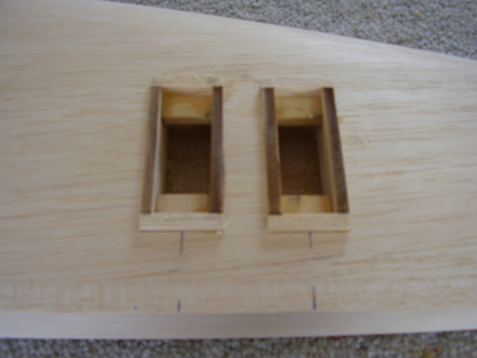
- Line the stab up with the elevators and transfer the centerline marks on to the elevators.
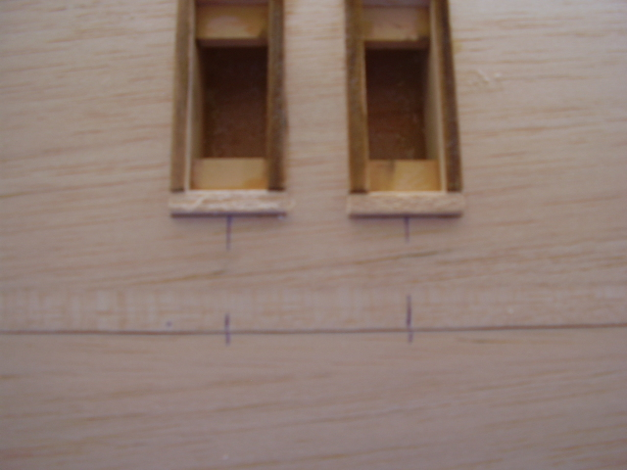
- Measure ¾” out from these marks towards the tip. This will be the location for the hard points for the control horns.
- Using the foam shucks to hold the elevators square drill a 5/8” hole on the centerline with a forstner bit. I like to just touch the edge of the ½” balsa when drilling the holes for the hard points. Drill to the top sheeting but not through it.
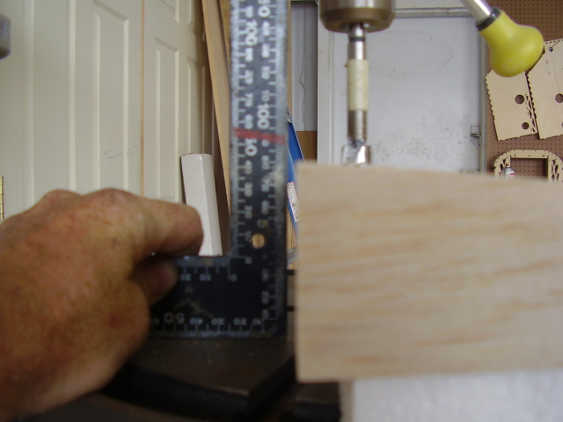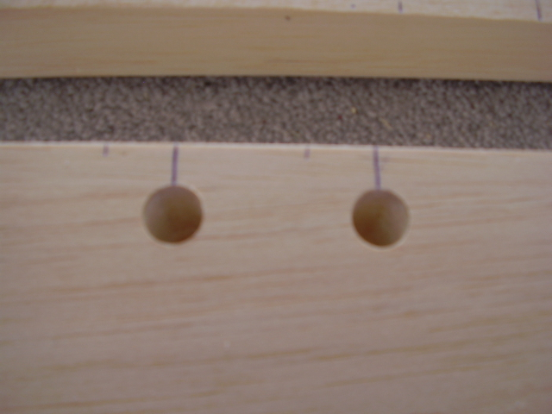
- Cut and glue in the 5/8” dowel hard points with polyurethane glue. It’s best to glue these in and keep and eye on them. Go back every few minutes and wipe of any excess glue and make sure that the expanding glue does not push the hard point out.
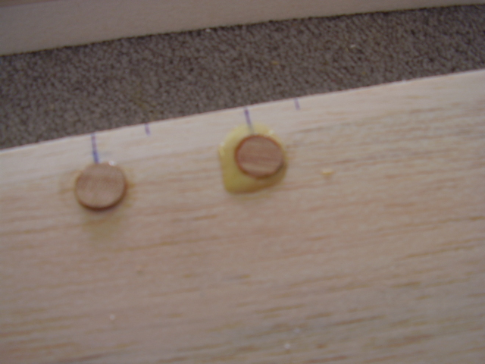
- Once the hard points and servo boxes are dry sand them flush with the sheeting.
- Next drill a 1/8” hole in the hard points for the 8/32” control horns.

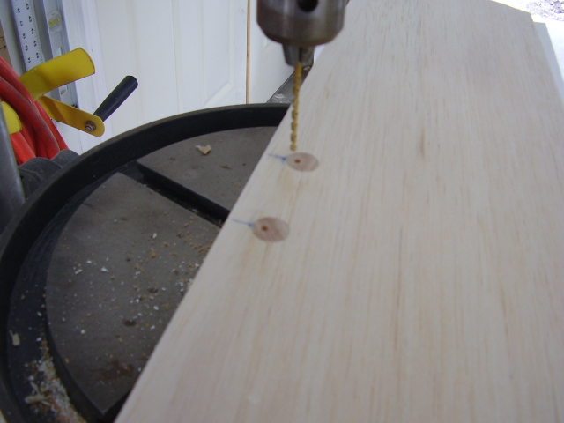
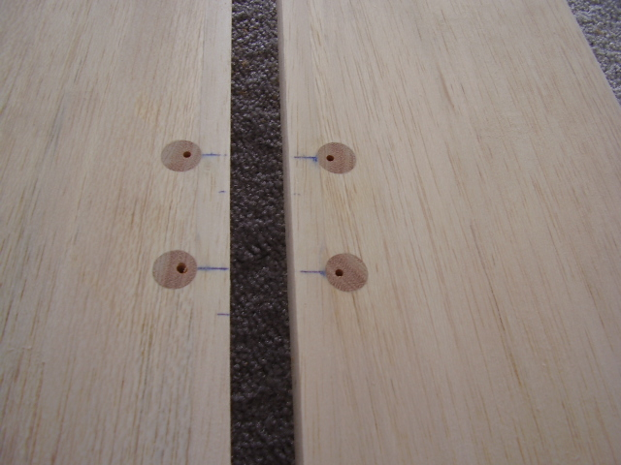
- Using 2 t pins locate the center lines on the stabs and elevators.
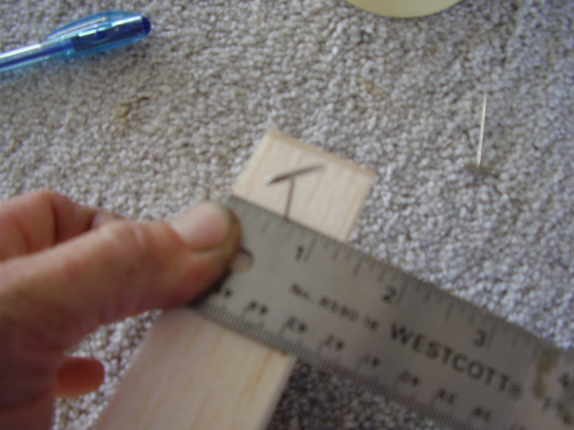
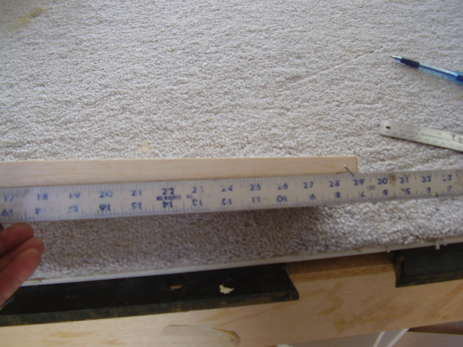
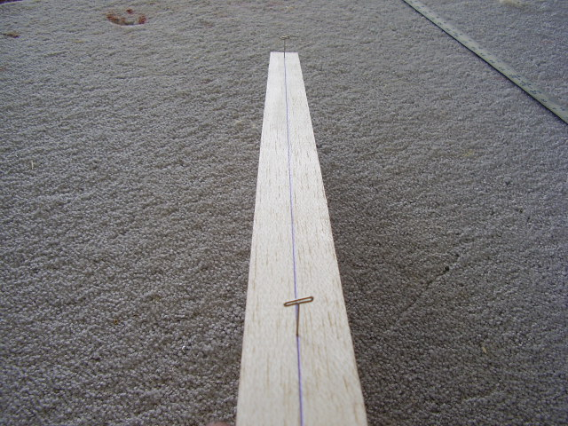
- Put a mark along the center line at each hinge location.
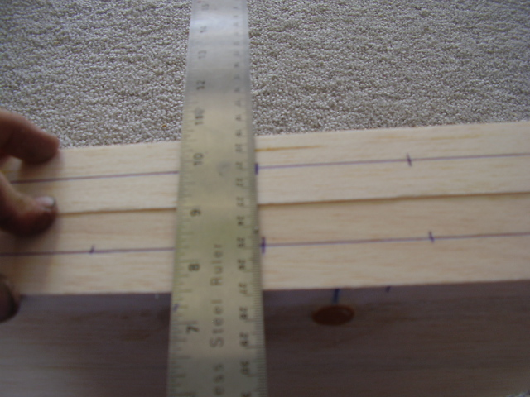
- The Great Planes hinge slotting tool with the heavy duty blades works great for cutting hinge slots. If using Robart hinges use there center line drill jig.
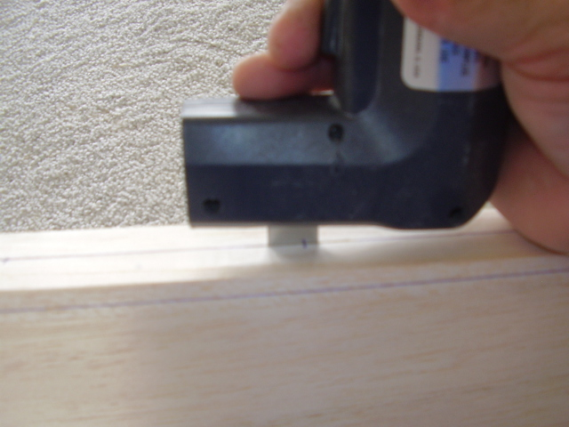
- After all hinge slots are cut measure up from the trailing edge on the stab at the root 3/8” and ¼” at the tip. Draw a straight line connecting these 2 points. This is the line that you will sand the bevel to. The measurements are the same for the elevators. Use a long razor knife to remove most of the material and then sand with a t sander to finish.
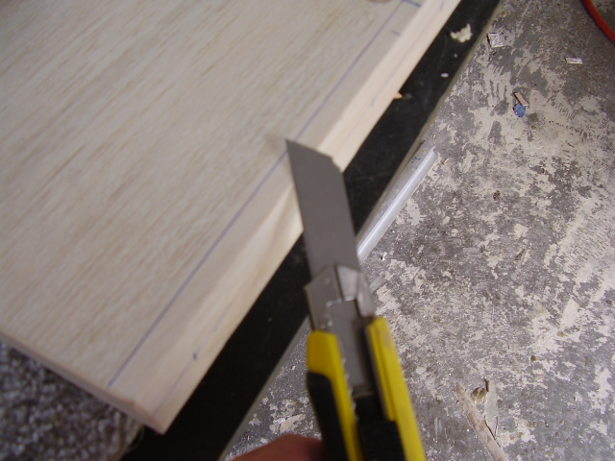
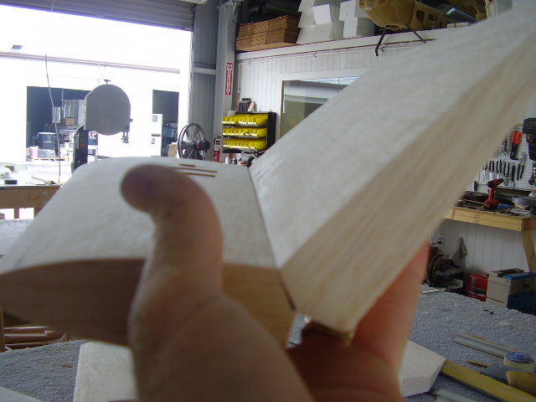
- Install the stab tube into the fuselage and measure to make sure you have an equal amount on each side. On this plane it was 5.75”. The tubes can vary in length up to ¼” so if your measurement is not the same don’t worry.
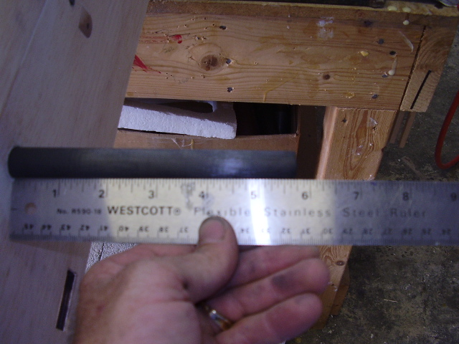
- I like to put the stab tube screw ½” from the end of the tube. So we need to put are hard point for this at 5.25” from the root of the stab. Put the stab tube into the stab and use a straight edge to locate the center of the hole for the hard point. Use the foam shuck to hold the stab square and drill the 5/8” hole for the hard point. Make sure that you DO NOT DRILL INTO THE STAB PHENOLIC! It’s best to just cut through the sheeting and use a #11 xacto blade to remove the foam down to the phenolic tube. You don’t want any glue to get into the phenolic when gluing in the hard point. Cut and glue the 2 hard points and sand flush to the sheeting.
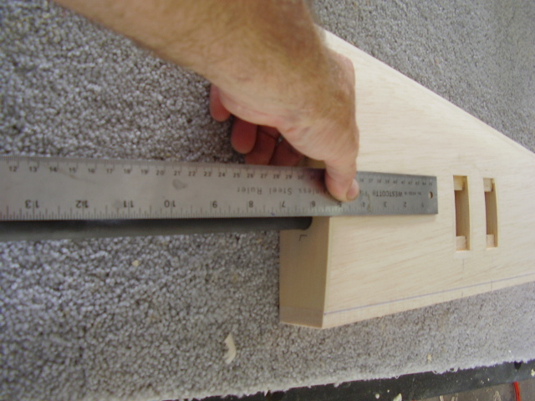
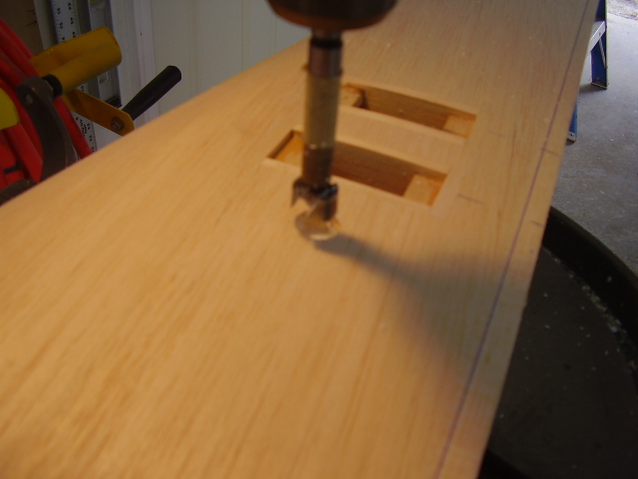
- Using some scrap 5/8” dowel sand them down to fit inside the stab tube. Cut these about ½” in length and ca them into the tube. Push them in about ¼” from the end of the tube. This should put your hole in the center of this block.
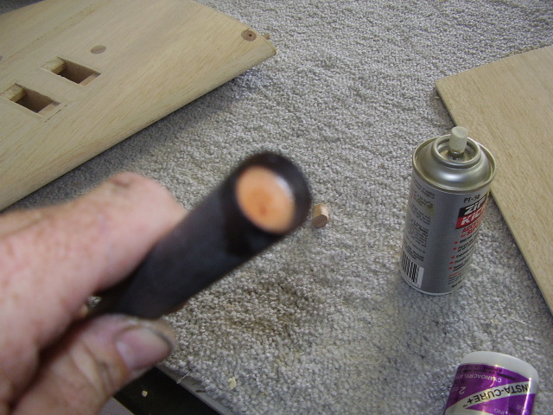
- Install the stab tube back in the fuselage and make sure you have equal distance on each side. Install one stab and drill and tap the tube and secure with 6/32” hardware. Next slide the other stab on and have someone compress the stab together while you drill and tap the other stab tube hole. Drill a servo lead hole through the root end of the stabs. Note picture shown is a Extra 300.
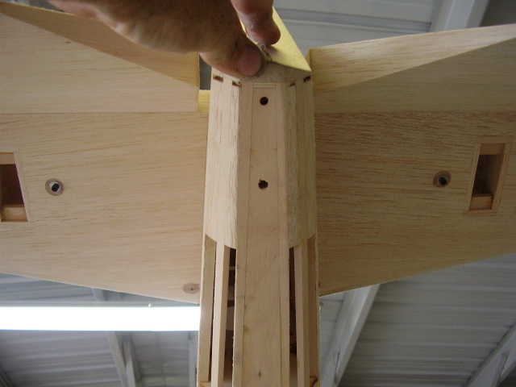

RUDDER CONSTRUCTION

- Using 1/16” x 36” balsa sheet rudder on a flat surface.
- Sand sheeting flush with foam then glue on ½” balsa L.E. and 1/8" balsa T.E.
- Cut out fin and rudder per plans.

- Glue the leading edge of the rudder and trailing edge of the fin. Note that the trailing edge of the fin extends down to the bottom of the fuselage.
- Use scrap balsa and make a ledge for the fin fairing to glue to.
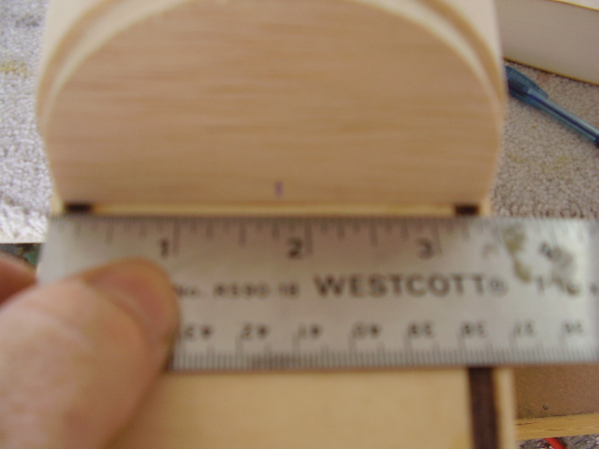
- Glue on fin to fuselage keeping it 90 degrees to the stabs. You will have to cut the front of the fin so that it fits up against the back of the turtldeck.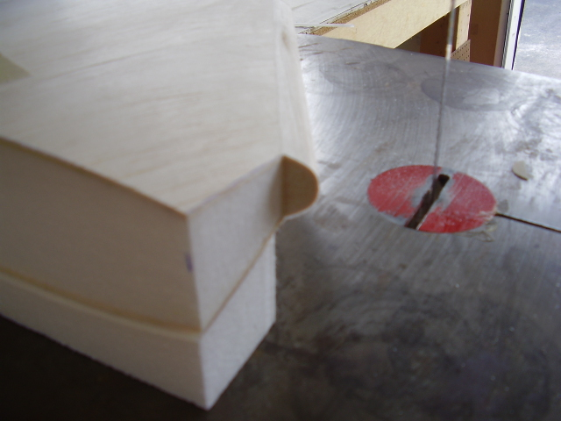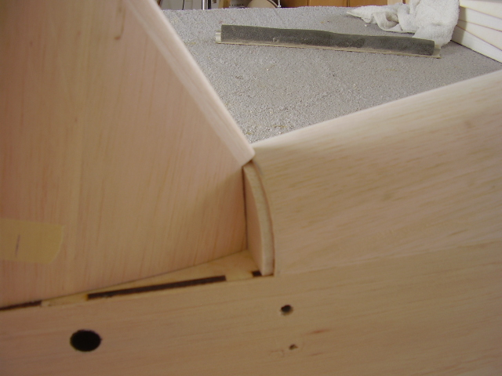
- Hinge and bevel fin and rudder.
- Glue on balsa fin fairings. The fairings are cut oversized so they need to be trimmed to fit. Use filler as needed for a smooth finish.
